Registered Building Contractor and Practitioner

Average 20 business days total  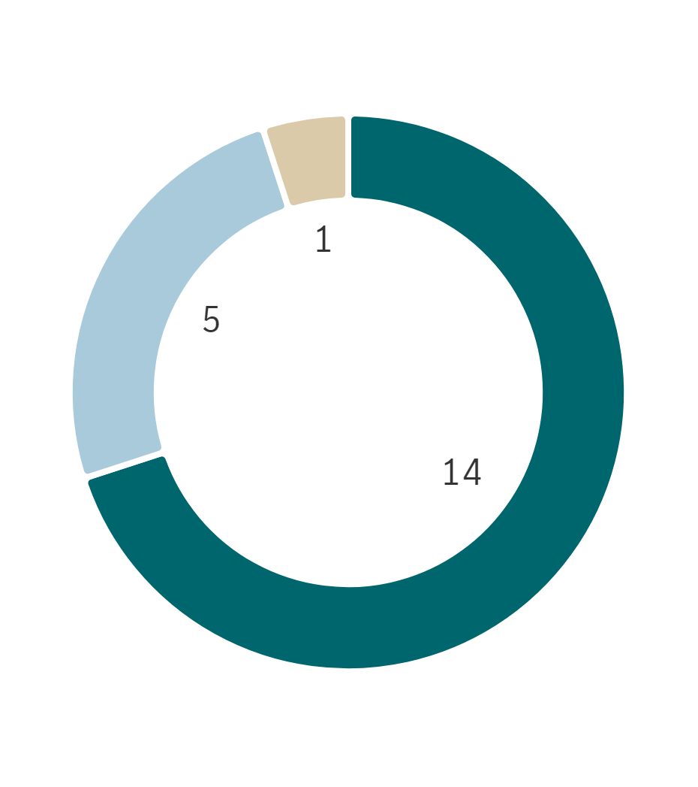 | % Finalised within target timeline  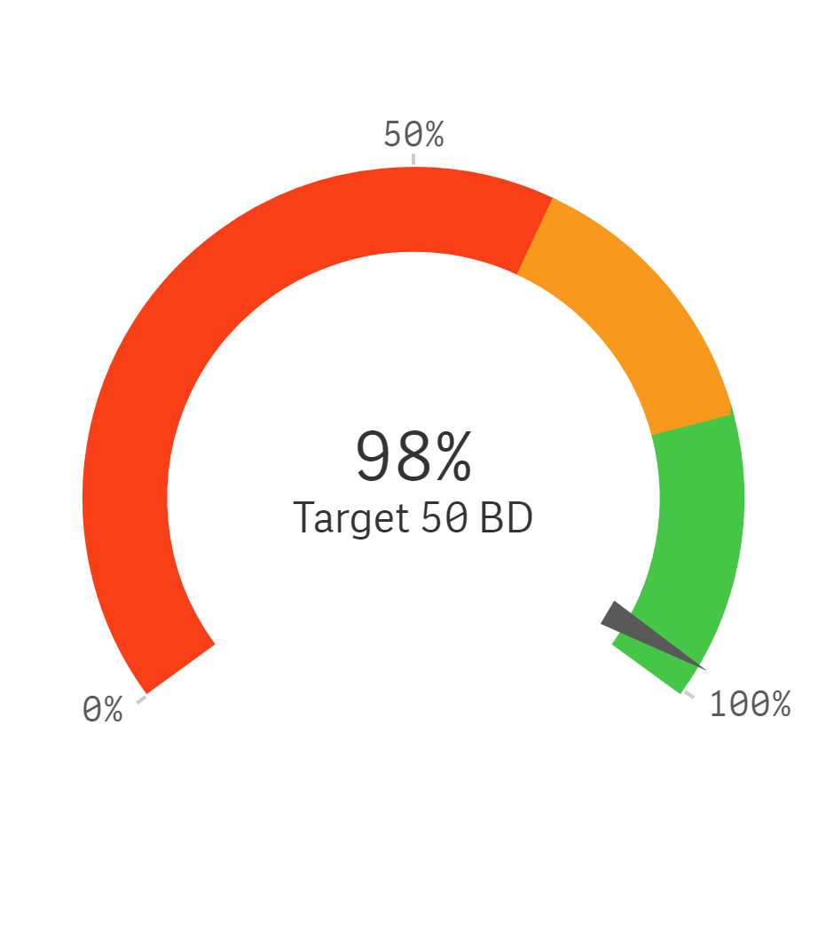
  ⬛ LGIRS Licensing | ⬛ Applicant
  ⬛ LGIRS Legal / Compliance / other
  ⬛ External party ⬛ Board / Statutory decision Maker
Trends for finalised applications and average business days to finalise

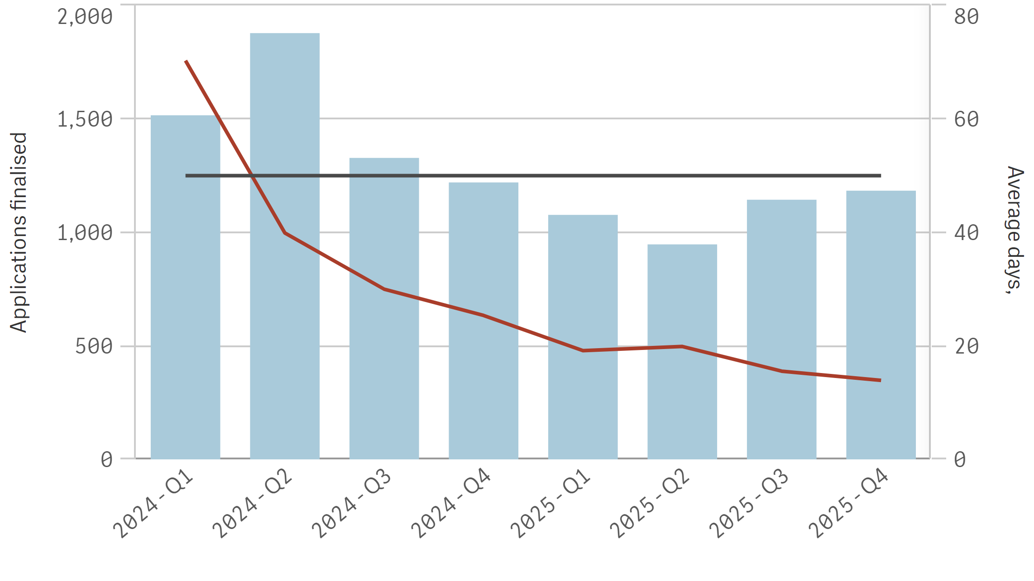
⬛ Finalised in year ➖⚫➖ Average LGIRS licensing days to finalise ➖⚫➖ Target days

Registered Painting Contractor and Practitioner

Average 17 business days total  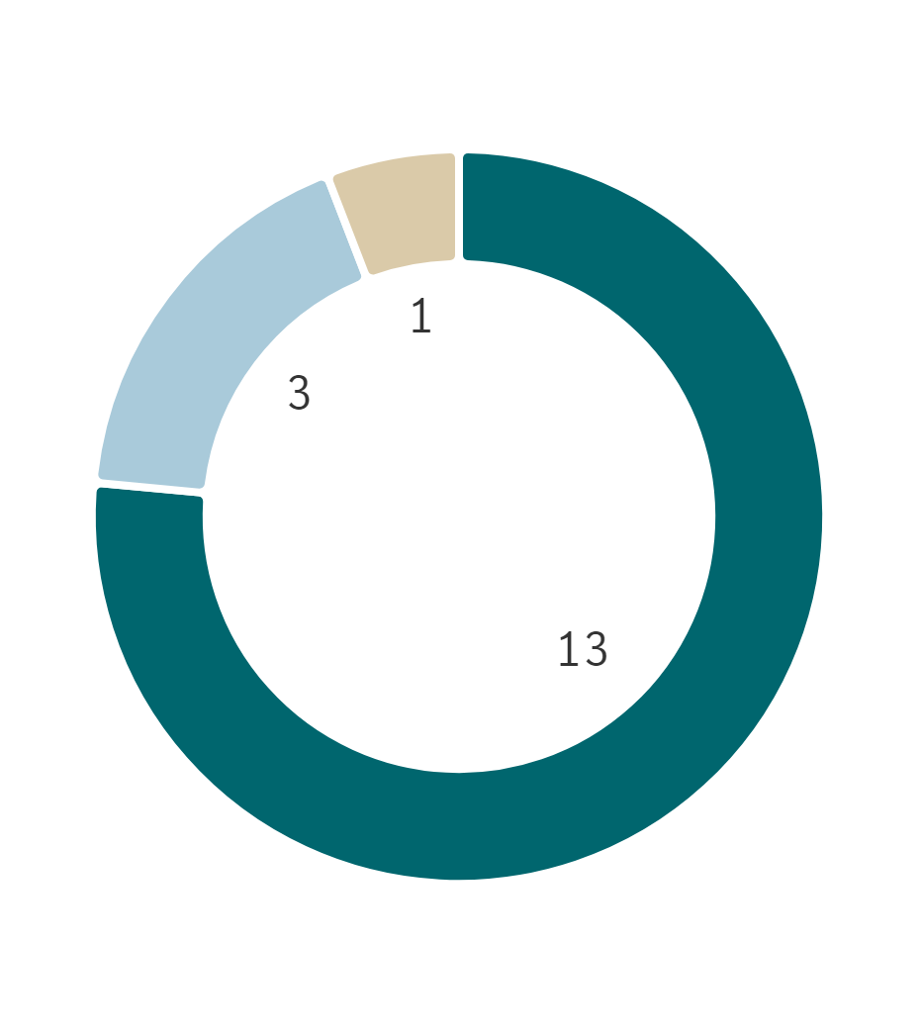 | % Finalised within target timeline  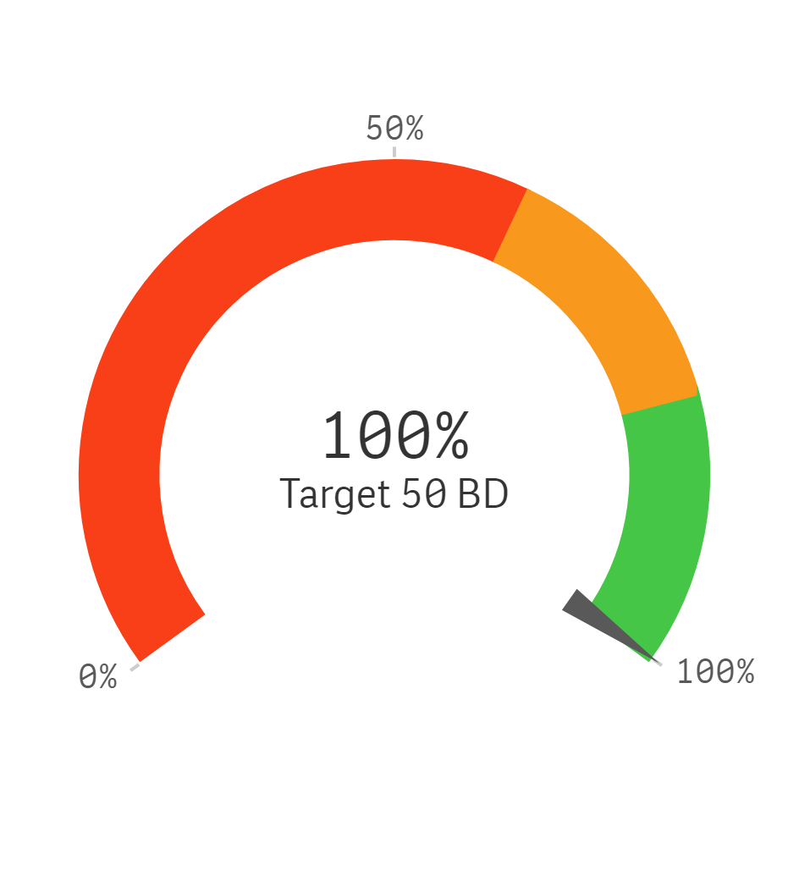
  ⬛ LGIRS Licensing | ⬛ Applicant
  ⬛ LGIRS Legal / Compliance / other
  ⬛ External party ⬛ Board / Statutory decision Maker
Trends for finalised applications and average business days to finalise

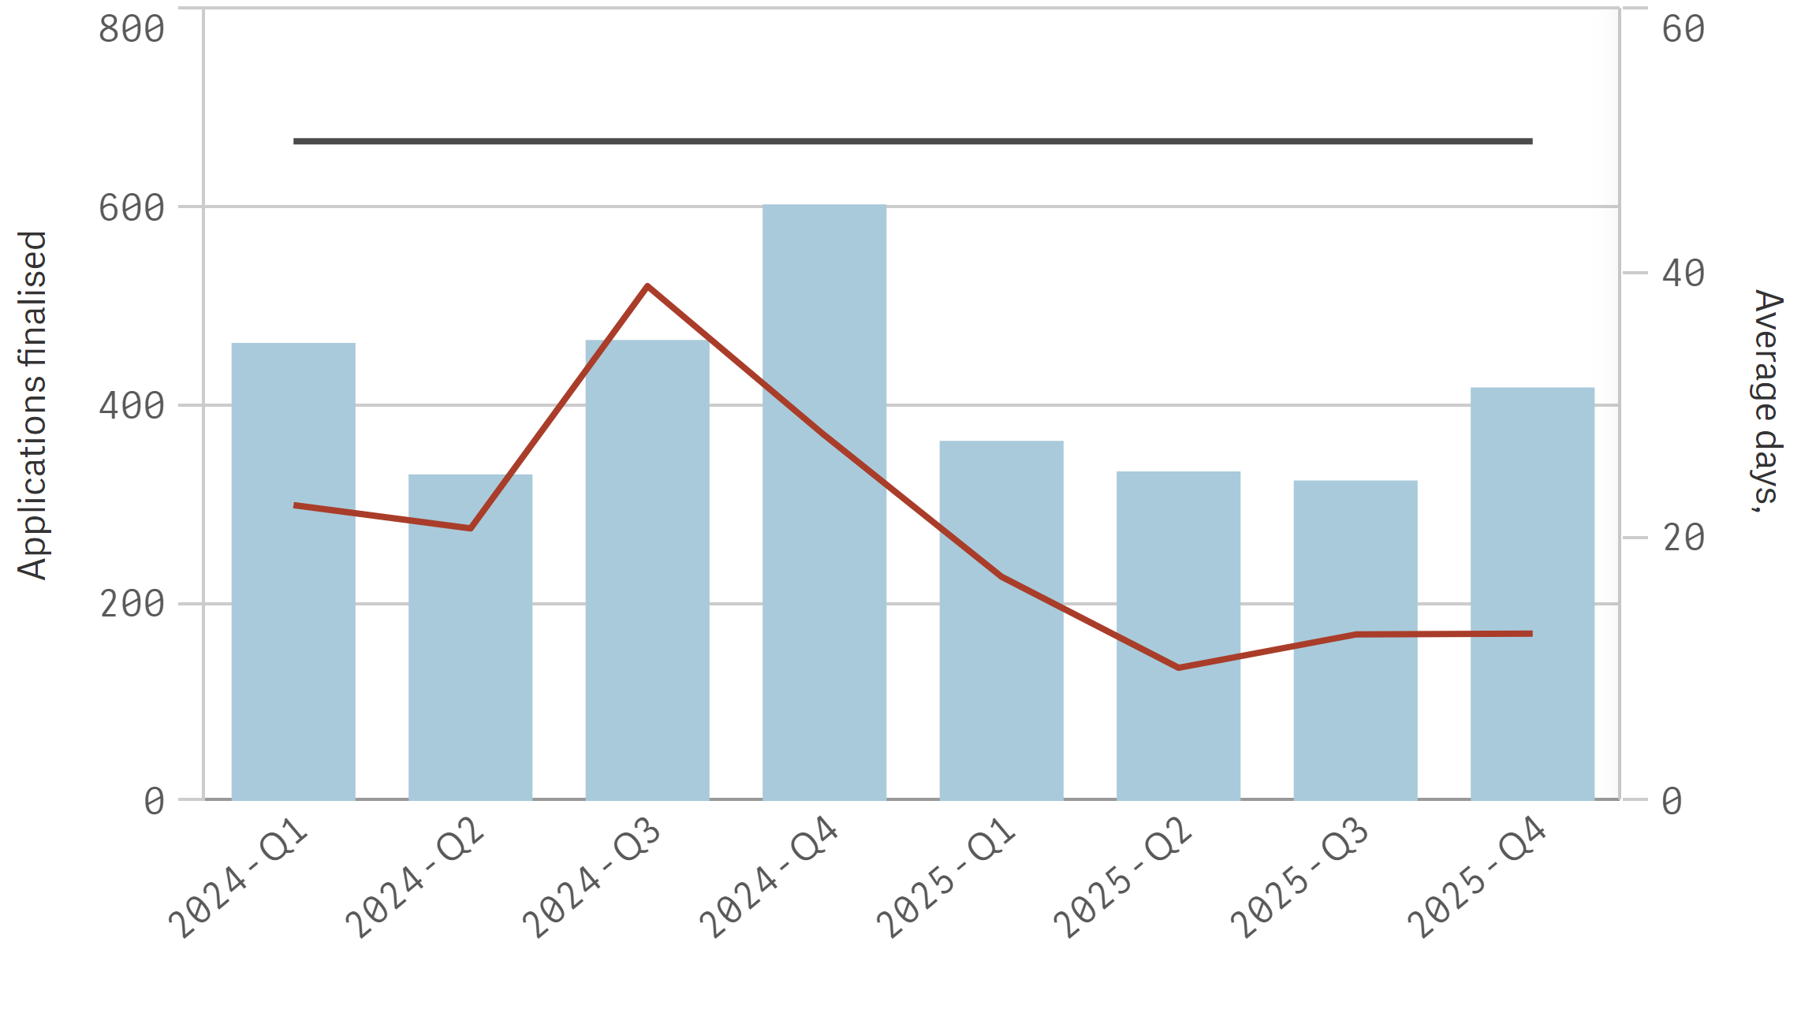
⬛ Finalised in year ➖⚫➖ Average LGIRS licensing days to finalise ➖⚫➖ Target days

Building Surveying Contractor and Practitioner

Average 24 business days total  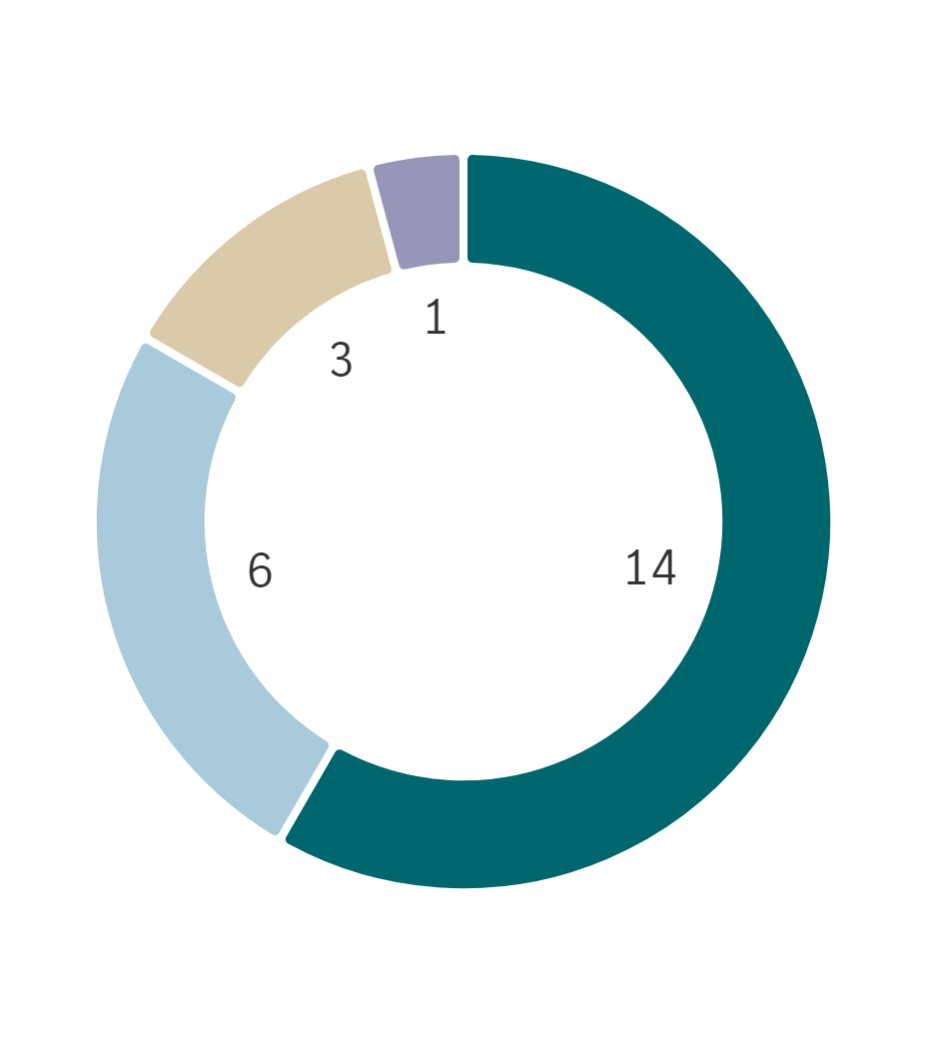 | % Finalised within target timeline  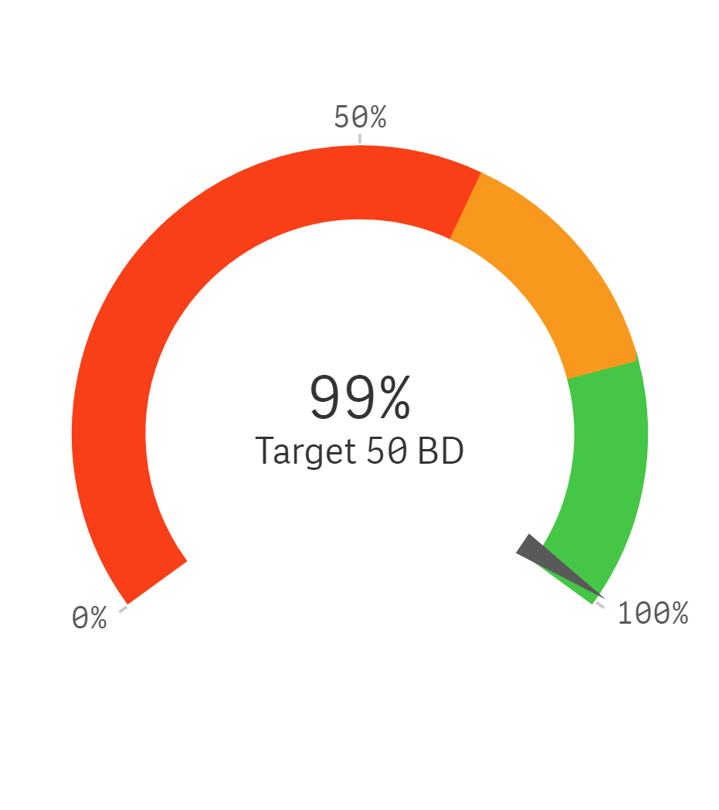
  ⬛ LGIRS Licensing | ⬛ Applicant
  ⬛ LGIRS Legal / Compliance / other
  ⬛ External party ⬛ Board / Statutory decision Maker
Trends for finalised applications and average business days to finalise

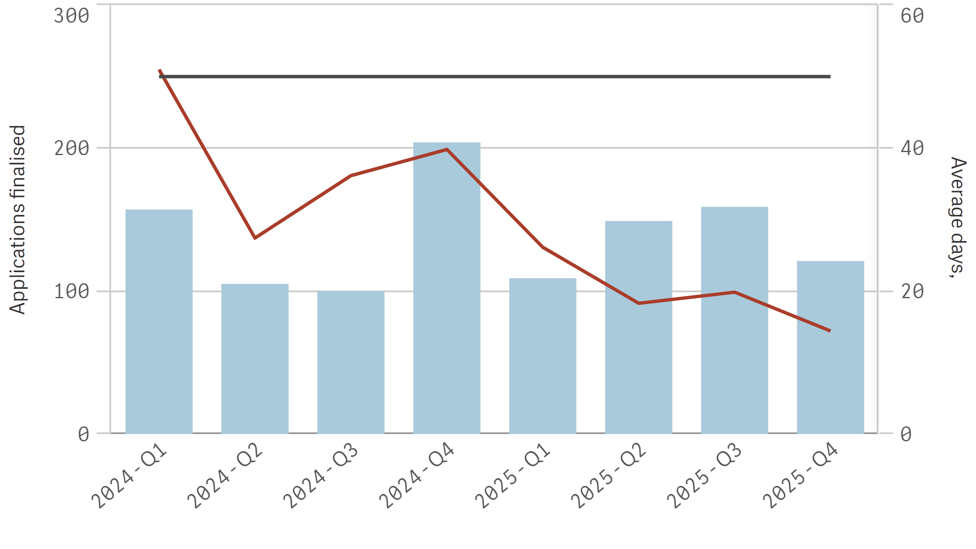
⬛ Finalised in year ➖⚫➖ Average LGIRS licensing days to finalise ➖⚫➖ Target days

Owner Builder

Average 26 business days total  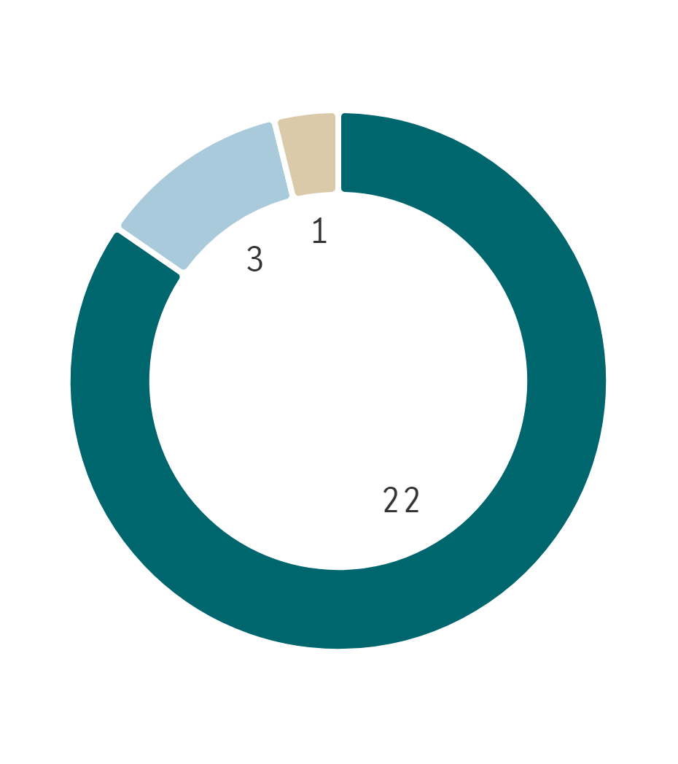 | % Finalised within target timeline  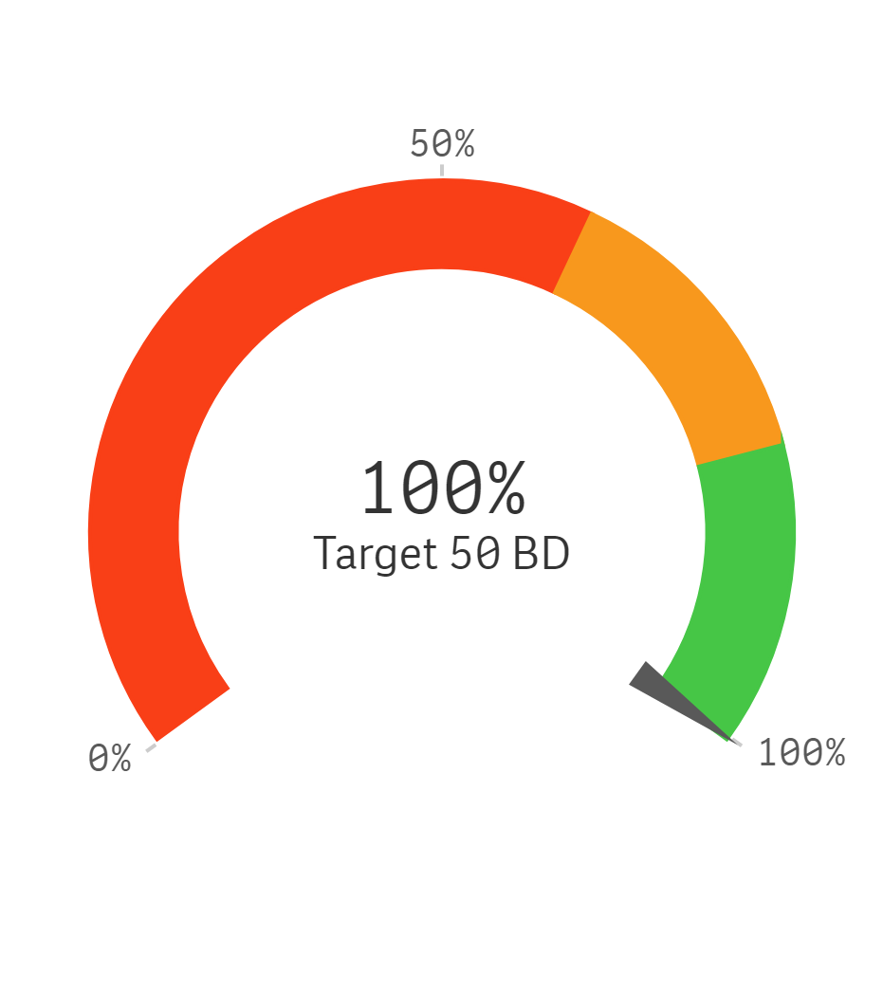
  ⬛ LGIRS Licensing | ⬛ Applicant
  ⬛ LGIRS Legal / Compliance / other
  ⬛ External party ⬛ Board / Statutory decision Maker
Trends for finalised applications and average business days to finalise

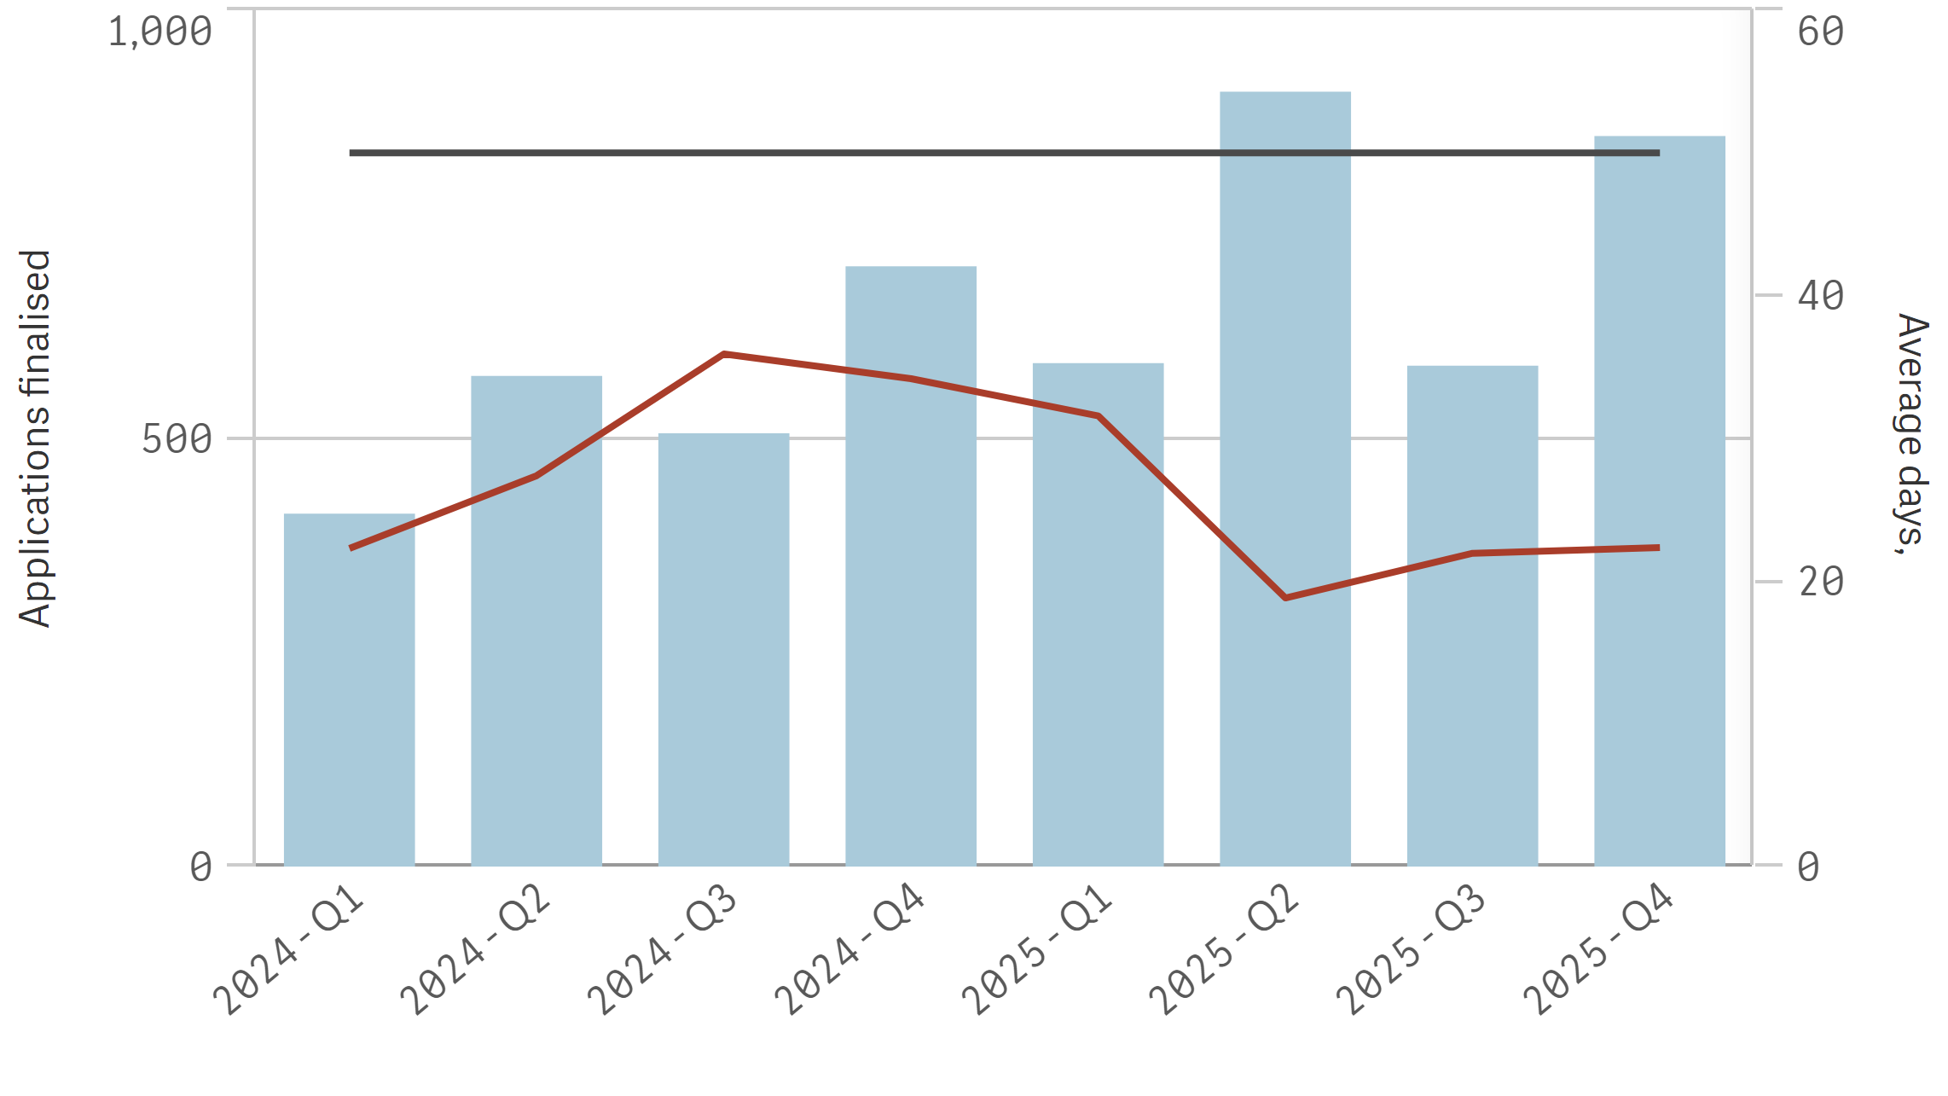
⬛ Finalised in year ➖⚫➖ Average LGIRS licensing days to finalise ➖⚫➖ Target days

Plumbing

Average 10 business days total  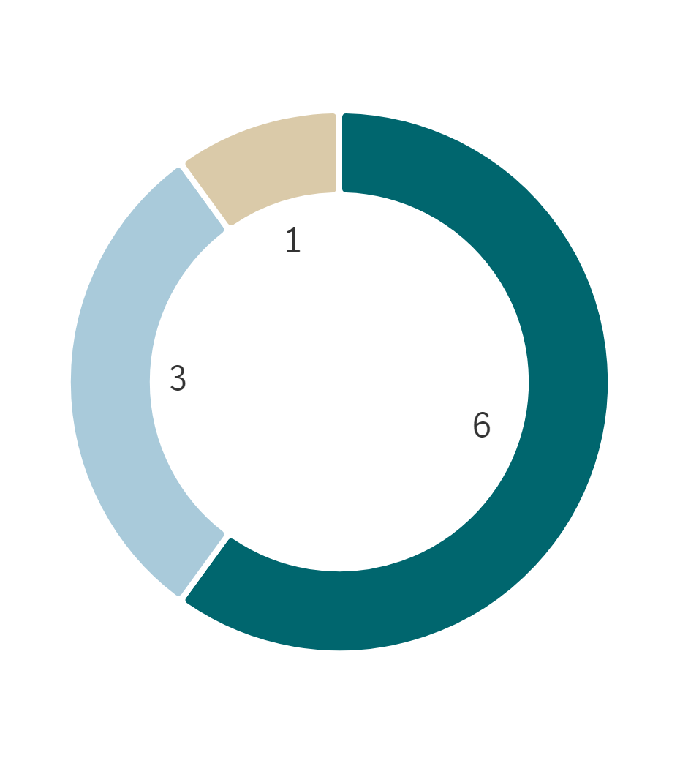 | % Finalised within target timeline  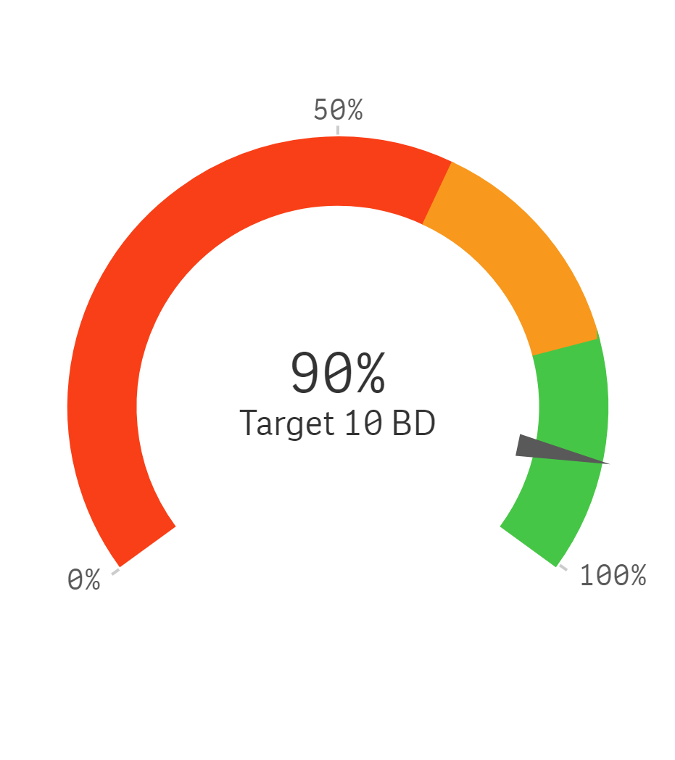
  ⬛ LGIRS Licensing | ⬛ Applicant
  ⬛ LGIRS Legal / Compliance / other
  ⬛ External party ⬛ Board / Statutory decision Maker
Trends for finalised applications and average business days to finalise

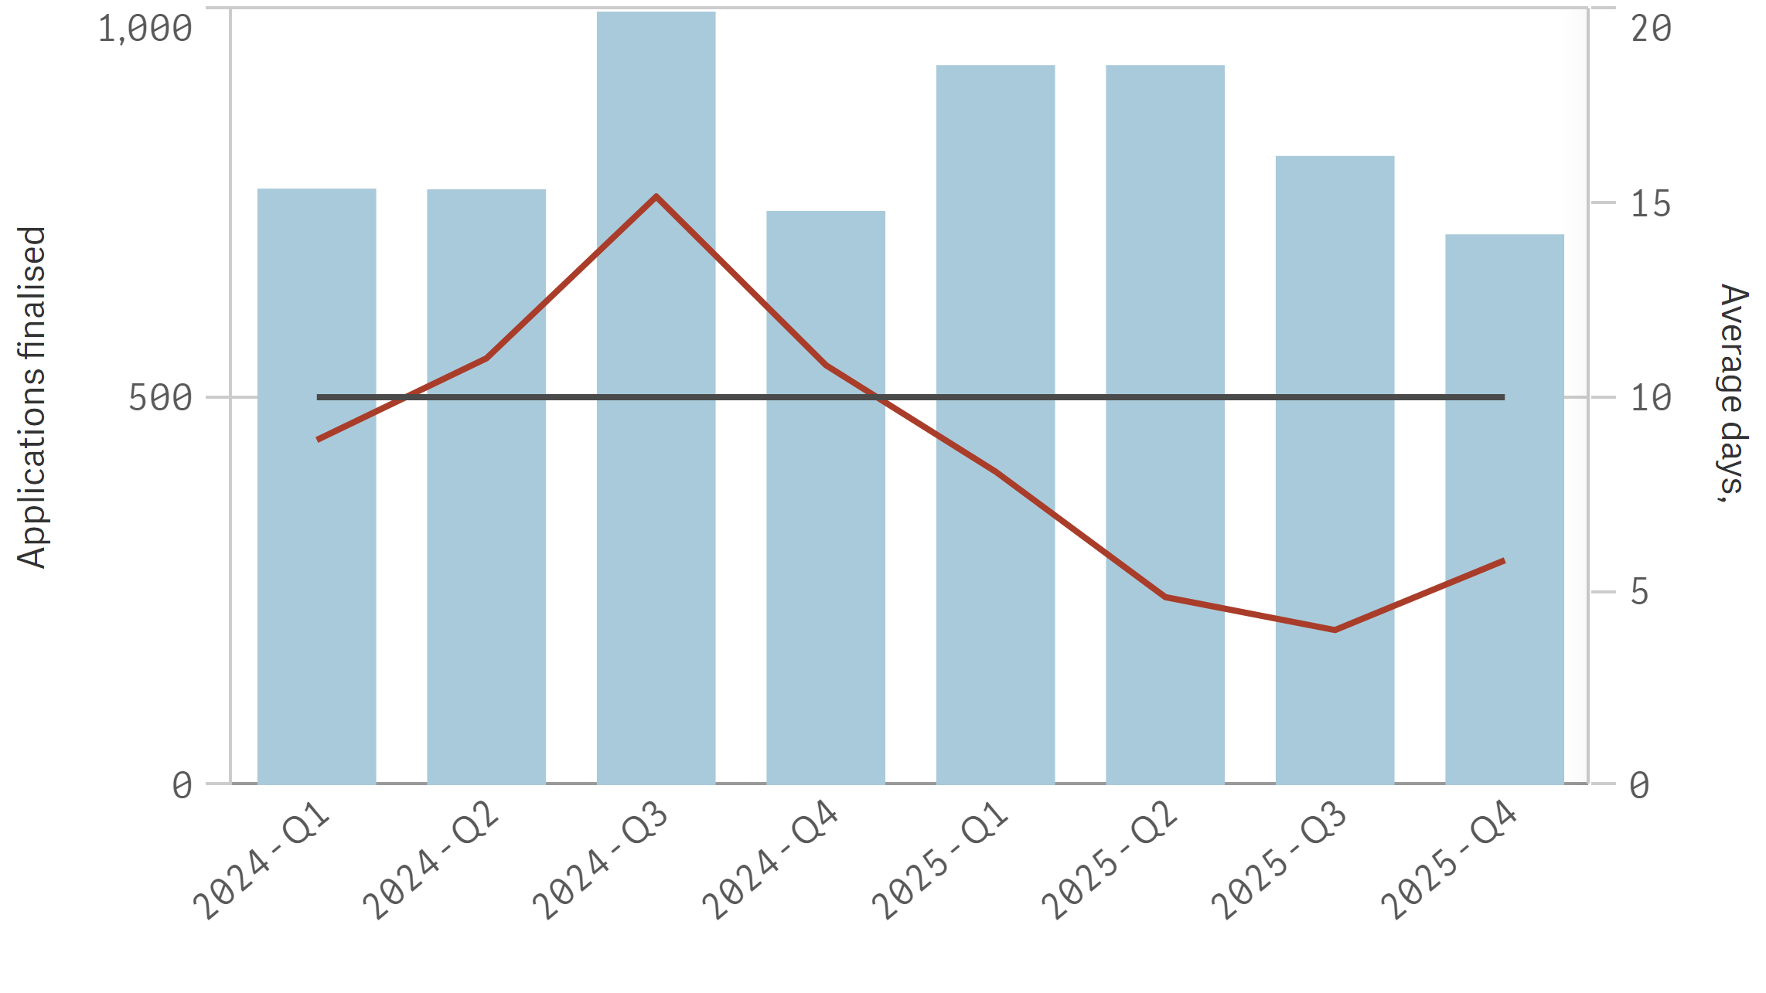
⬛ Finalised in year ➖⚫➖ Average LGIRS licensing days to finalise ➖⚫➖ Target days

Electrical

Average 10 business days total  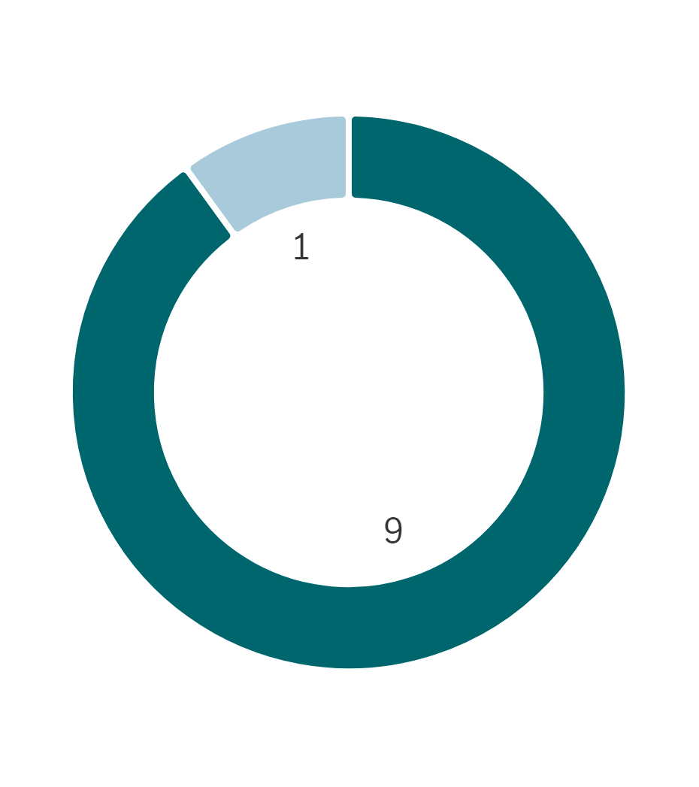 | % Finalised within target timeline  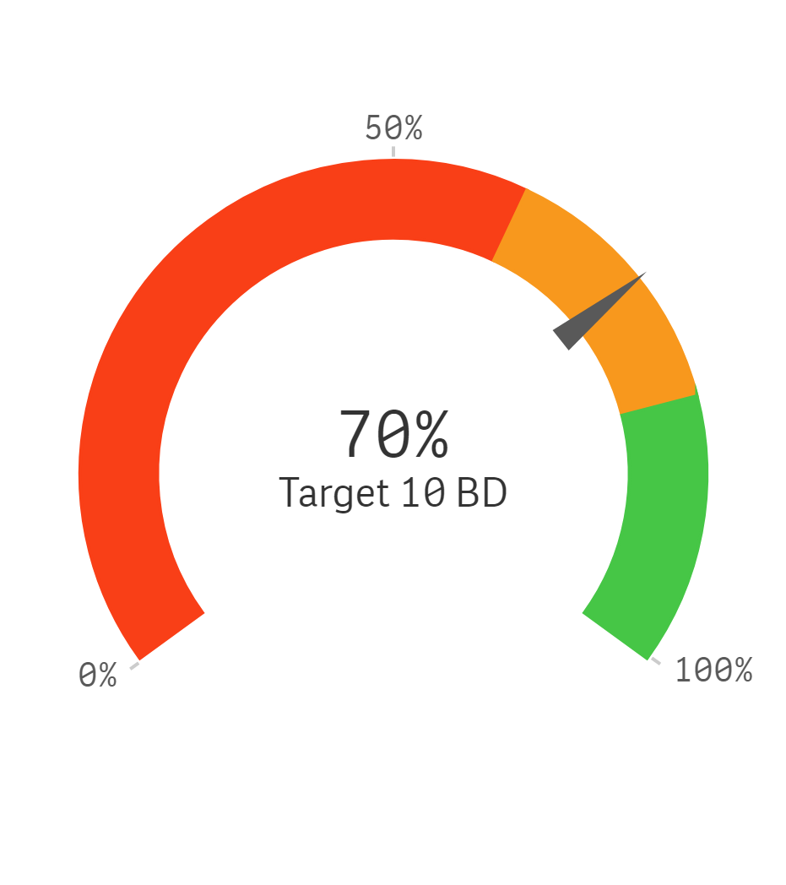
  ⬛ LGIRS Licensing | ⬛ Applicant
  ⬛ LGIRS Legal / Compliance / other
  ⬛ External party ⬛ Board / Statutory decision Maker
Trends for finalised applications and average business days to finalise

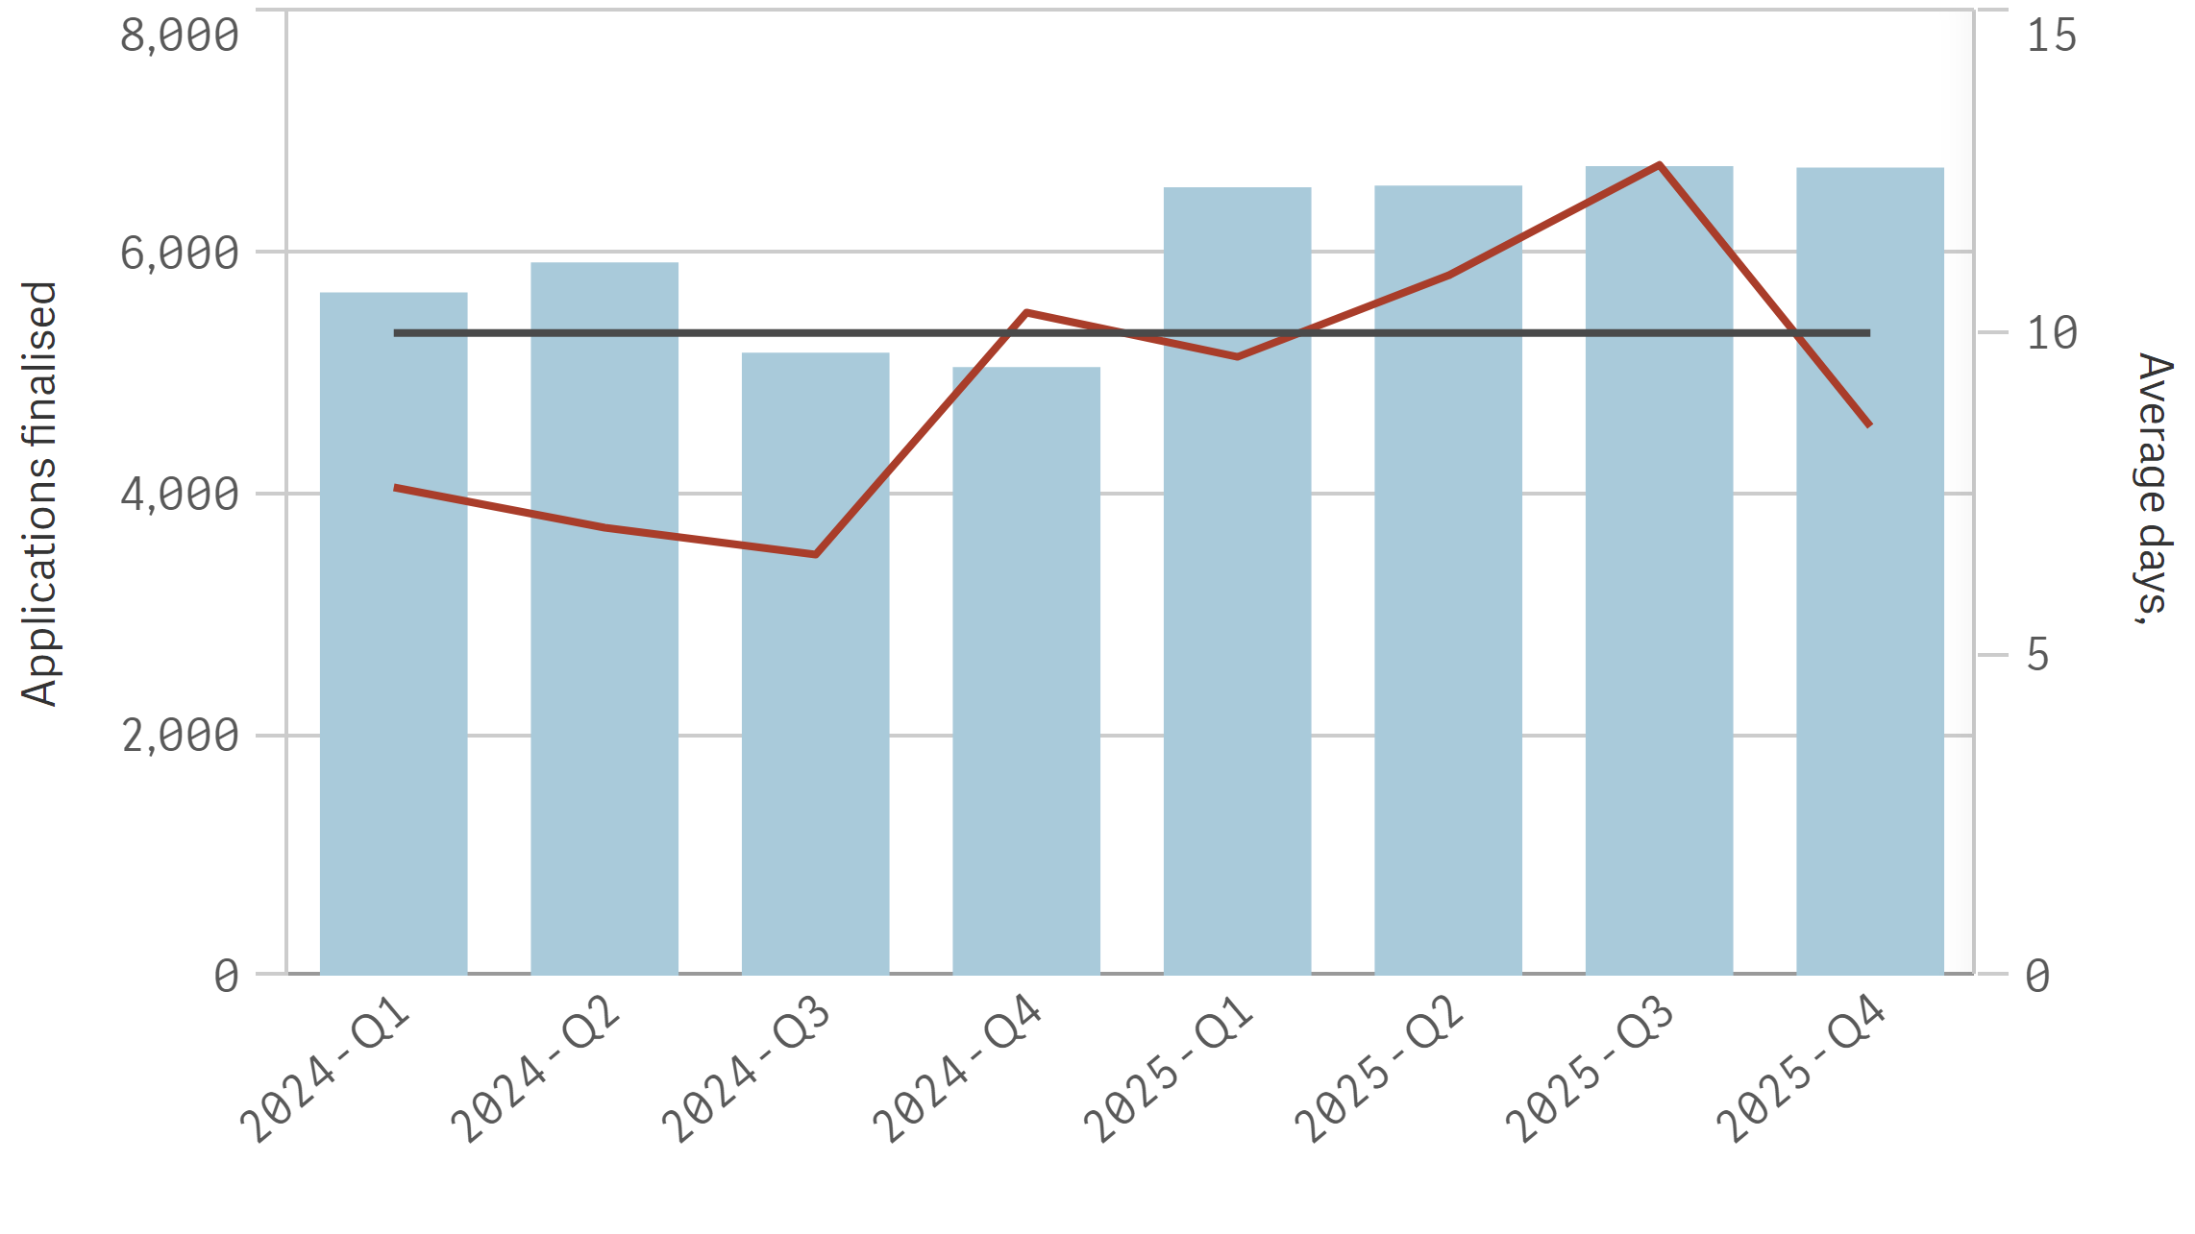
⬛ Finalised in year ➖⚫➖ Average LGIRS licensing days to finalise ➖⚫➖ Target days

Gas

Average 10 business days total | % Finalised within target timeline  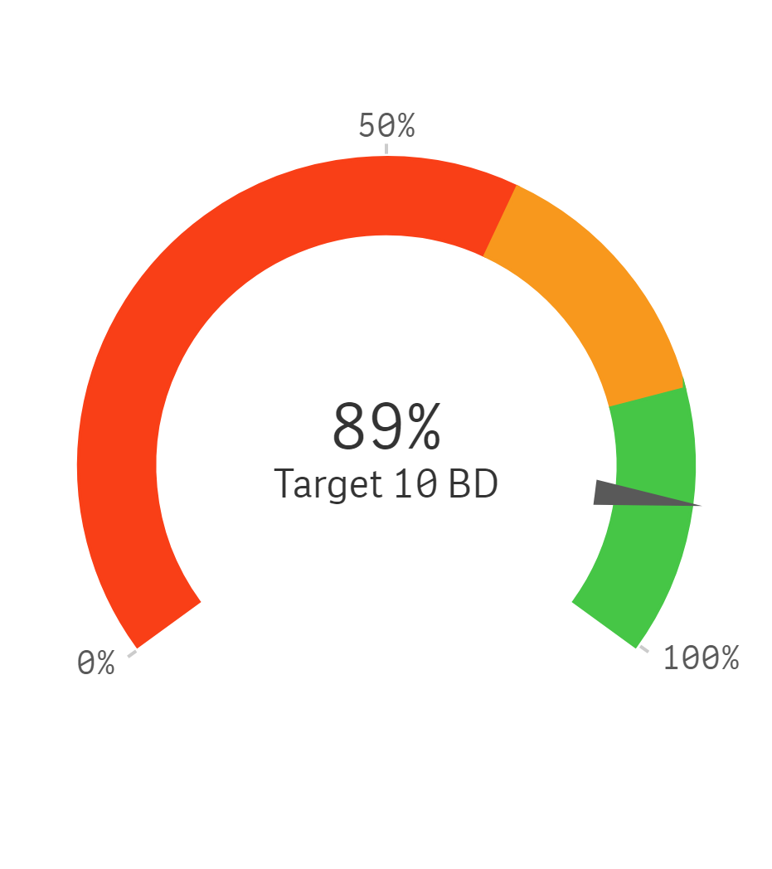
  ⬛ LGIRS Licensing | ⬛ Applicant
  ⬛ LGIRS Legal / Compliance / other
  ⬛ External party ⬛ Board / Statutory decision Maker
Trends for finalised applications and average business days to finalise

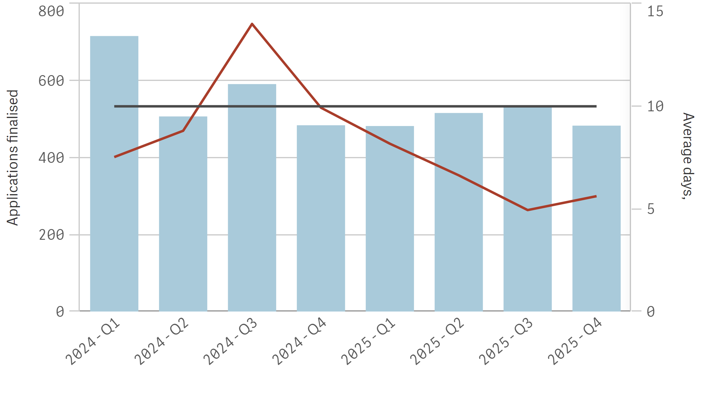
⬛ Finalised in year ➖⚫➖ Average LGIRS licensing days to finalise ➖⚫➖ Target days

Dangerous Goods

Average 11 business days total  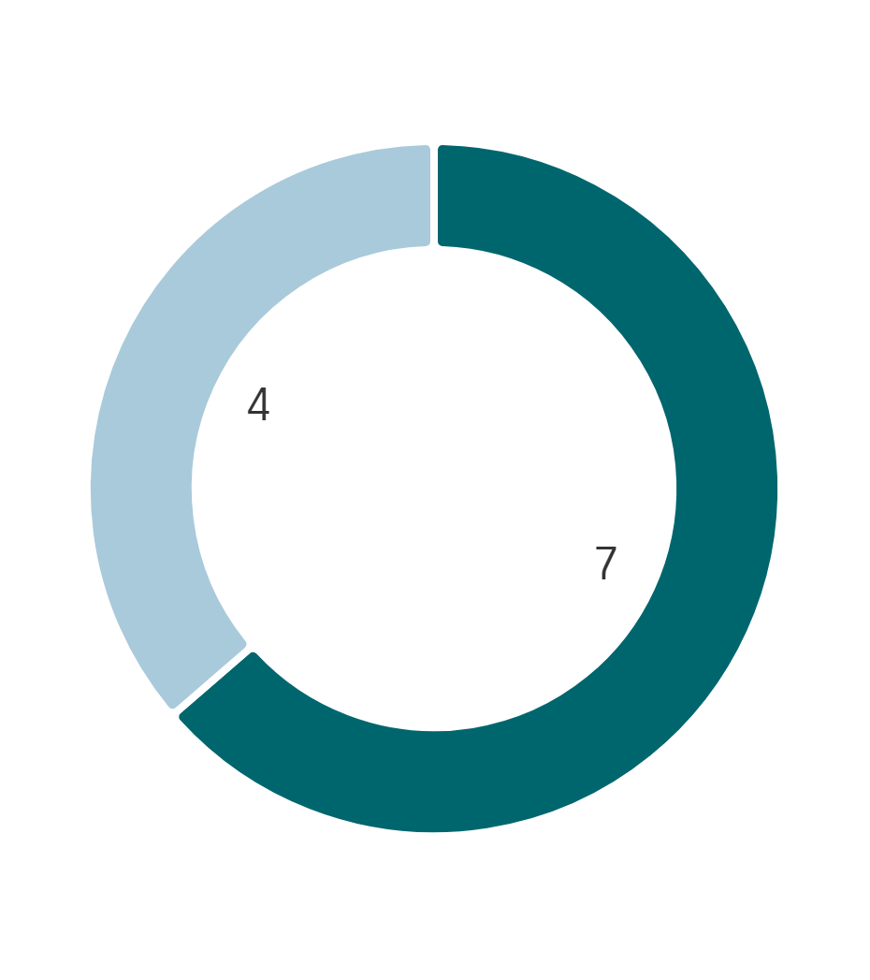 | % Finalised within target timeline  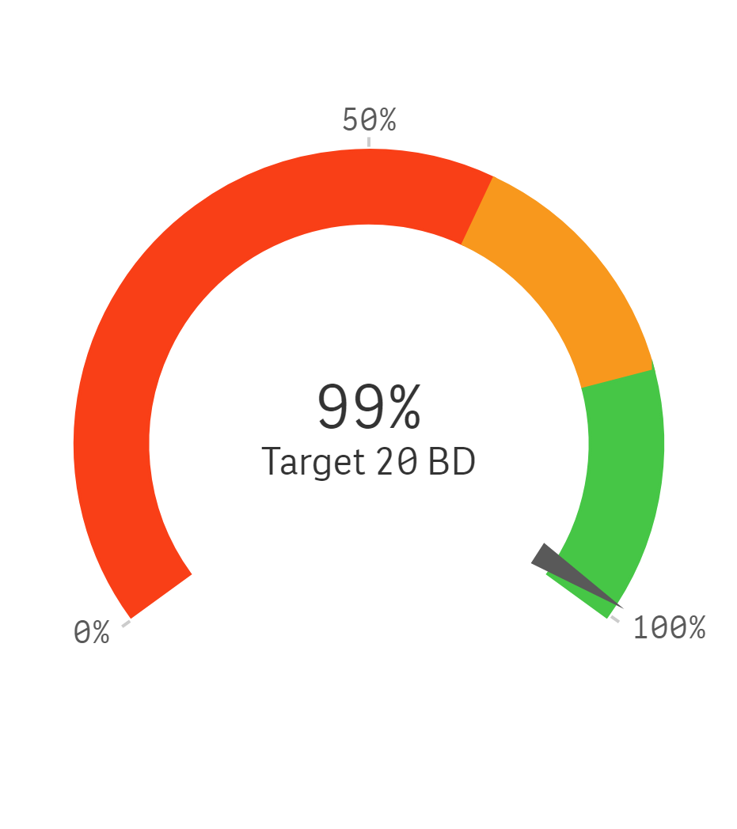
  ⬛ LGIRS Licensing | ⬛ Applicant
  ⬛ LGIRS Legal / Compliance / other
  ⬛ External party ⬛ Board / Statutory decision Maker
Trends for finalised applications and average business days to finalise

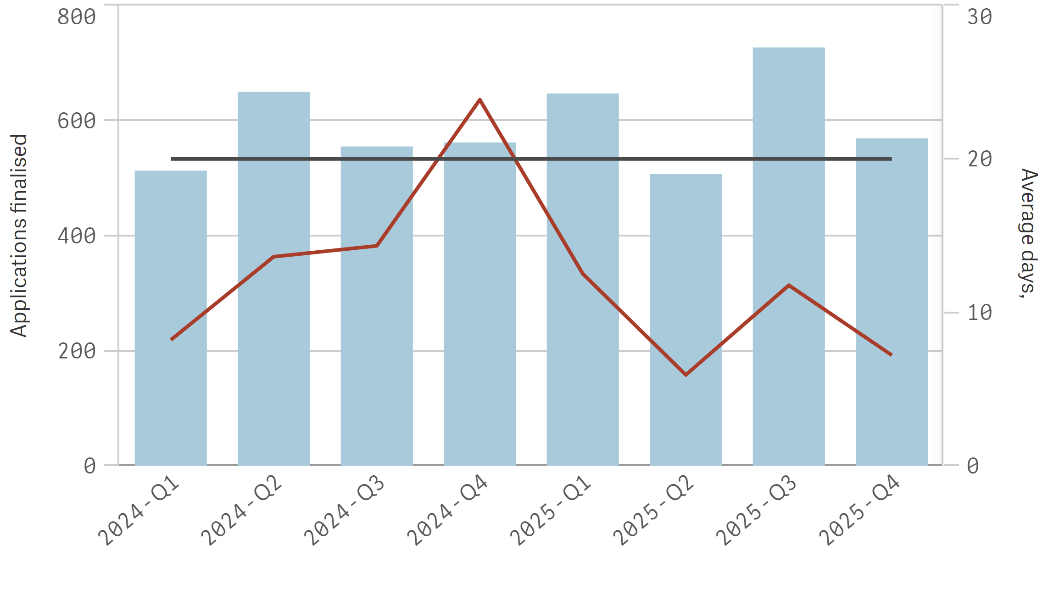
⬛ Finalised in year ➖⚫➖ Average LGIRS licensing days to finalise ➖⚫➖ Target days

High Risk Work Licence

Average 21 business days total  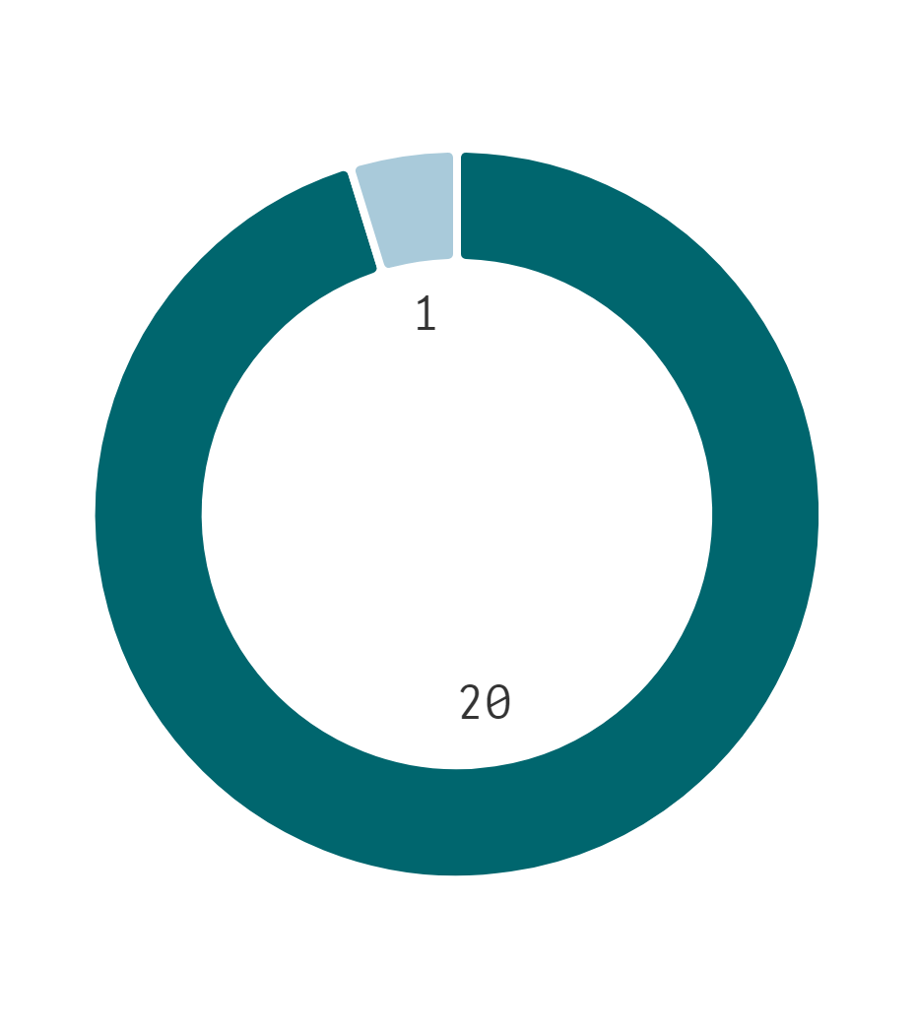 | % Finalised within target timeline  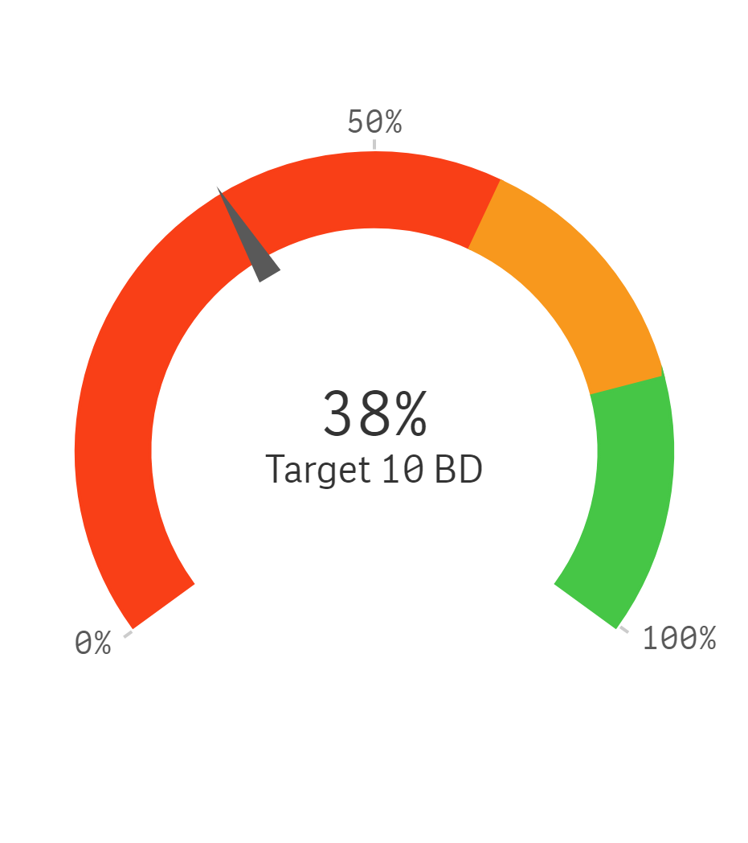
  ⬛ LGIRS Licensing | ⬛ Applicant
  ⬛ LGIRS Legal / Compliance / other
  ⬛ External party ⬛ Board / Statutory decision Maker
Trends for finalised applications and average business days to finalise

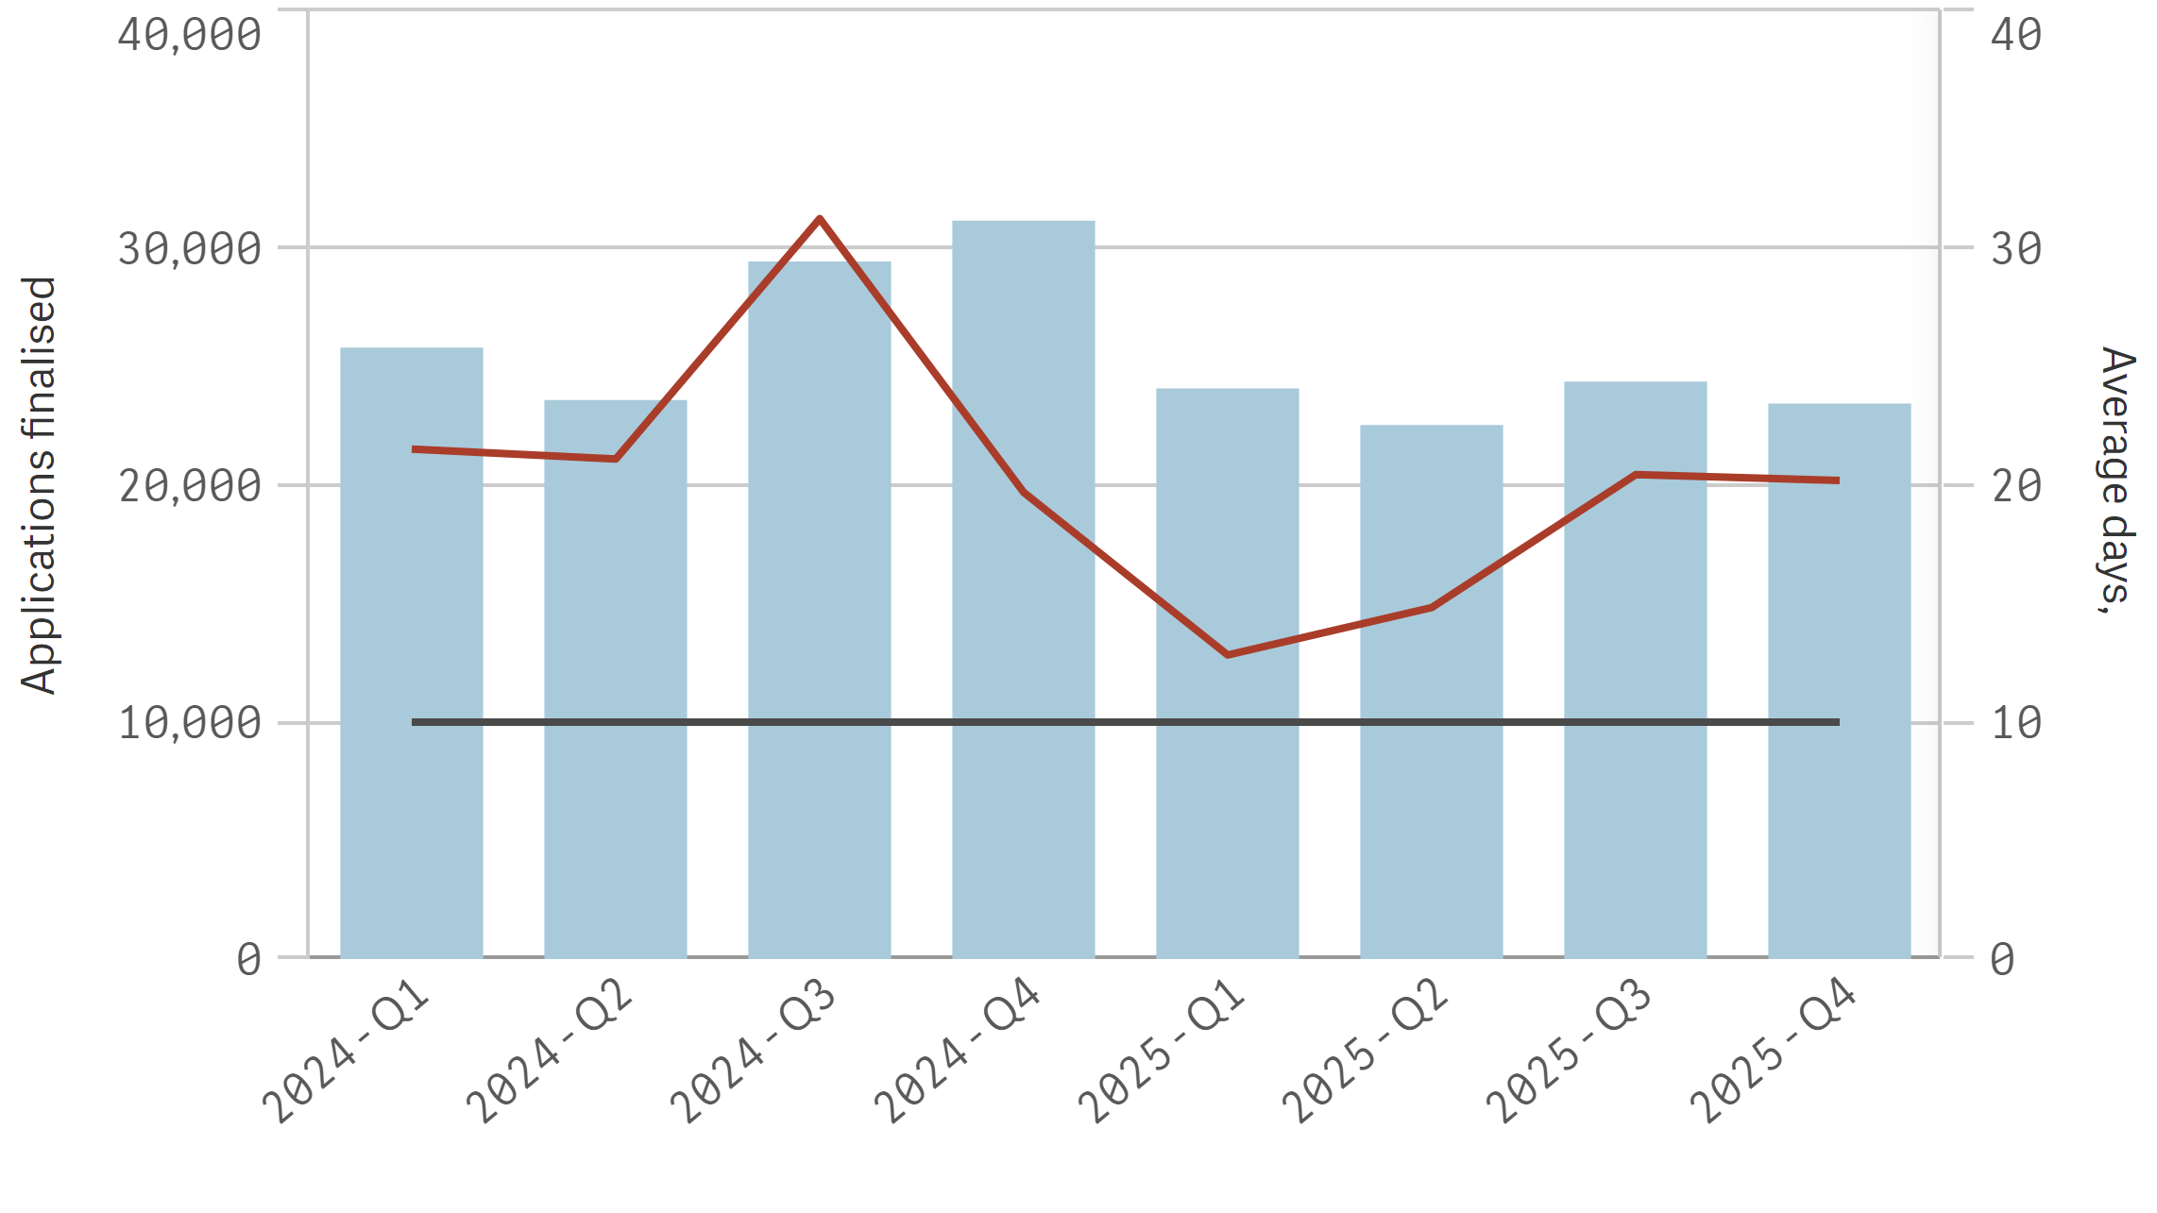
⬛ Finalised in year ➖⚫➖ Average LGIRS licensing days to finalise ➖⚫➖ Target days

Motor Vehicle Industries

Average 17 business days total  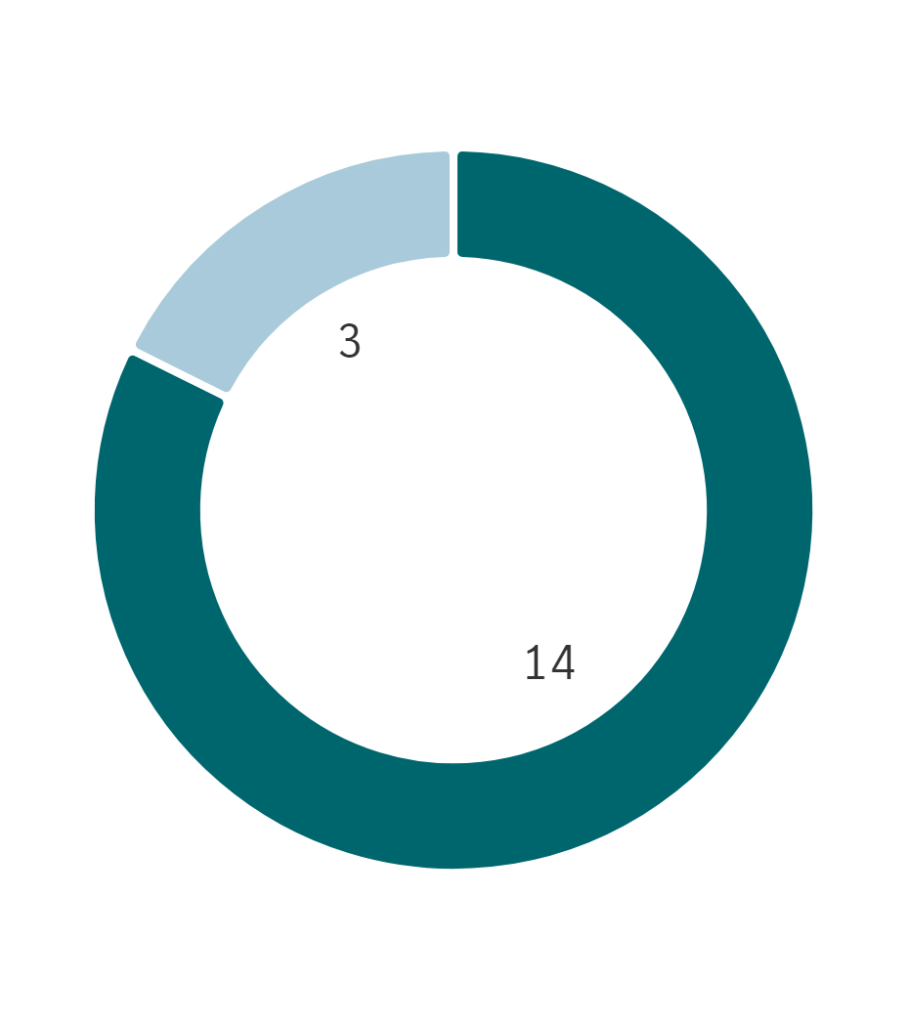 | % Finalised within target timeline  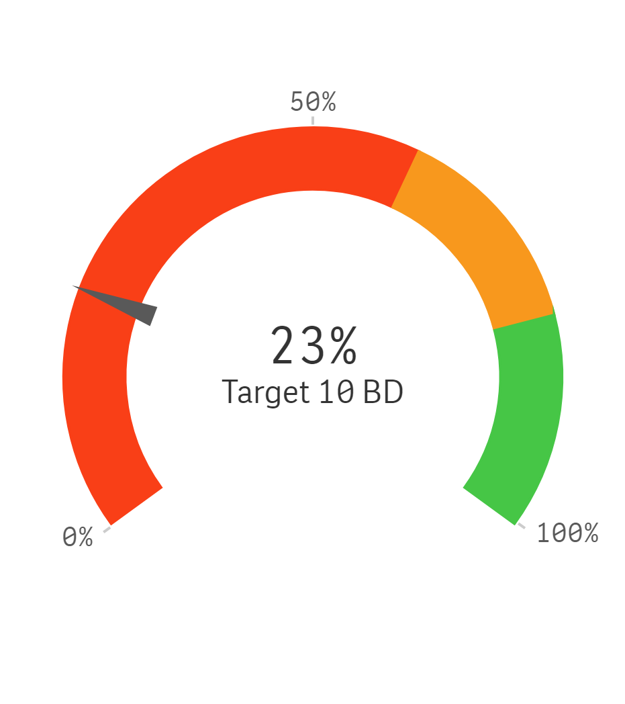
  ⬛ LGIRS Licensing | ⬛ Applicant
  ⬛ LGIRS Legal / Compliance / other
  ⬛ External party ⬛ Board / Statutory decision Maker
Trends for finalised applications and average business days to finalise

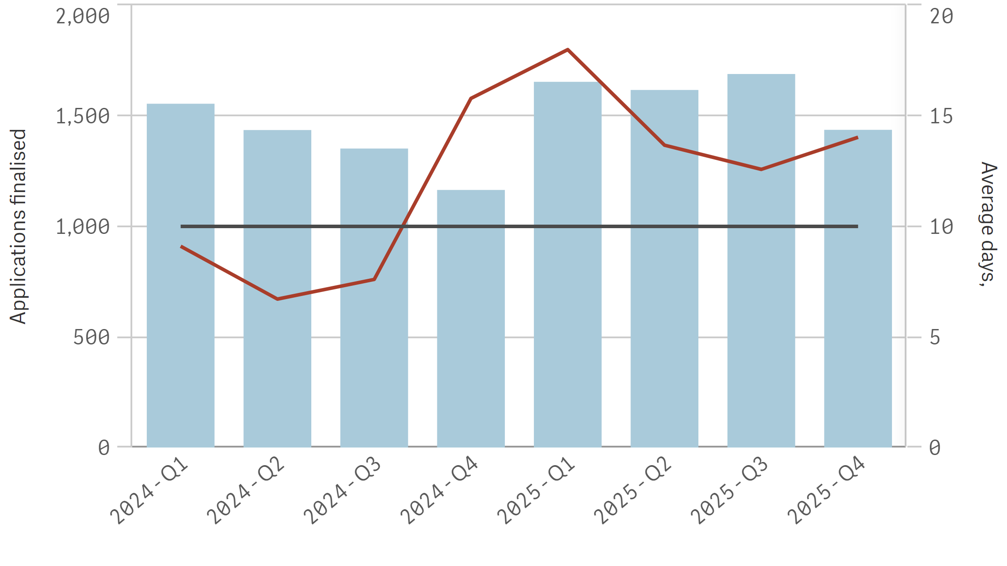
⬛ Finalised in year ➖⚫➖ Average LGIRS licensing days to finalise ➖⚫➖ Target days

Property Industries

Average 21 business days total | % Finalised within target timeline  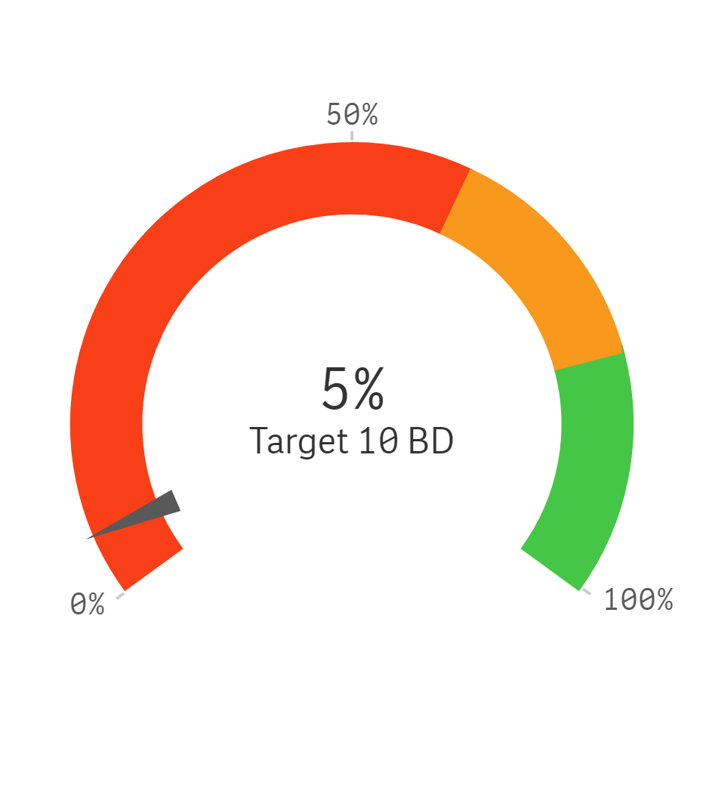
  ⬛ LGIRS Licensing | ⬛ Applicant
  ⬛ LGIRS Legal / Compliance / other
  ⬛ External party ⬛ Board / Statutory decision Maker
Trends for finalised applications and average business days to finalise

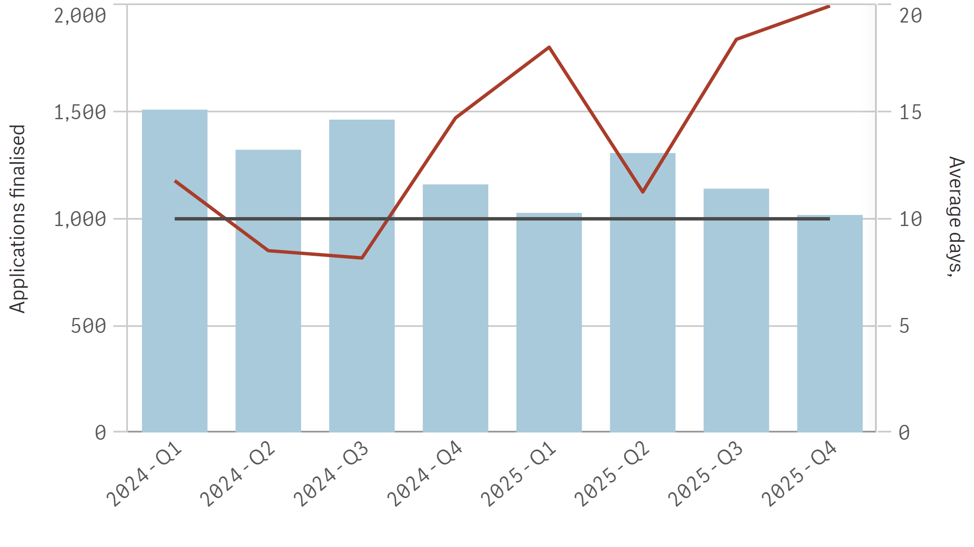
⬛ Finalised in year ➖⚫➖ Average LGIRS licensing days to finalise ➖⚫➖ Target days

Licence Holders as at
Registered Building Contractor and Practitioner
- Registered Building Contractor (5,810)
- Registered Building Practitioner (6,444)
Registered Painting Contractor and Practitioner
- Registered Painting Contractor (2,362)
- Registered Painting Practitioner (2,421)
Building Surveying Contractor and Practitioner
- Building Surveying Contractor (83)
- Building Surveying Practitioner (954)
Owner Builder
- Owner Builder Approval (10,955)
Plumbing
- Plumbing Contractor (4,074)
- Provisional Tradesperson's Licence (44)
- Restricted Plumbers Permit (102)
- Tradesperson Plumber (4,087)
Electrical
- Electrical Contractor (6,640)
- Electrical Worker's Permit (202)
- Electrician (40,011)
- Electrician's Training Licence (6,276)
- In-House Electrical Installing Work Licence (275)
- Provisional Electrician's Licence (393)
- Restricted Electrical Licence (4,499)
- Restricted Logbook Request (61)
Gas
- Authorisation - Gasfitting (154)
- Certificate of Competency - Gasfitting (221)
- Gasfitting Permit (7,663)
- Gasfitting Training Permit (1,312)
Dangerous Goods
- Dangerous Goods Driver Licence (5,960)
- Shotfiring Licence (3,137)
High Risk Work Licence
- WS High Risk Work Licence (331,035)
Motor Vehicle Industries
- Motor Vehicle Auctioneer Exemption (1)
- Motor Vehicle Car Hire Exemption (101)
- Motor Vehicle Dealer (1,563)
- Motor Vehicle Financier Exemption (8)
- Motor Vehicle Repair Business (4,982)
- Motor Vehicle Repairer (21,214)
- Motor Vehicle Salesperson (1,753)
- Motor Vehicle Yard Manager (1,461)
Property Industries
- Business Settlement Agent Licence (23)
- Land Valuer (873)
- Real Estate & Business Agent Licence (5,059)
- Real Estate Developer Registration (762)
- Real Estate Sales Representative Registration (7,370)
- Real Estate Settlement Agent Licence (717)

Registered Building Contractor and Practitioner
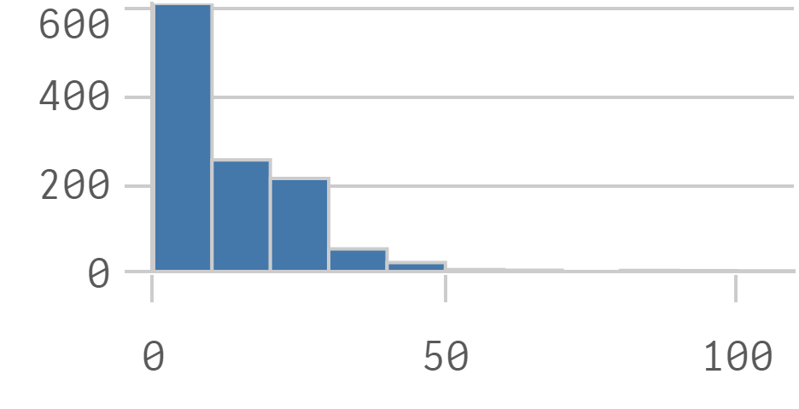
Registered Painting Contractor and Practitioner
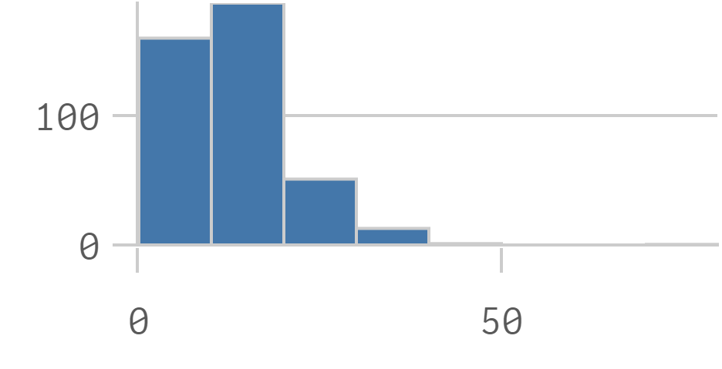
Building Surveying Contractor and Practitioner
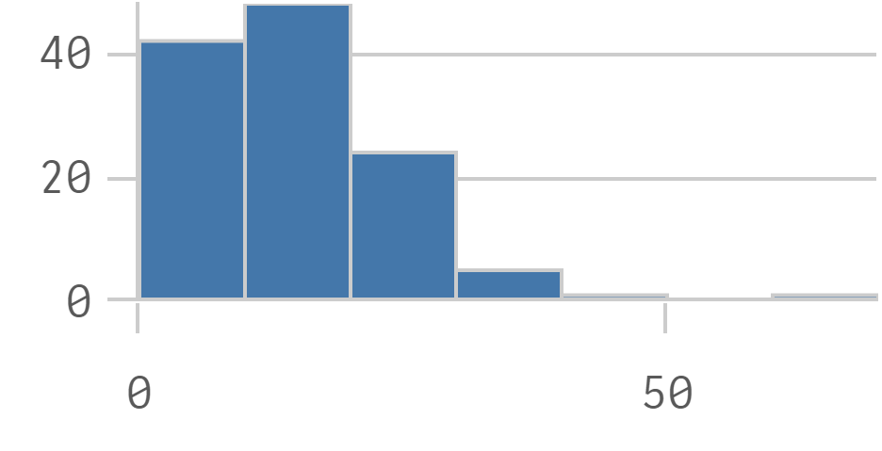
Owner Builder
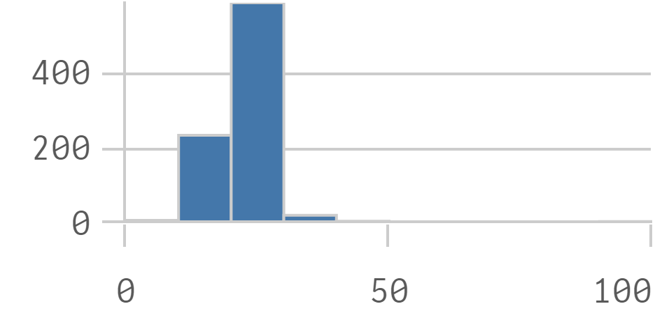
Plumbing
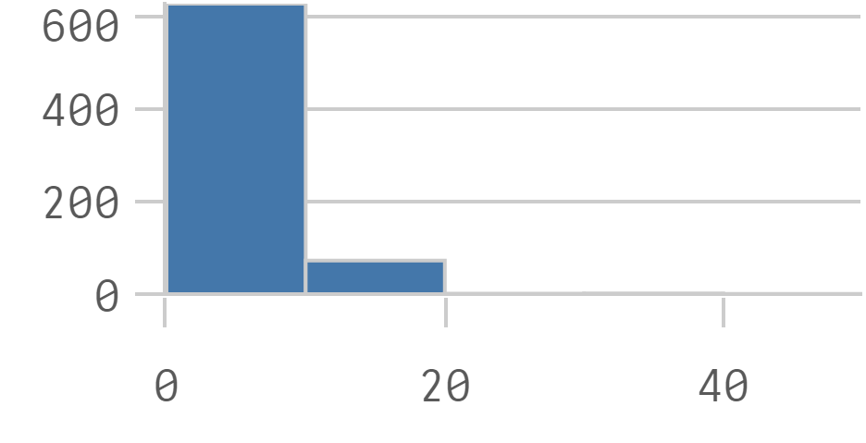
Electrical
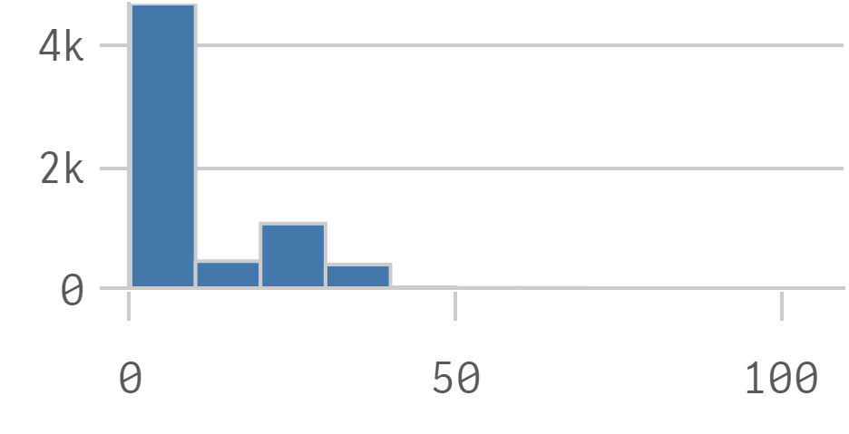
Gas
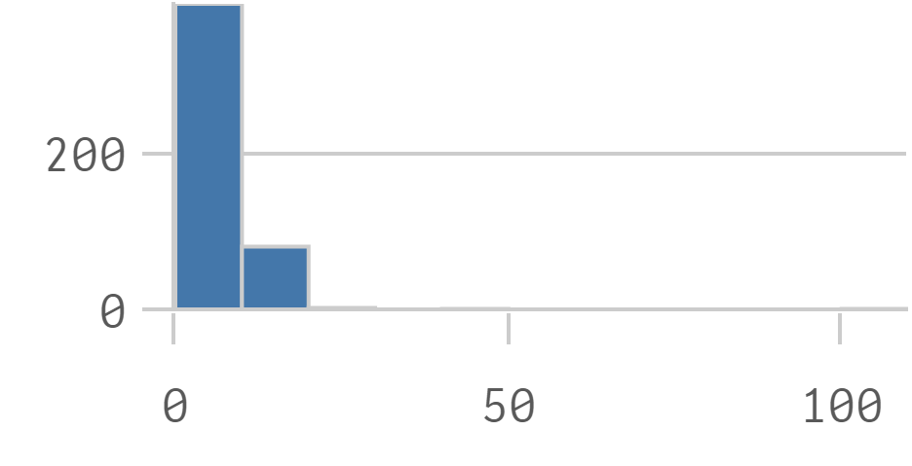
Dangerous Goods
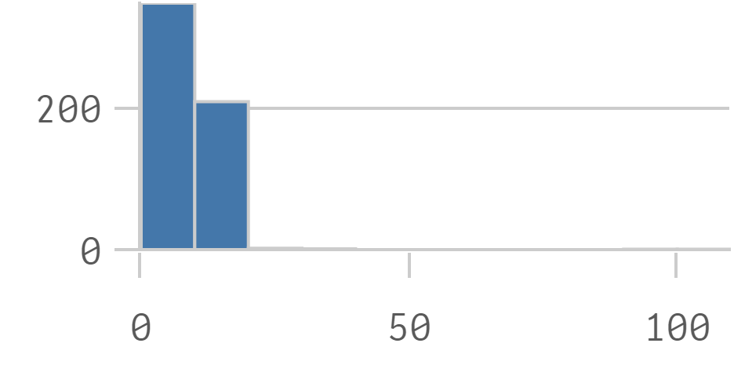
High Risk Work Licence
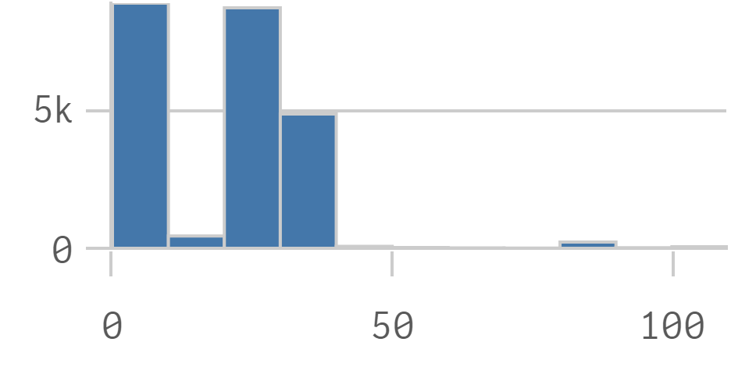
Motor Vehicle Industries
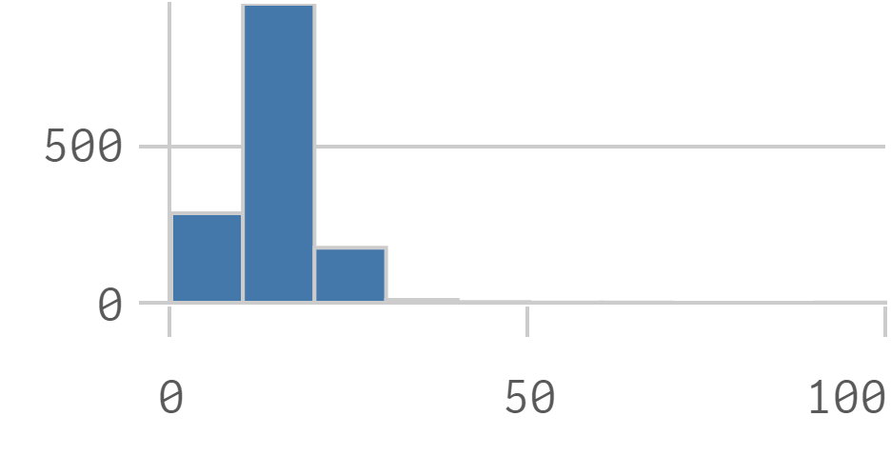
Property Industries
