Mining Act 1978 - Mineral tenure applications
Prospecting Licence

Average 268 days total | % Finalised within Target Timeline
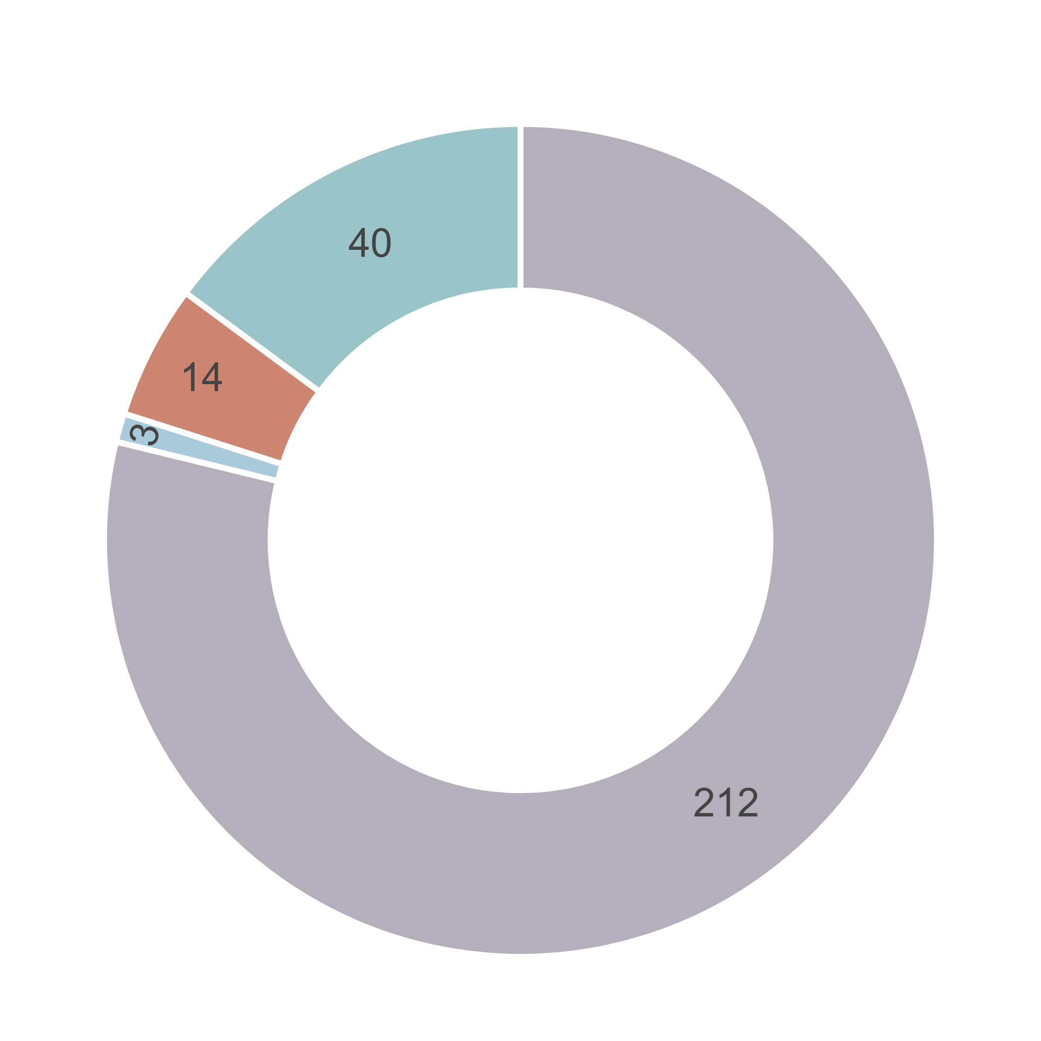  ⬛DMPE ⬛Proponent ⬛Other Agencies  ⬛ Parallel Processing | 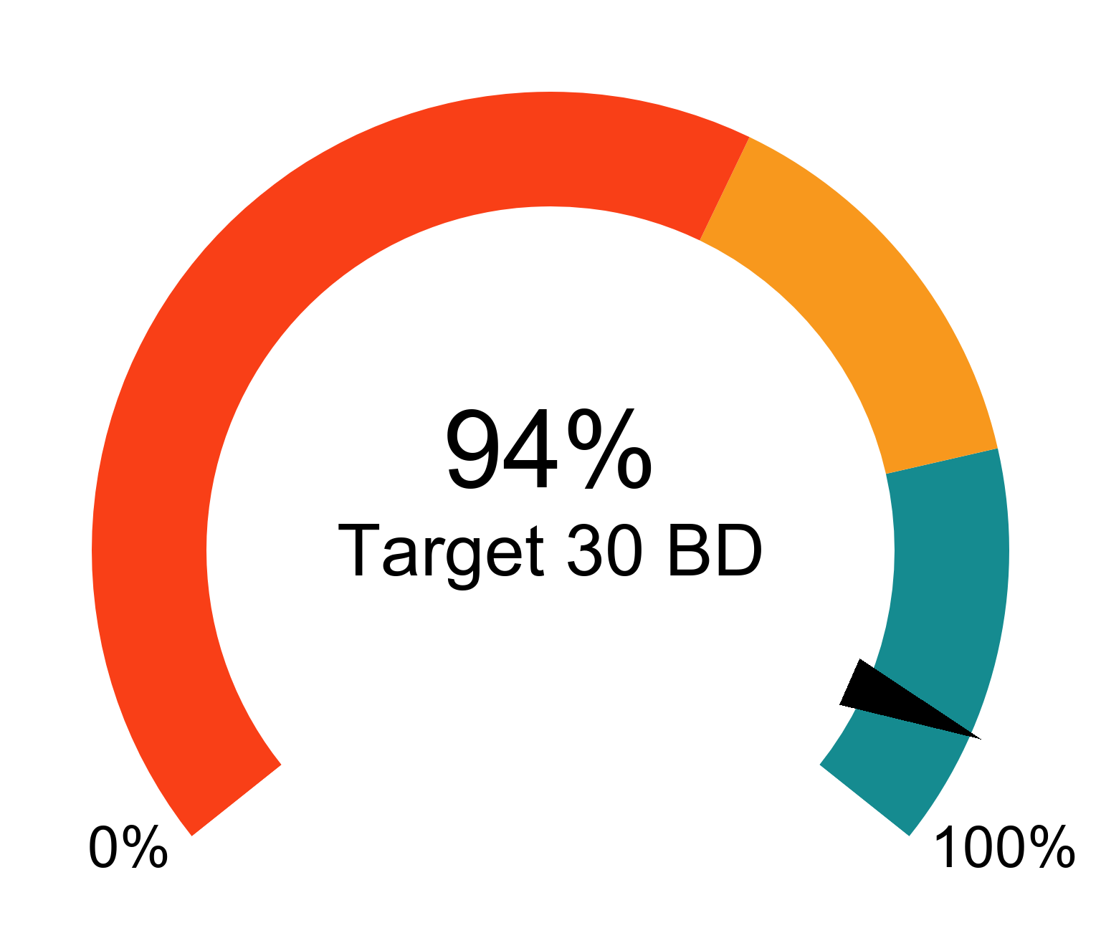
Trends for Received, Finalised and Open

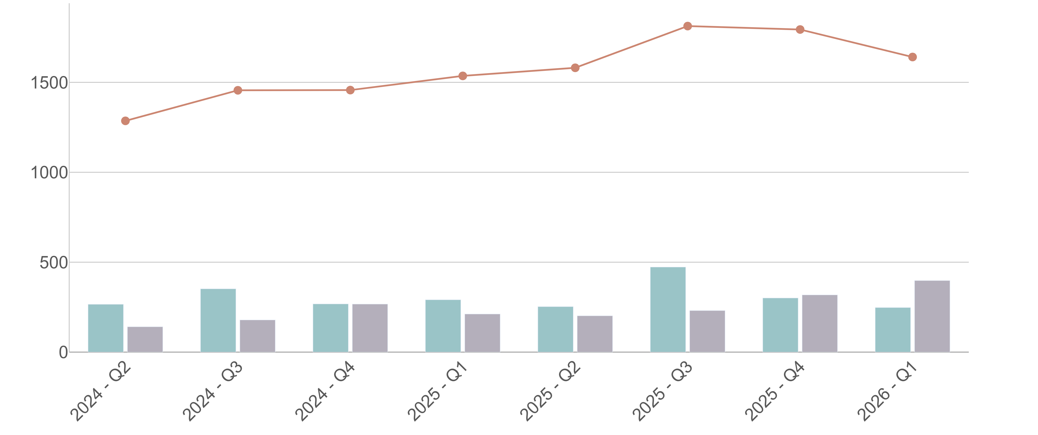
⬛Received in quarter ⬛Finalised in quarter — Open at end of quarter

Mining Act 1978 - Mineral tenure applications
Exploration Licence

Average 341 days total | % Finalised within Target Timeline
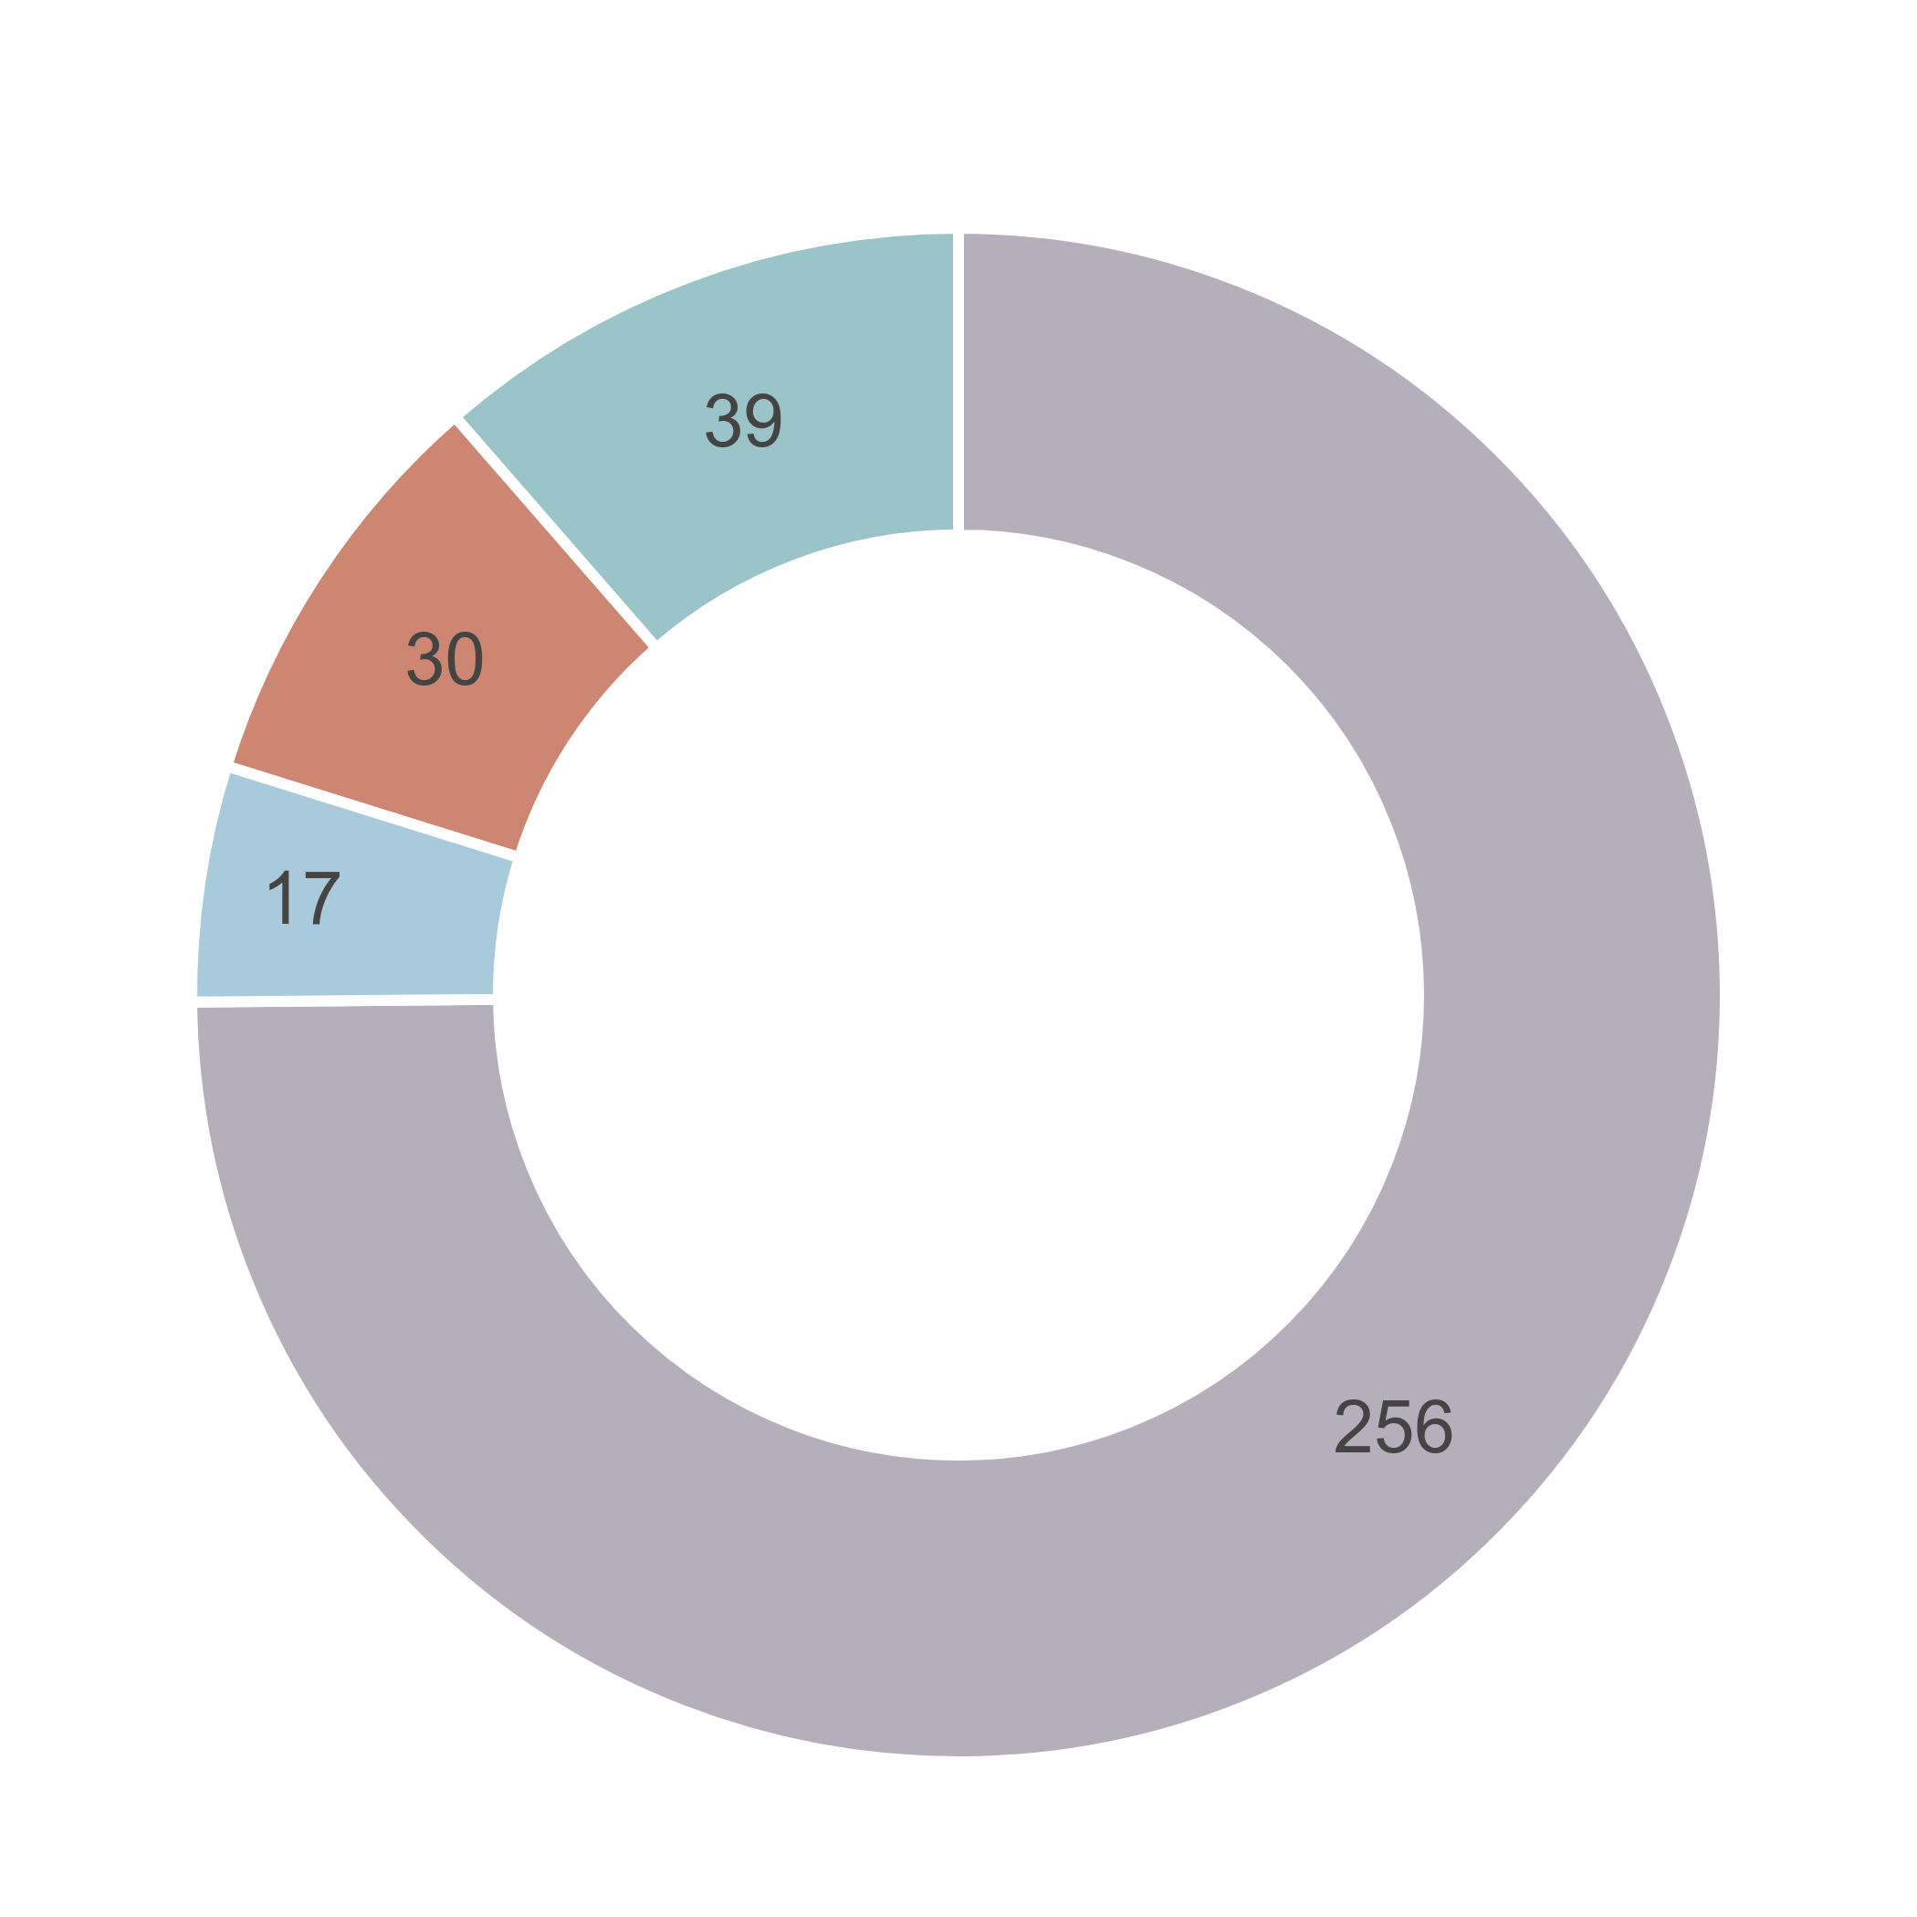  ⬛DMPE ⬛Proponent ⬛Other Agencies  ⬛ Parallel Processing | 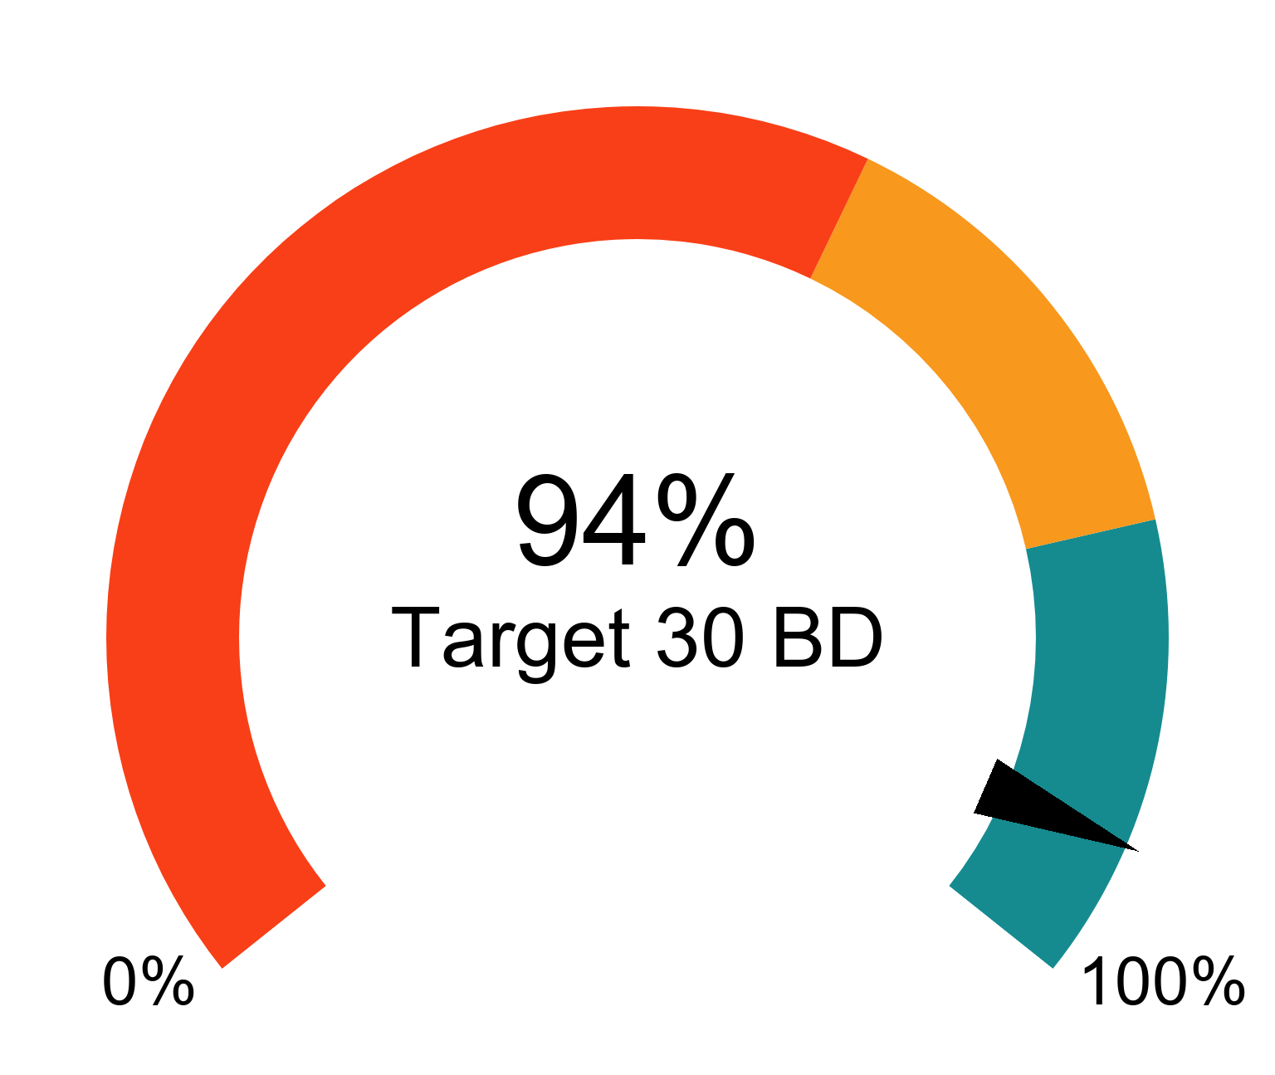
Trends for Received, Finalised and Open

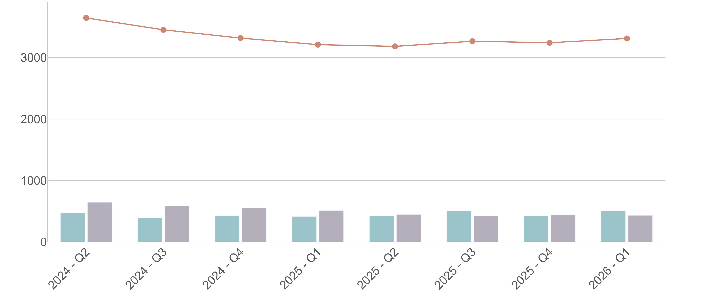
⬛Received in quarter ⬛Finalised in quarter — Open at end of quarter

Mining Act 1978 - Mineral tenure applications
Mining Lease

Average 410 days total | % Finalised within Target Timeline
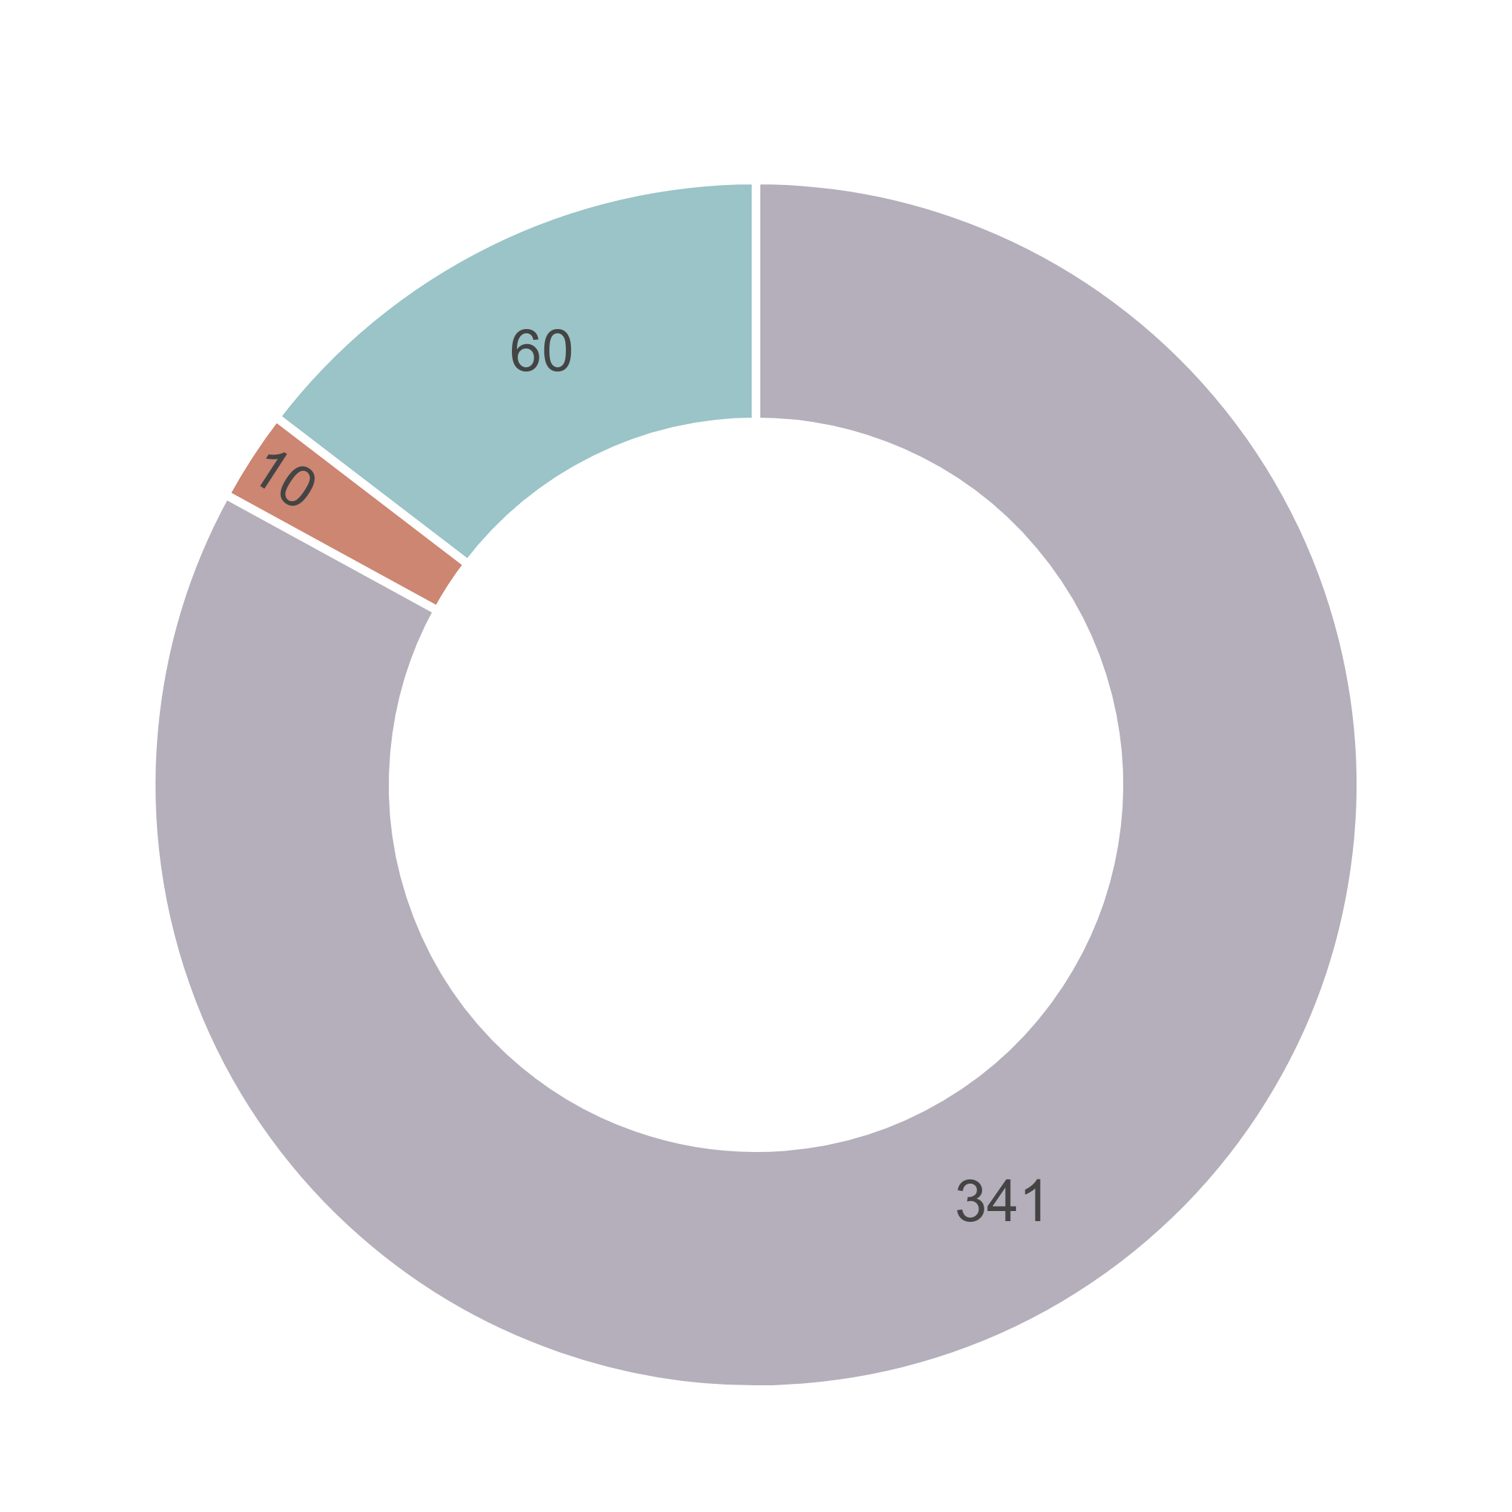  ⬛DMPE ⬛Proponent ⬛Other Agencies  ⬛ Parallel Processing | 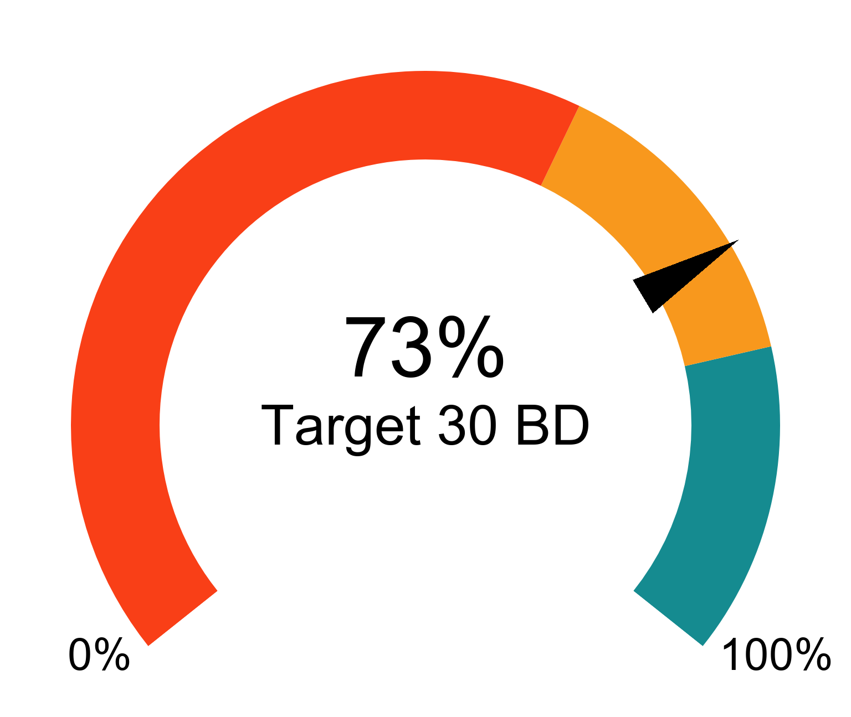
Trends for Received, Finalised and Open

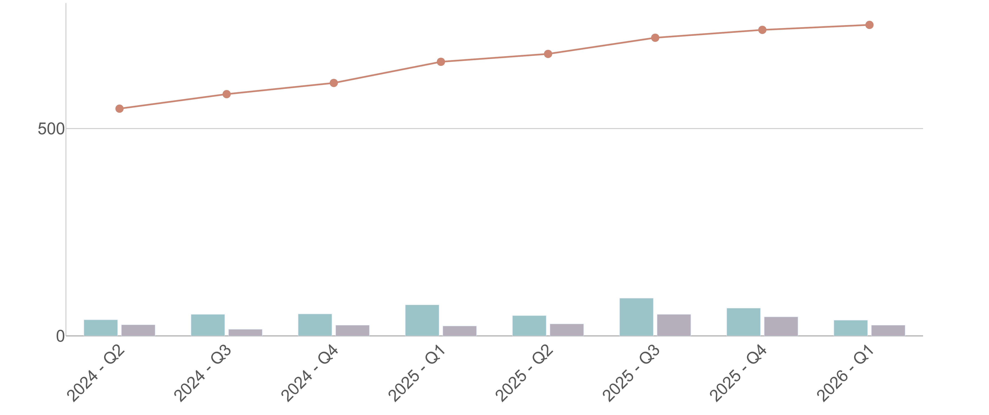
⬛Received in quarter ⬛Finalised in quarter — Open at end of quarter

Mining Act 1978 - Mineral tenure applications
Miscellaneous Licence and other tenure

Average 331 days total | % Finalised within Target Timeline
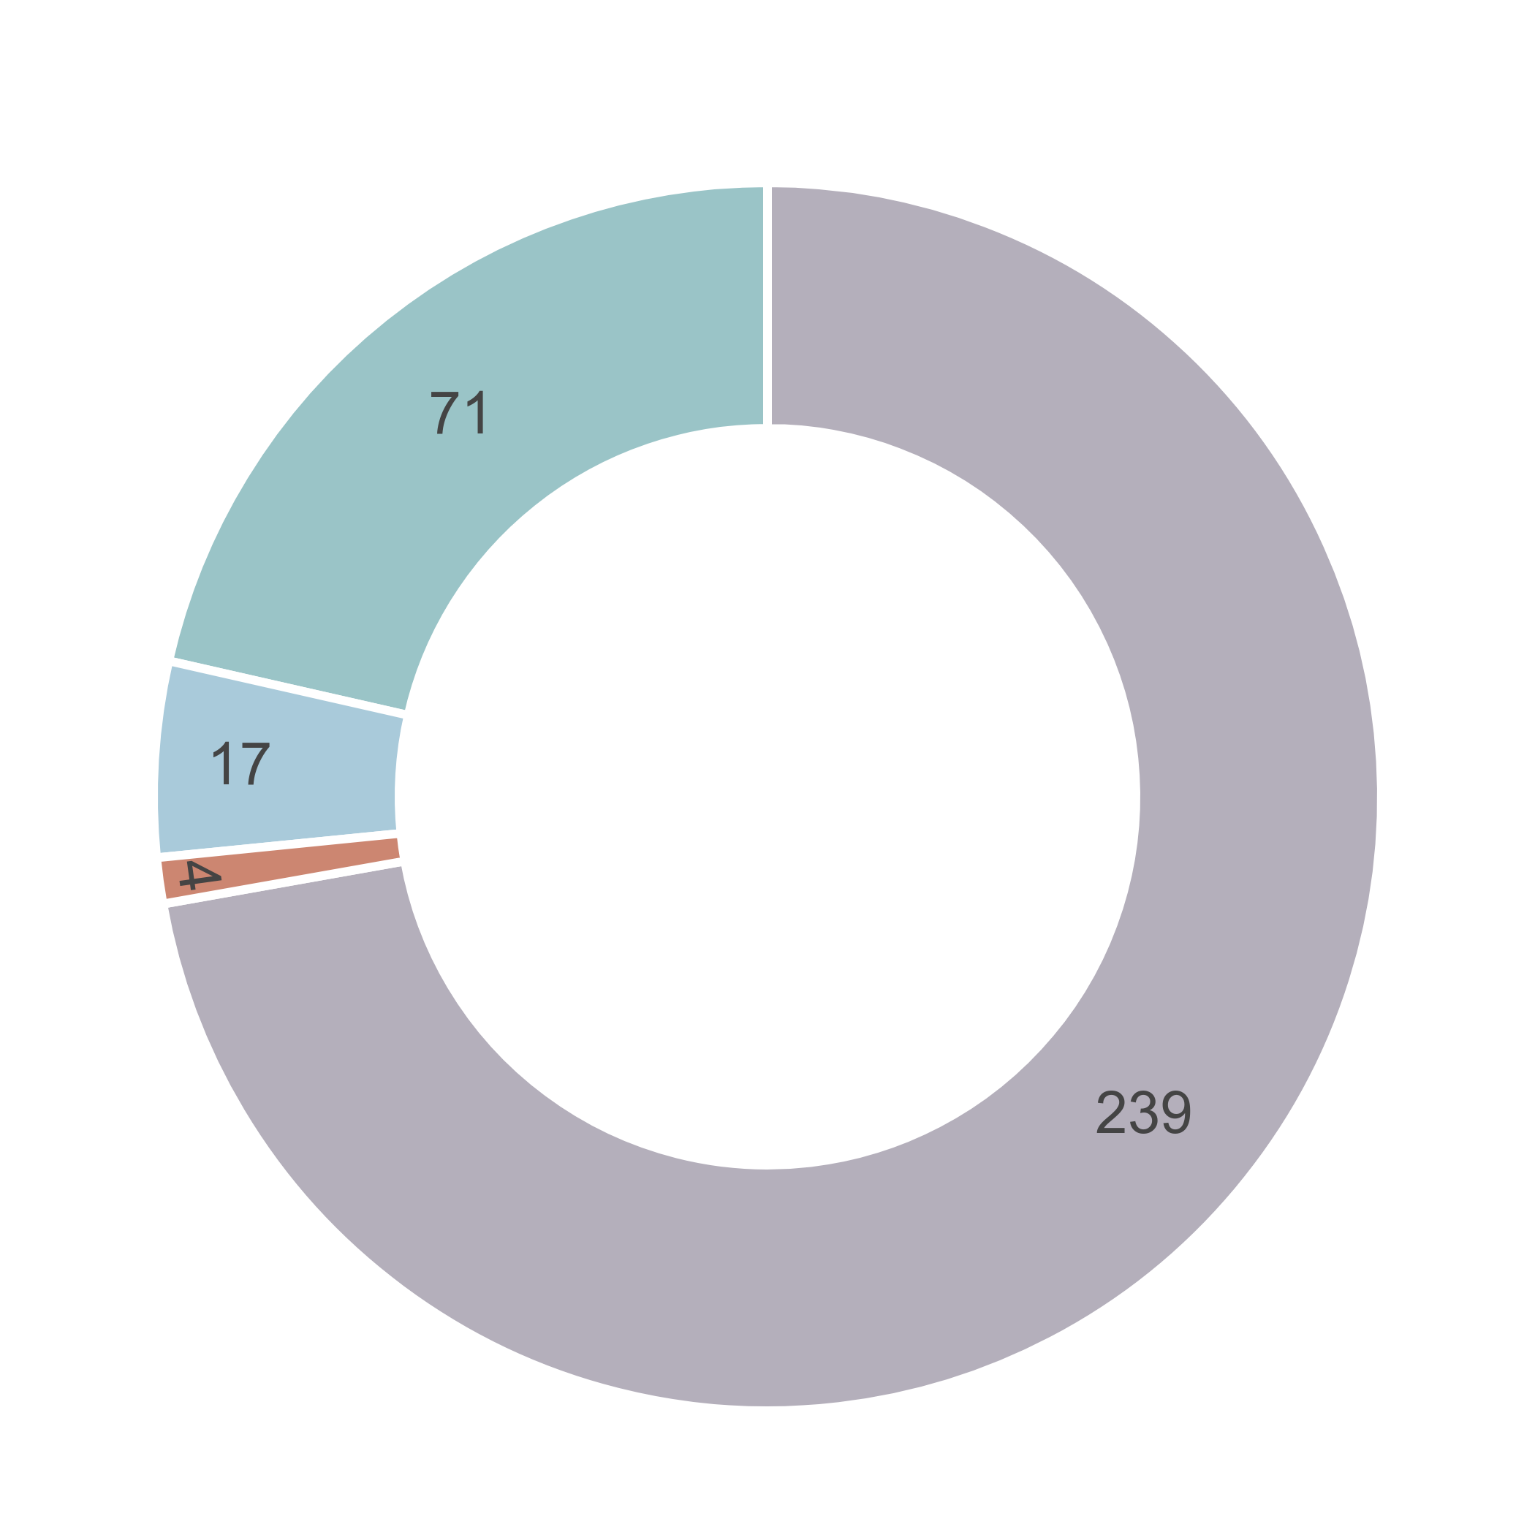  ⬛DMPE ⬛Proponent ⬛Other Agencies  ⬛ Parallel Processing | 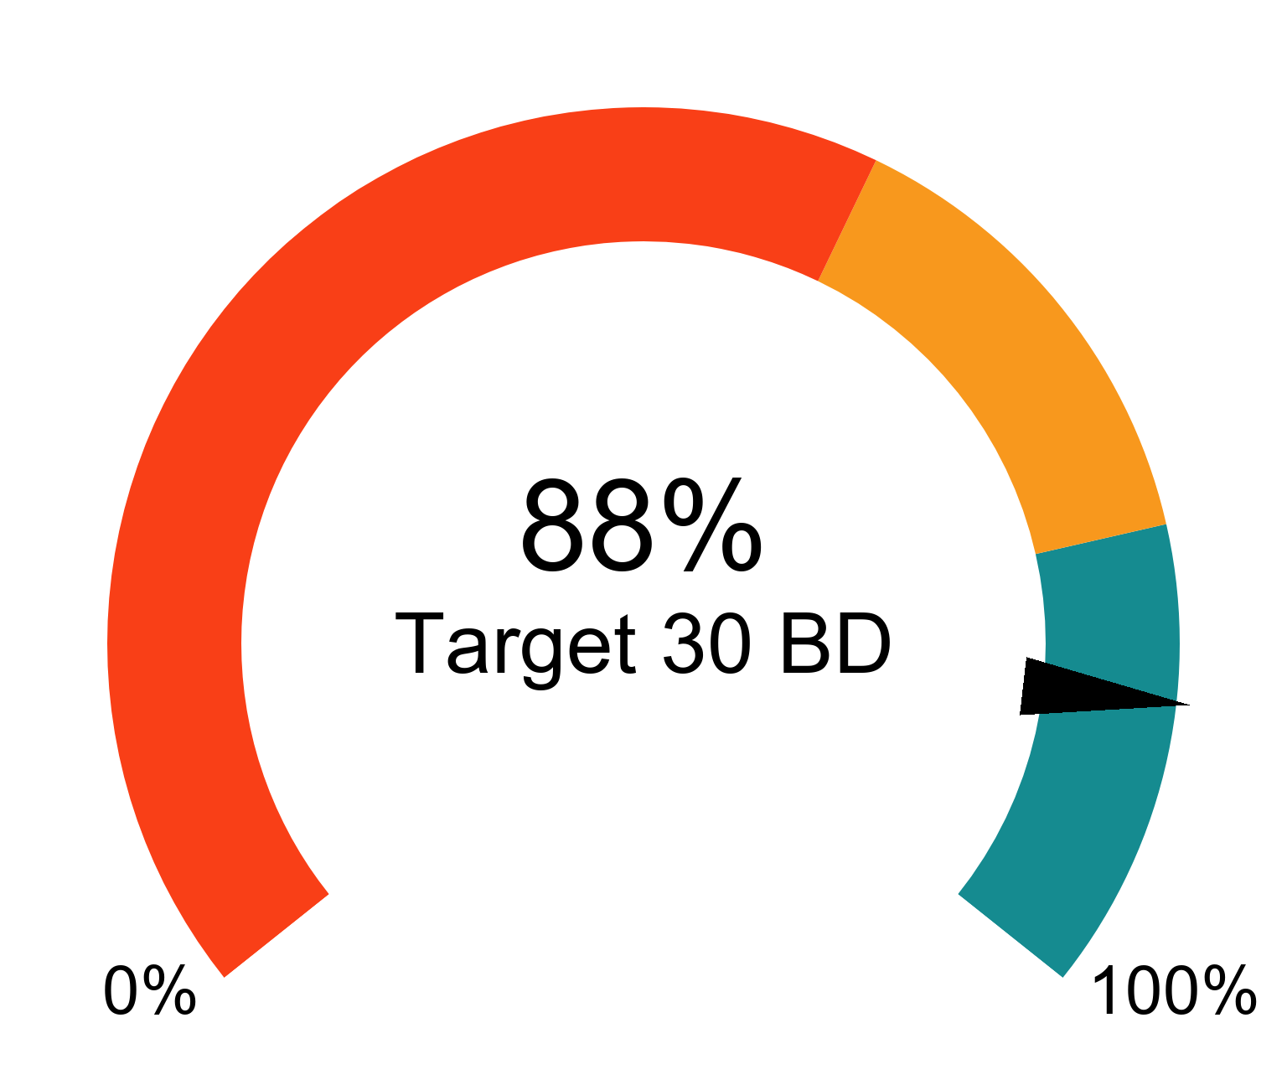
Trends for Received, Finalised and Open

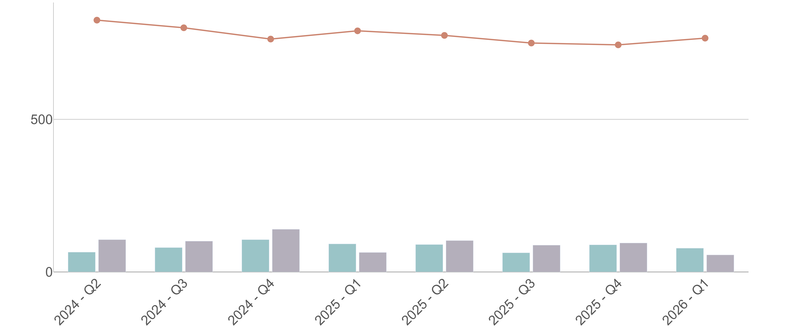
⬛Received in quarter ⬛Finalised in quarter — Open at end of quarter

Mining Act 1978 - Environmental applications
Programme of Work

Average 25 days total | % Finalised within Target Timeline
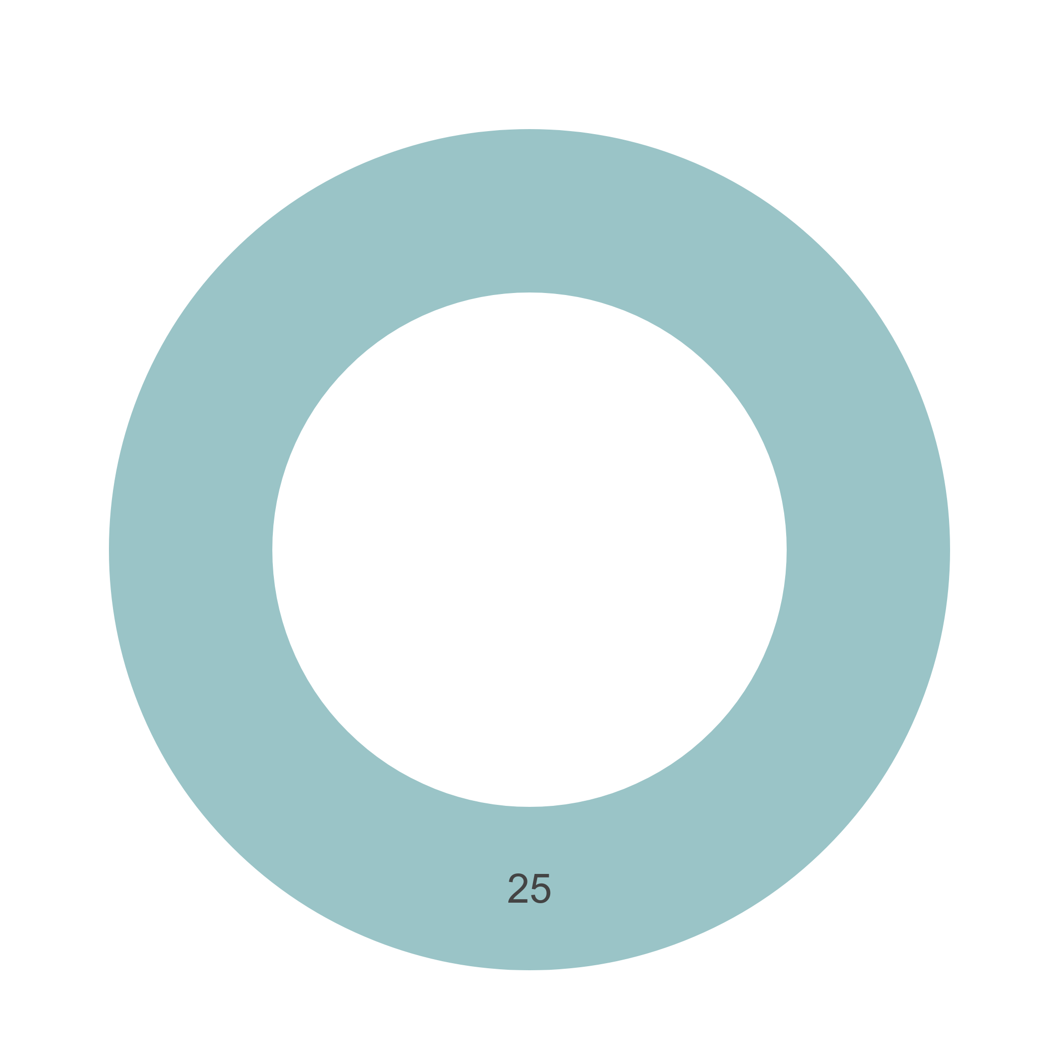  ⬛DMPE ⬛Proponent ⬛Other Agencies  ⬛ Parallel Processing | 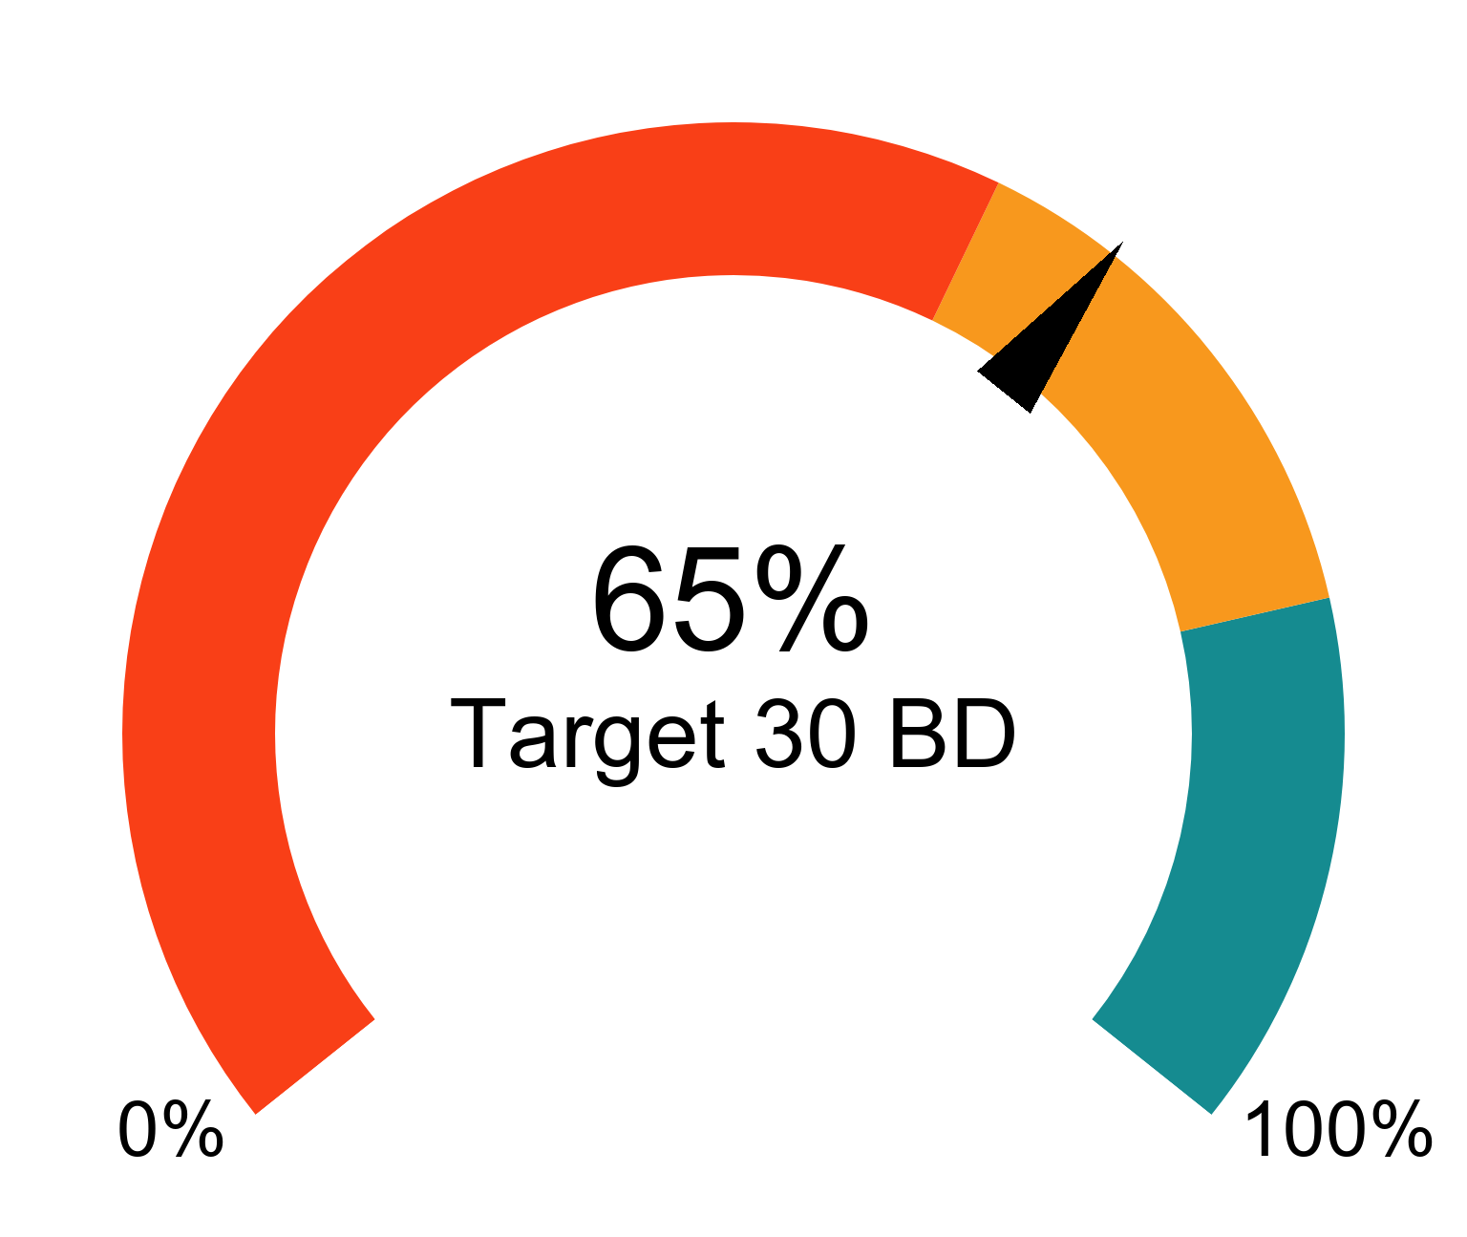
Trends for Received, Finalised and Open

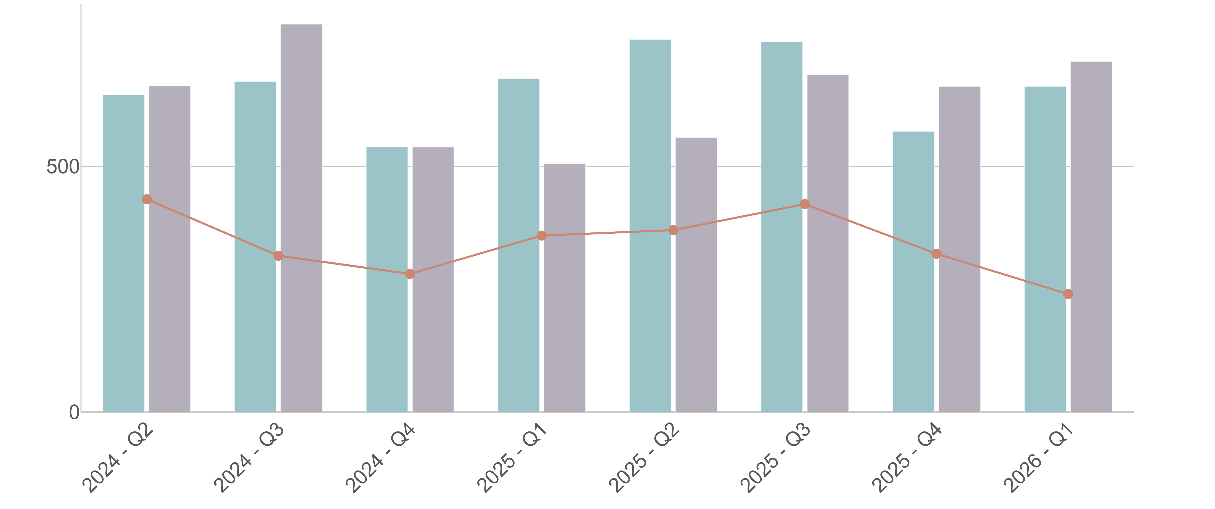
⬛Received in quarter ⬛Finalised in quarter — Open at end of quarter

Mining Act 1978 - Environmental applications
Mining Proposal

Average 439 days total | % Finalised within Target Timeline
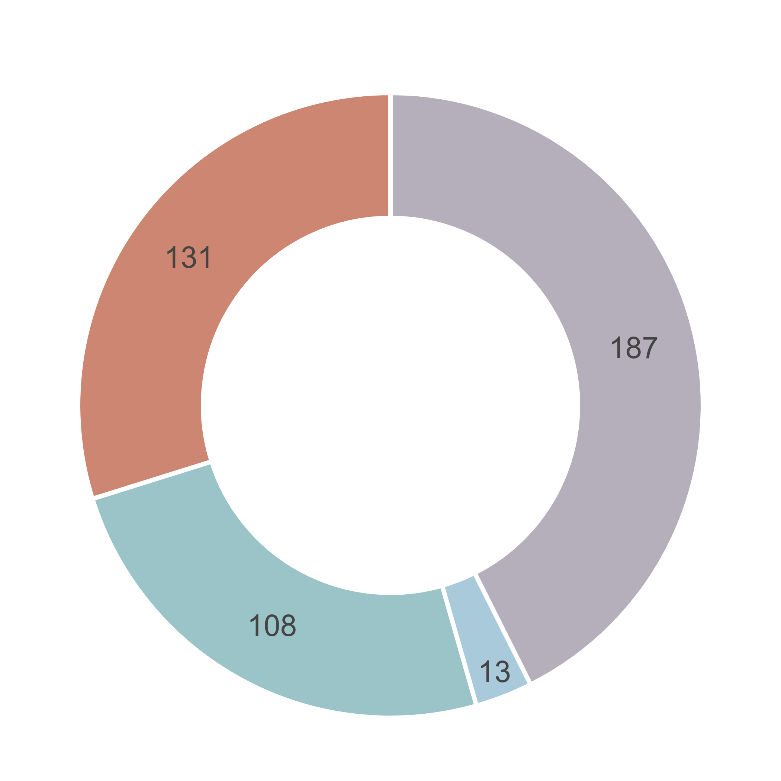  ⬛DMPE ⬛Proponent ⬛Other Agencies  ⬛ Parallel Processing | 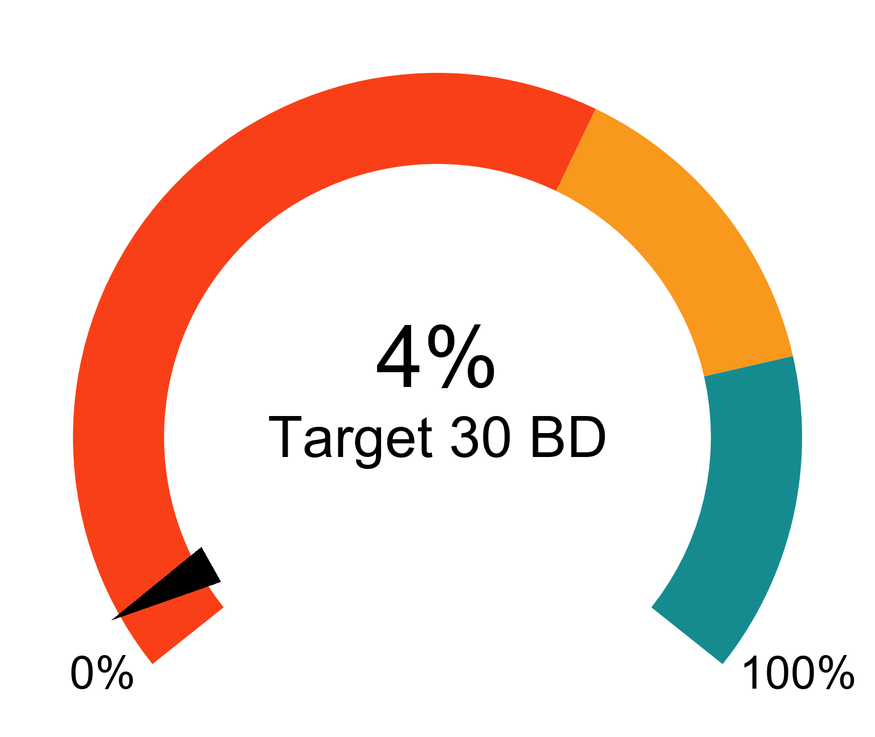
Trends for Received, Finalised and Open

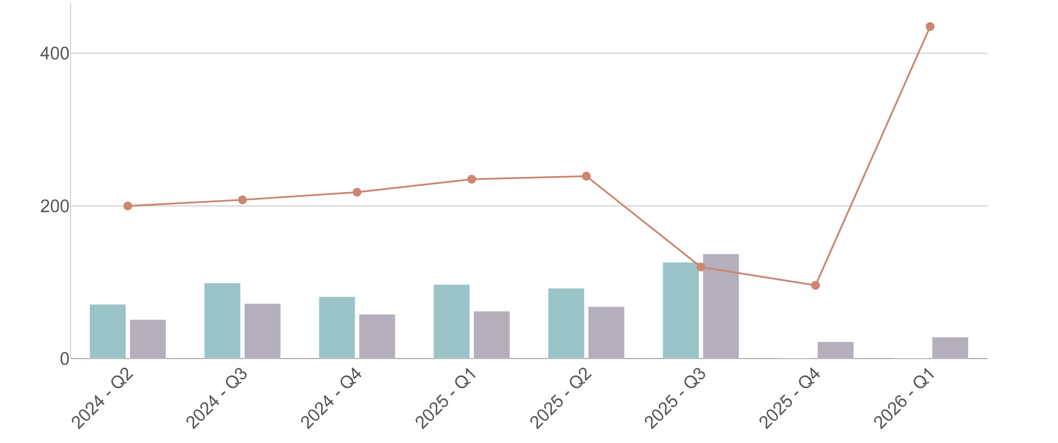
⬛Received in quarter ⬛Finalised in quarter — Open at end of quarter

Mining Act 1978 - Environmental applications
Mine Development and Closure Proposal

Average 35 days total | % Finalised within Target Timeline
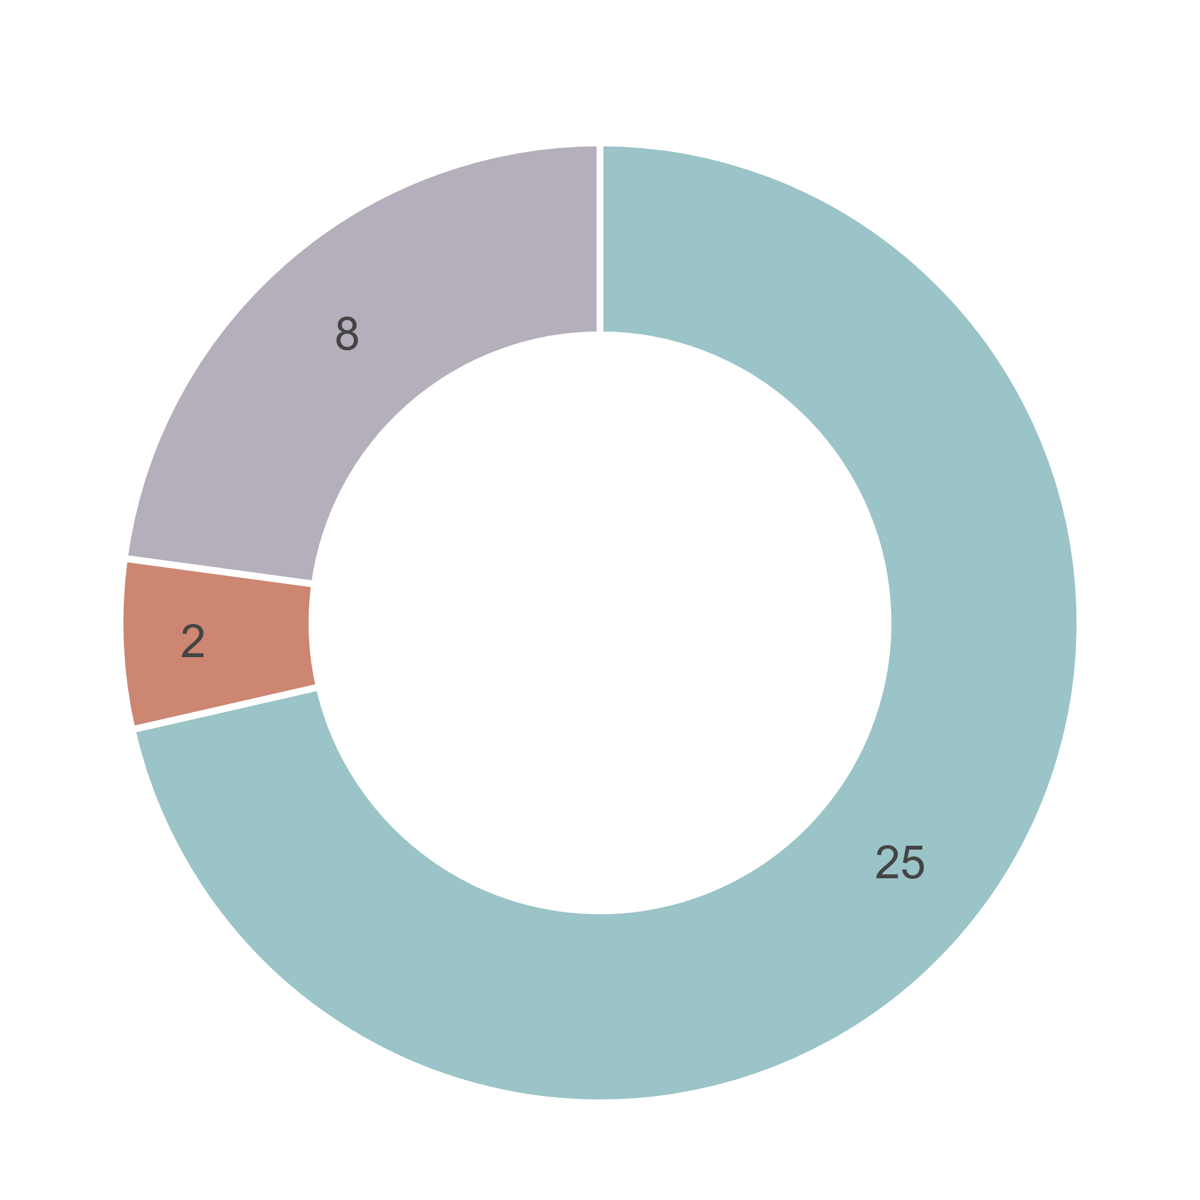  ⬛DMPE ⬛Proponent ⬛Other Agencies  ⬛ Parallel Processing | 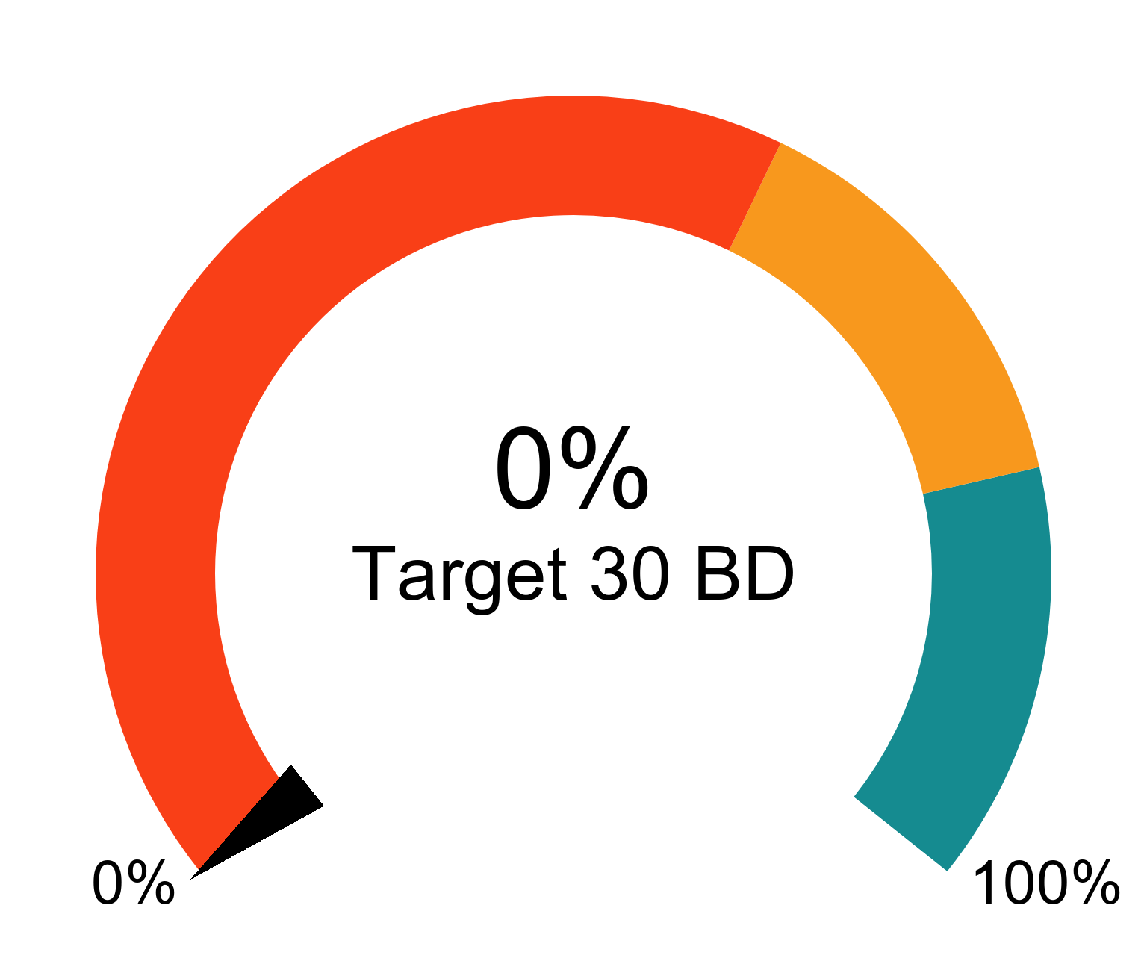
Trends for Received, Finalised and Open

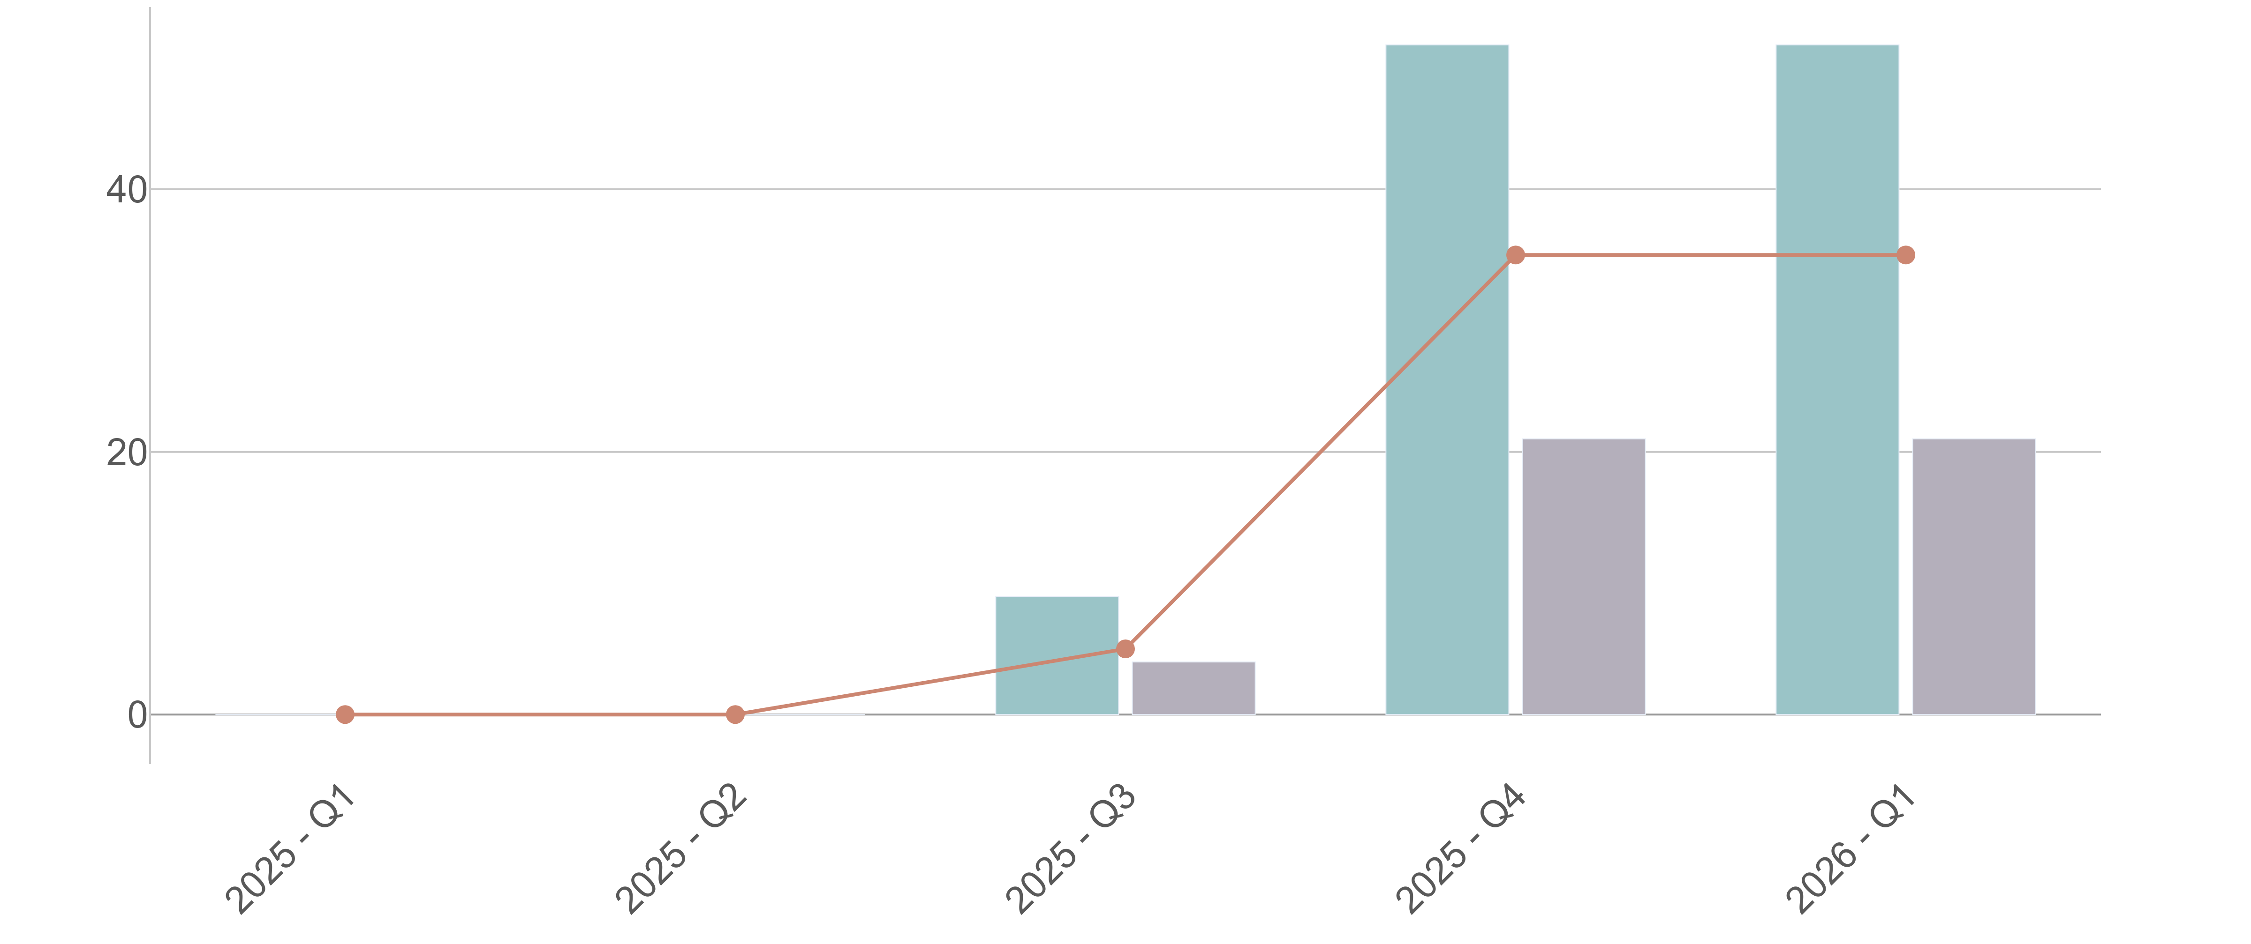
⬛Received in quarter ⬛Finalised in quarter — Open at end of quarter

Mining Act 1978 - Environmental applications
Eligible Mining Activity

Average 0 days total | % Finalised within Target Timeline

⬛DMPE ⬛Proponent ⬛Other Agencies
⬛ Parallel Processing

Trends for Received, Finalised and Open

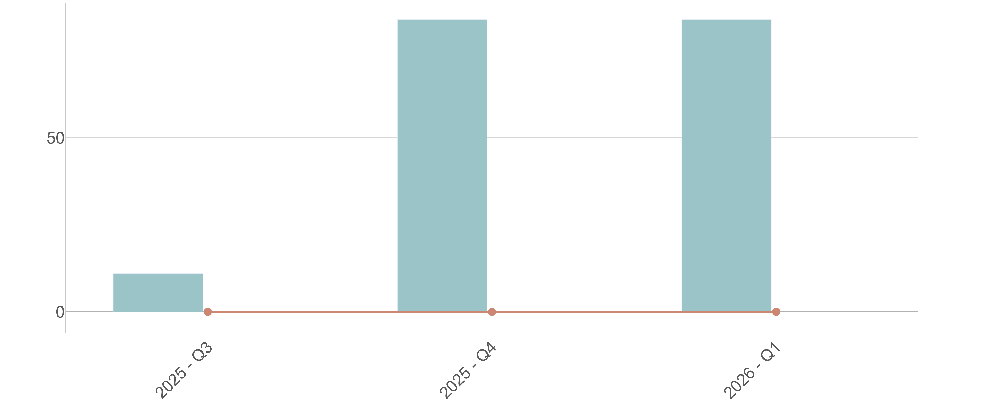
⬛Received in quarter ⬛Finalised in quarter — Open at end of quarter

WA Petroleum Legislation
Petroleum Tenure

Average 89 days total | % Finalised within Target Timeline
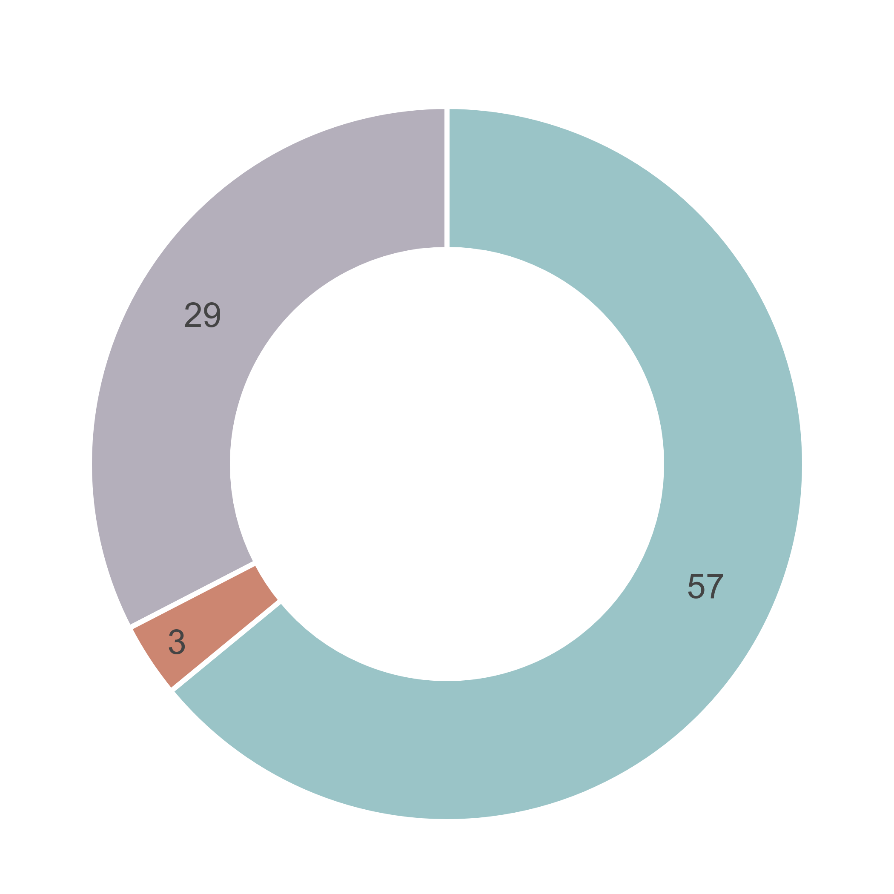  ⬛DMPE ⬛Proponent ⬛Other Agencies  ⬛ Parallel Processing | 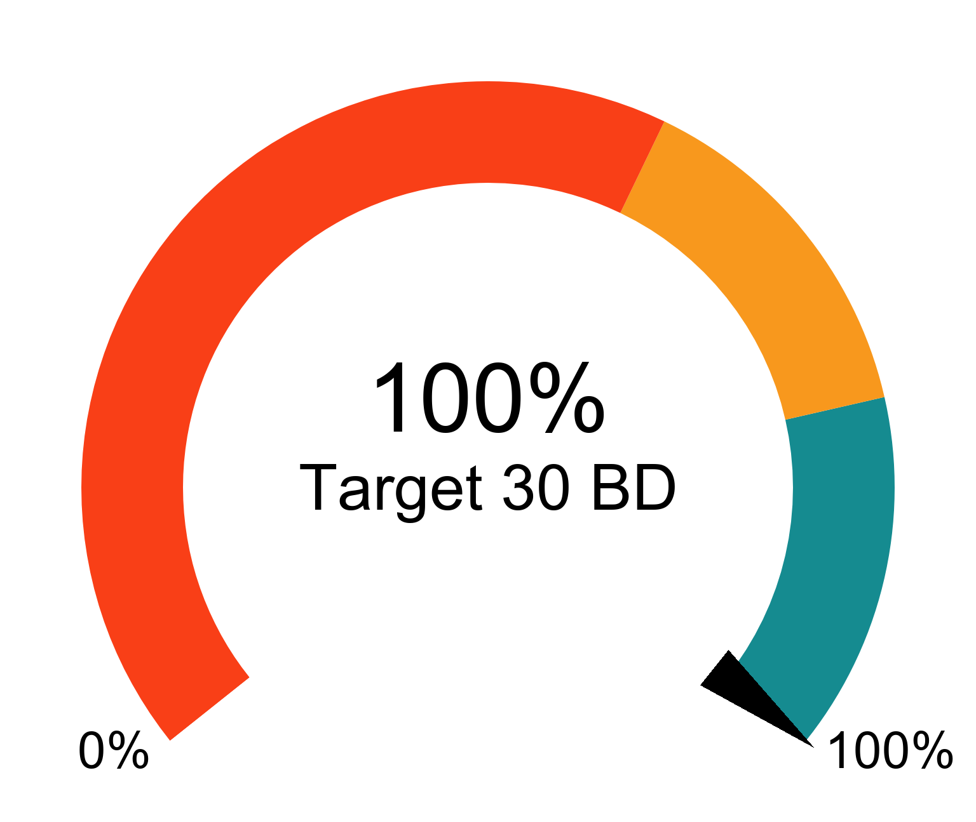
Trends for Received, Finalised and Open

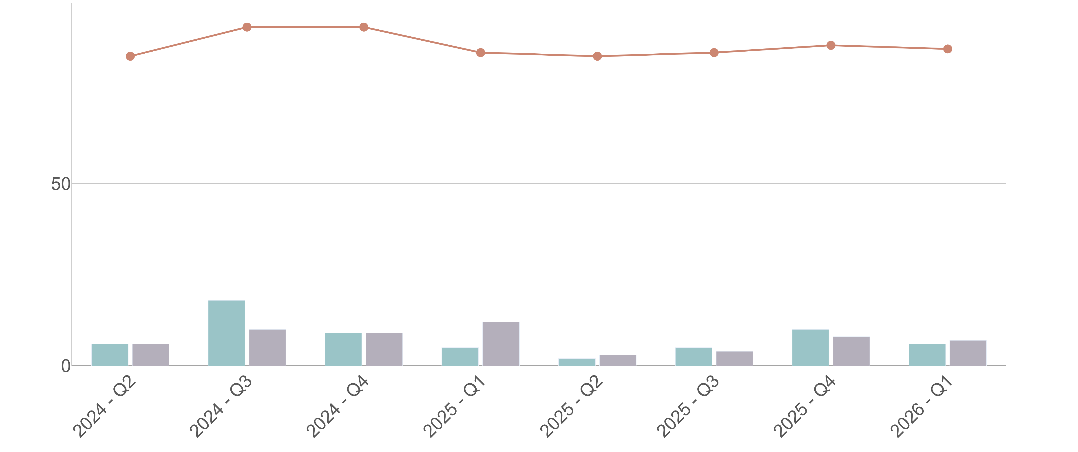
⬛Received in quarter ⬛Finalised in quarter — Open at end of quarter

WA Petroleum Legislation
Petroleum Environment Plans

Average 31 days total | % Finalised within Target Timeline
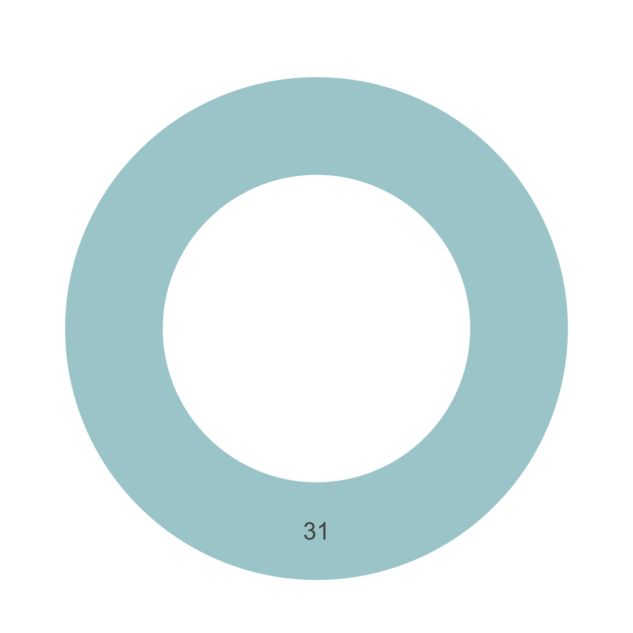  ⬛DMPE ⬛Proponent ⬛Other Agencies  ⬛ Parallel Processing | 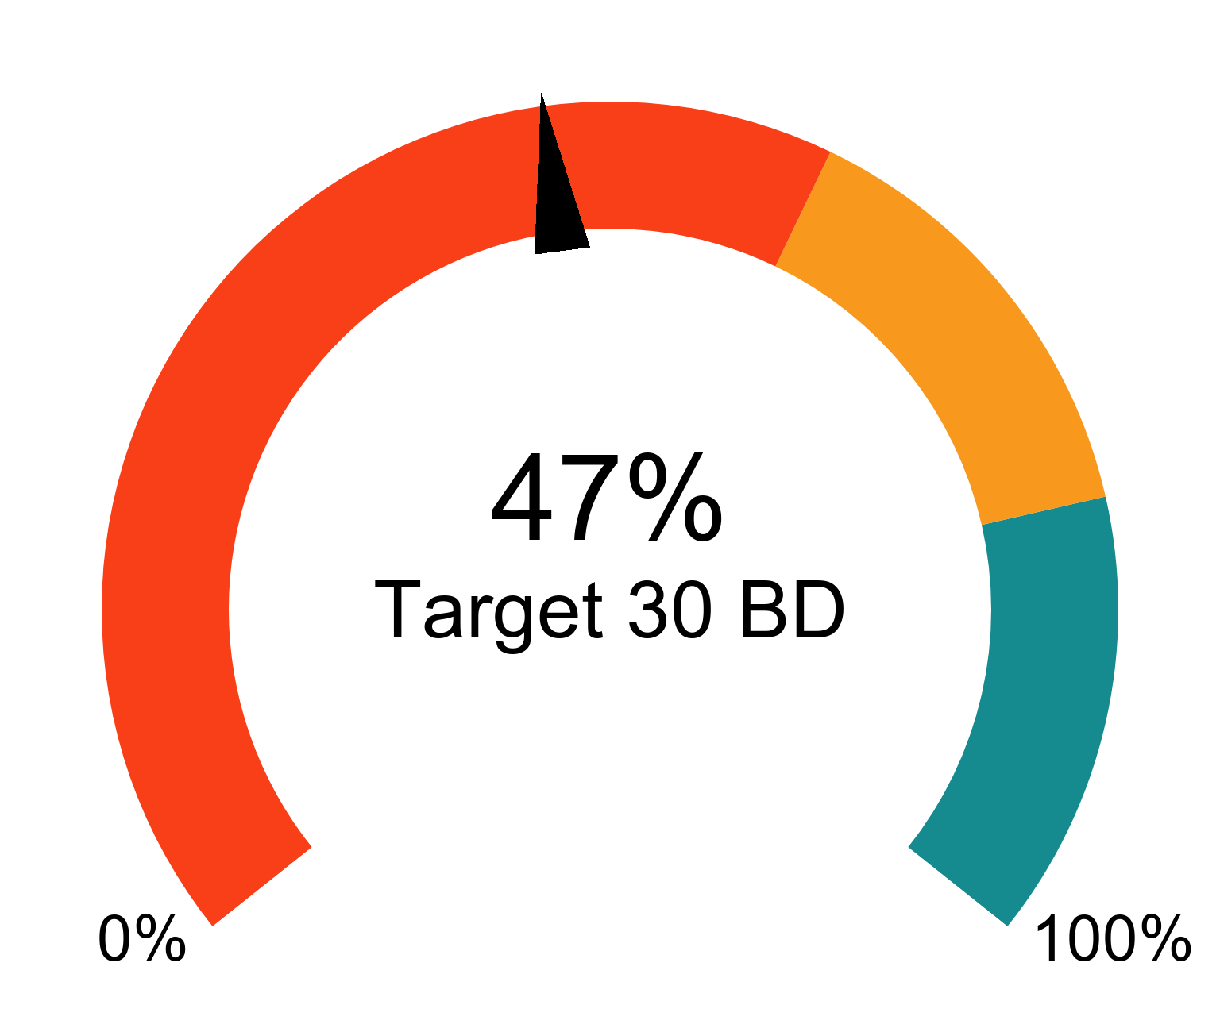
Trends for Received, Finalised and Open

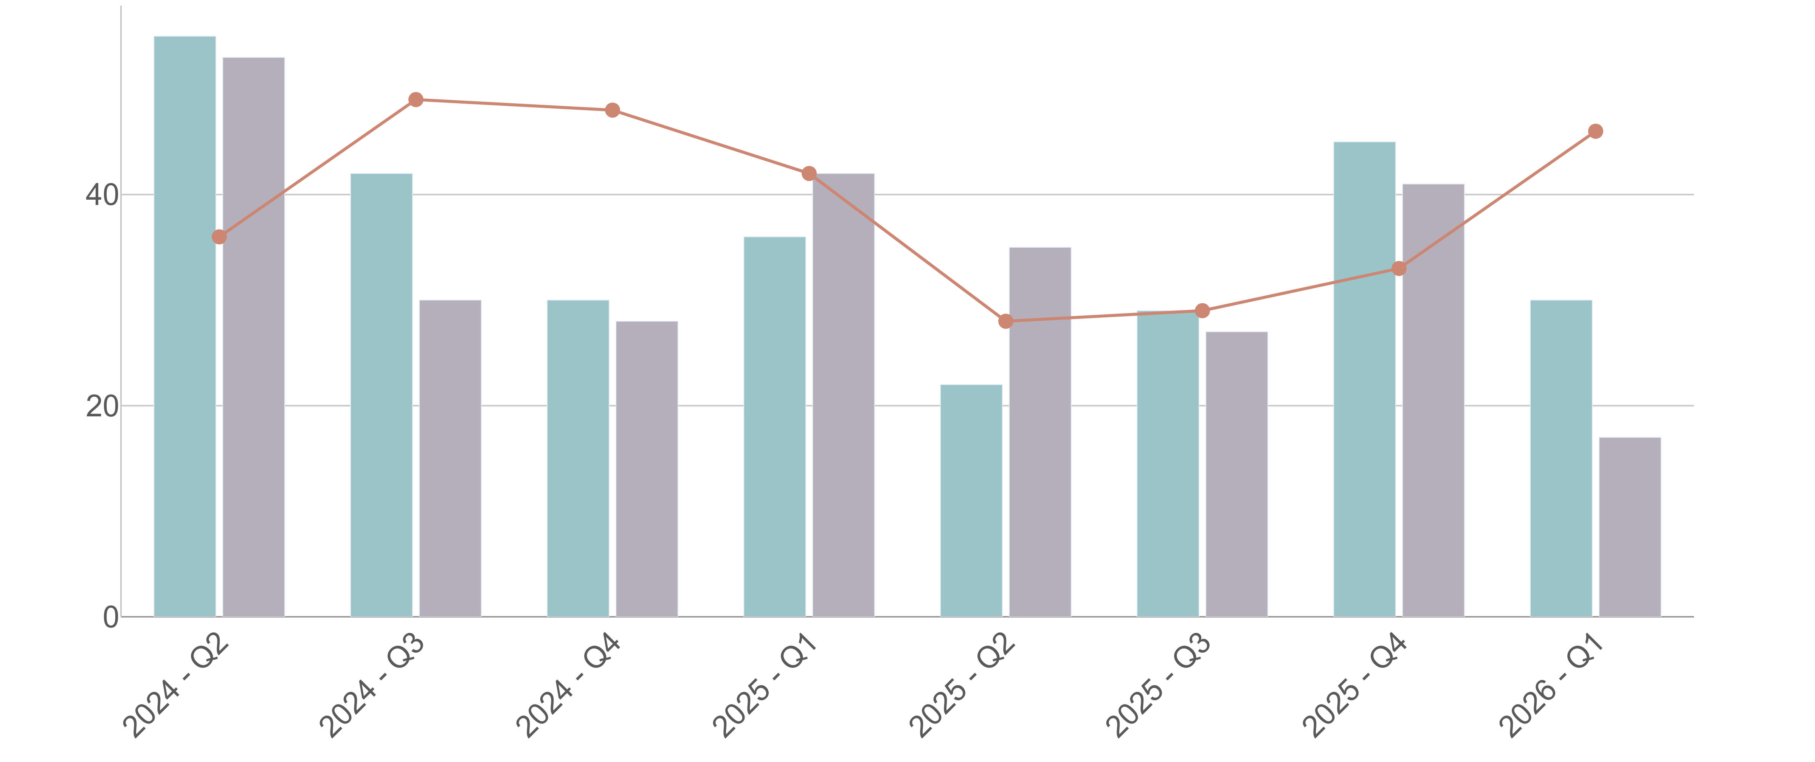
⬛Received in quarter ⬛Finalised in quarter — Open at end of quarter

WA Petroleum Legislation
Well Activities

Average 24 days total | % Finalised within Target Timeline
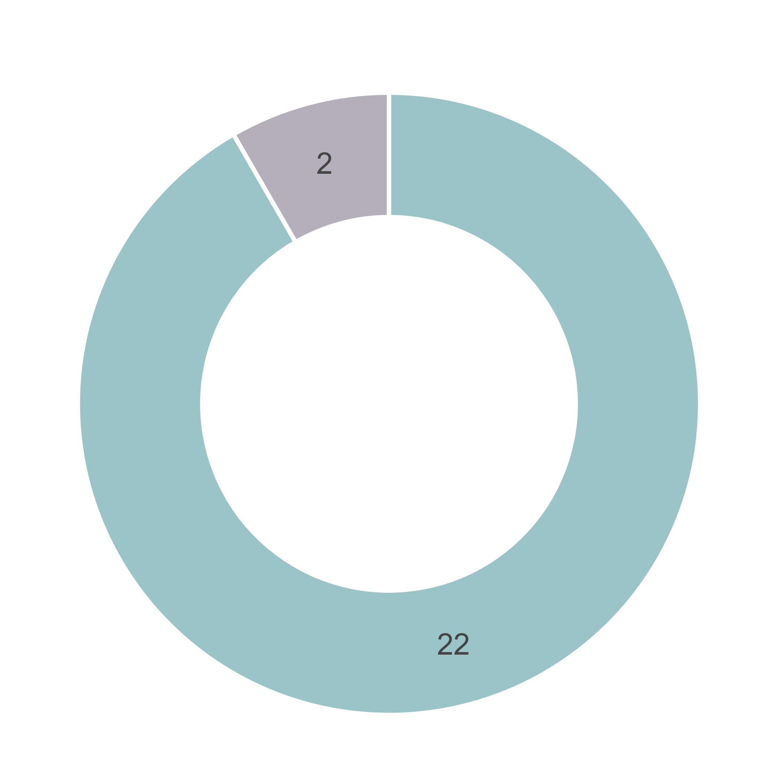
⬛DMPE ⬛Proponent ⬛Other Agencies
⬛ Parallel Processing

Trends for Received, Finalised and Open

⬛Received in quarter ⬛Finalised in quarter — Open at end of quarter

Appendix – DMPE target timeline information
Key approval processes | Target timeline  (business days)
Mining Tenure | 65
Petroleum Tenure | 120
Petroleum Environment Plan | 21
Mine Development and Closure Proposal | 30
Programme of Works | 15
Radiation Management Plan | 30
Well Activities | 21
Native Vegetation Clearing Permit | 60

Note: Petroleum Environment Plans and Well Activities have a statutory target of 30 calendar days (21 business days).

