Mining Act 1978 - Mineral tenure applications
Prospecting Licence

Average 269 days total | % Finalised within Target Timeline
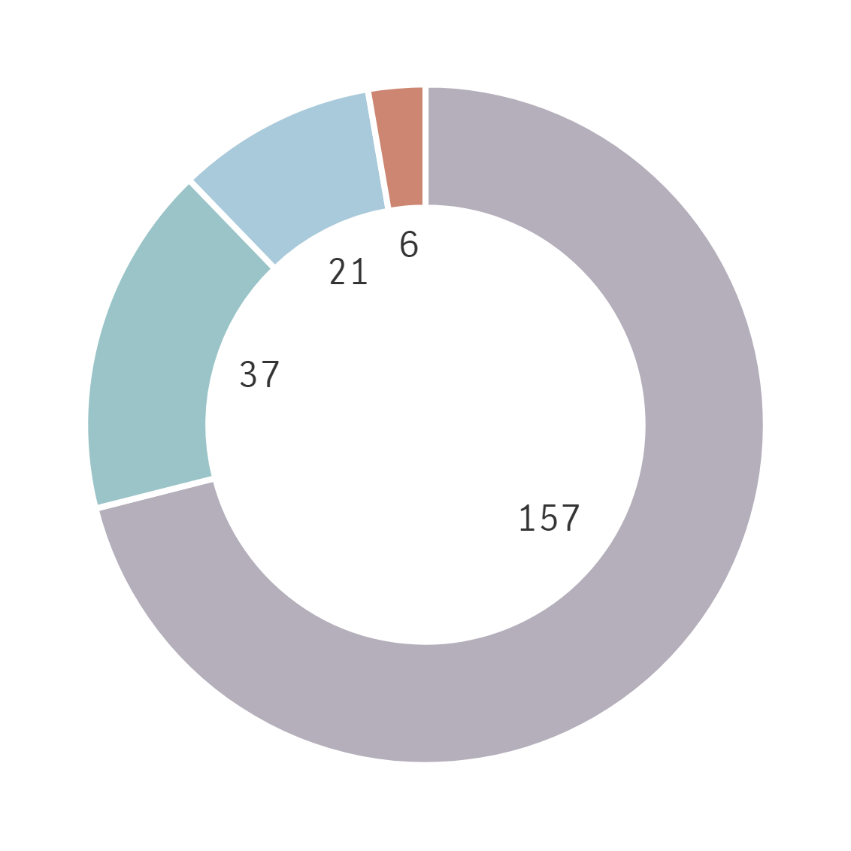  ⬛DMPE ⬛Proponent ⬛Other Agencies  ⬛ Parallel Processing | 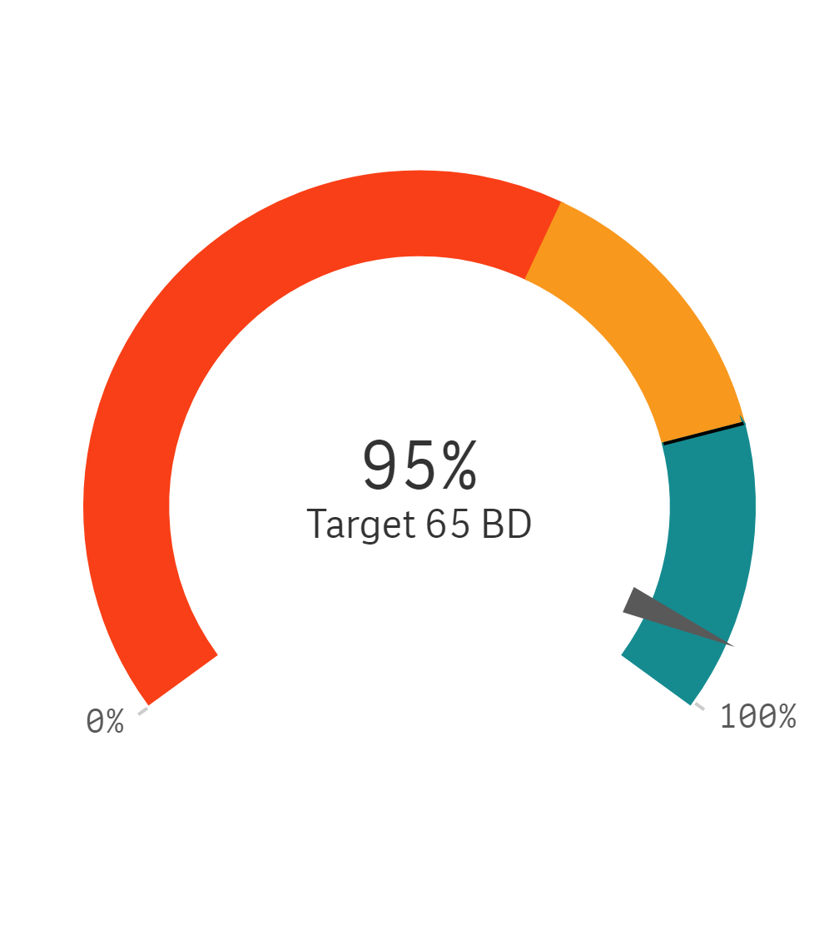
Trends for Received, Finalised and Open

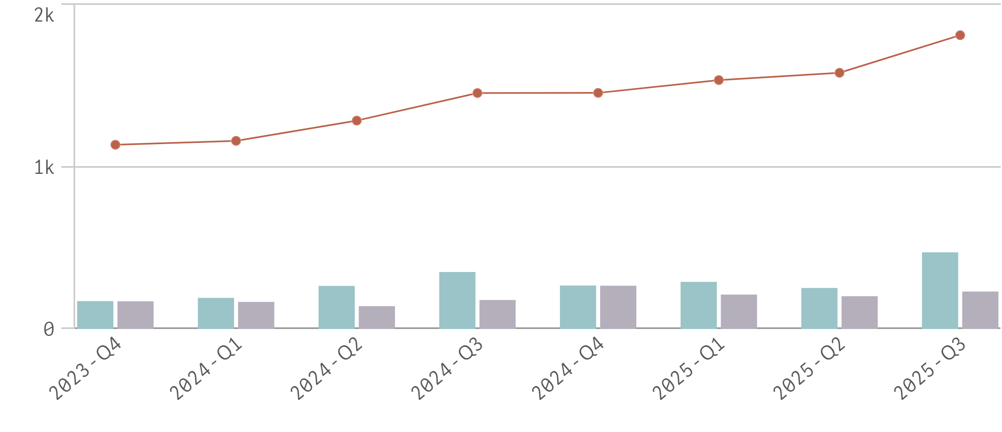
⬛Received in quarter ⬛Finalised in quarter — Open at end of quarter

Mining Act 1978 - Mineral tenure applications
Exploration Licence

Average 342 days total | % Finalised within Target Timeline
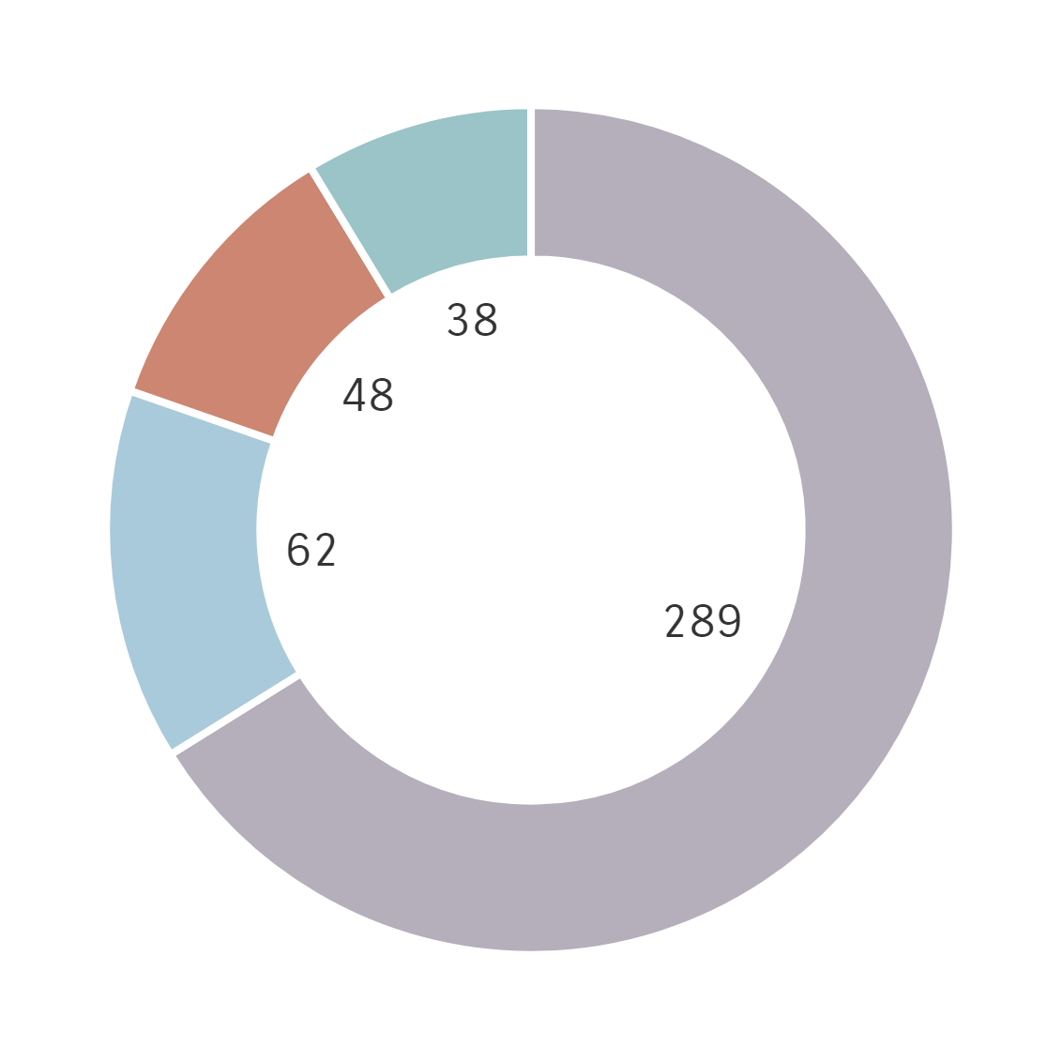  ⬛DMPE ⬛Proponent ⬛Other Agencies  ⬛ Parallel Processing | 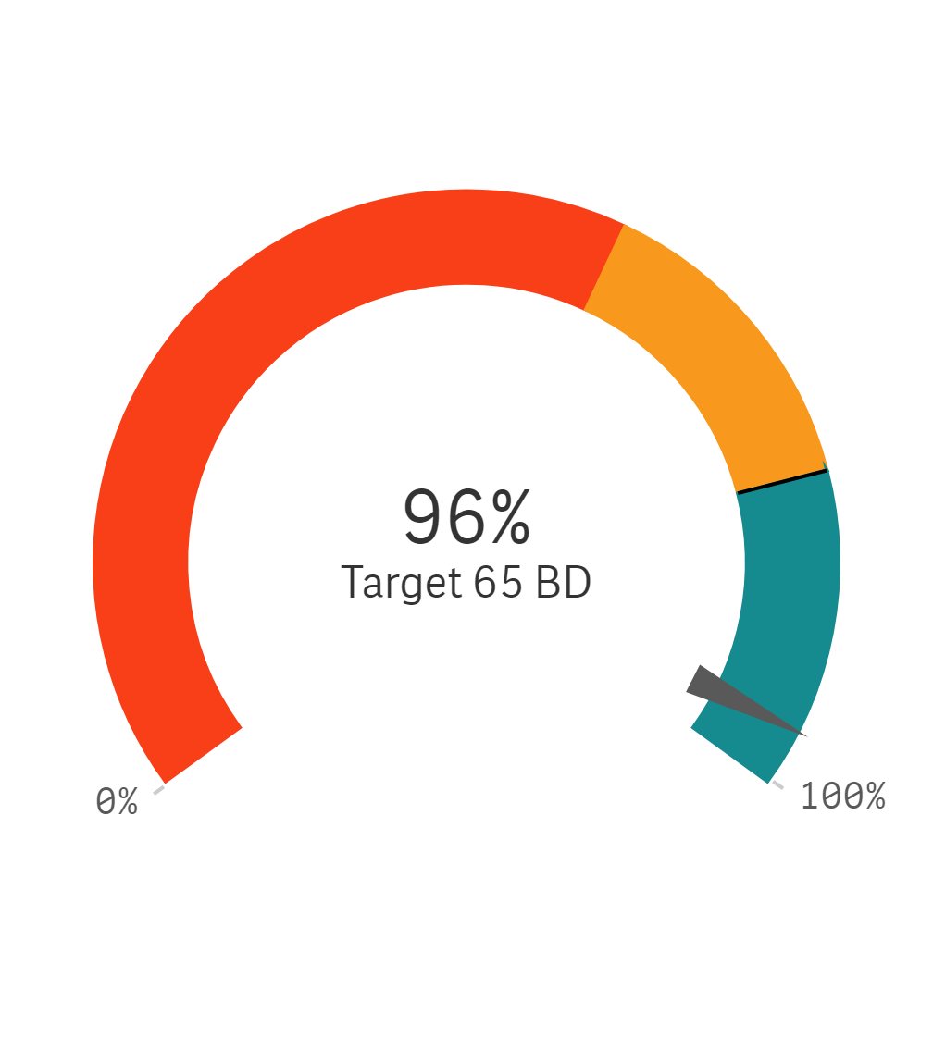
Trends for Received, Finalised and Open

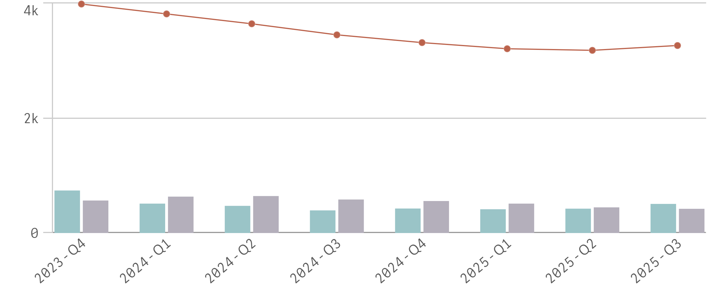
⬛Received in quarter ⬛Finalised in quarter — Open at end of quarter

Mining Act 1978 - Mineral tenure applications
Mining Lease

Average 411 days total | % Finalised within Target Timeline
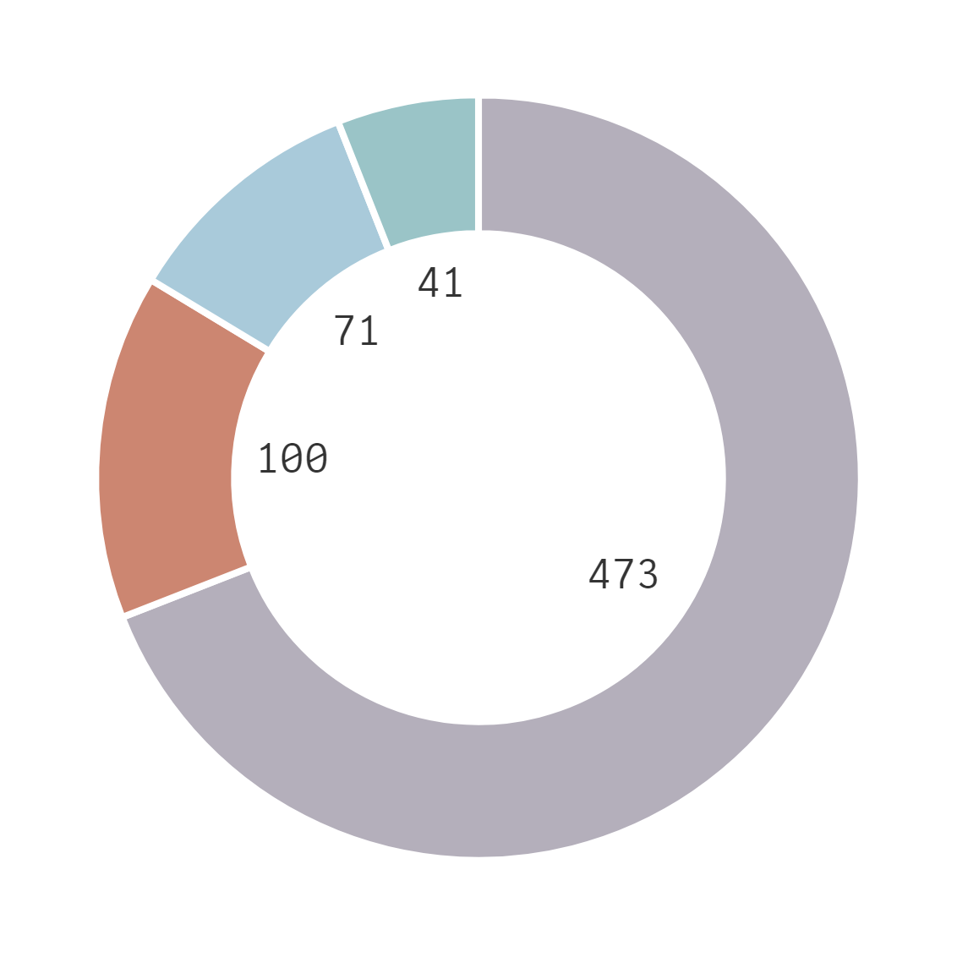  ⬛DMPE ⬛Proponent ⬛Other Agencies  ⬛ Parallel Processing | 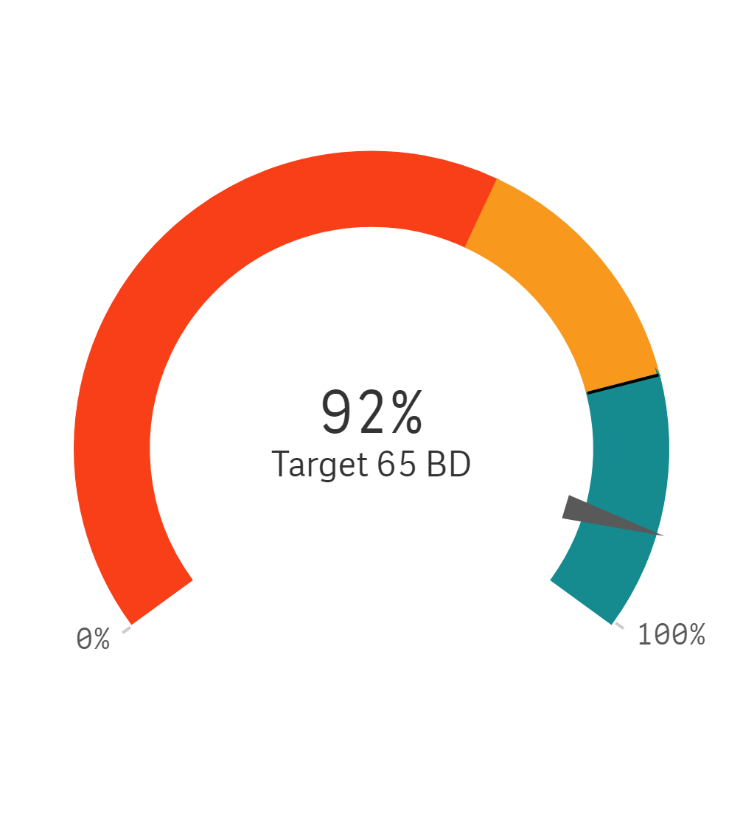
Trends for Received, Finalised and Open

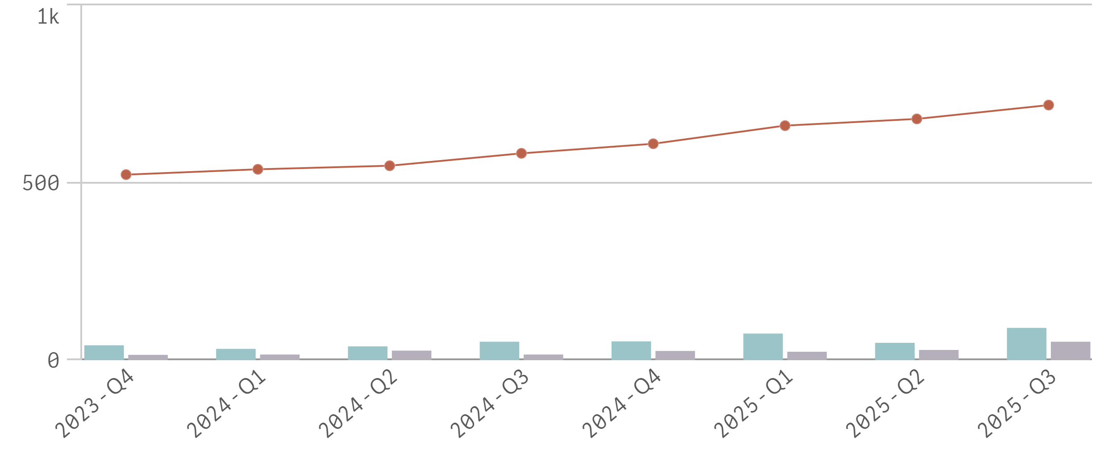
⬛Received in quarter ⬛Finalised in quarter — Open at end of quarter

Mining Act 1978 - Mineral tenure applications
Miscellaneous Licence and other tenure

Average 331 days total | % Finalised within Target Timeline
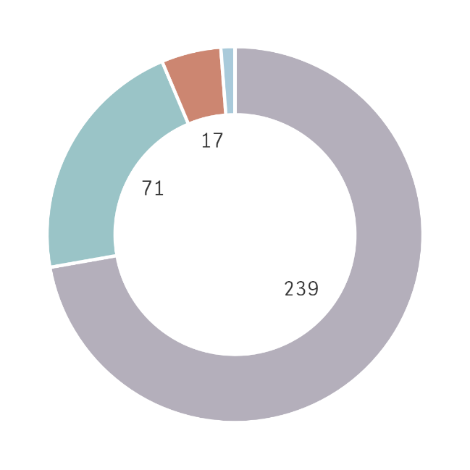  ⬛DMPE ⬛Proponent ⬛Other Agencies  ⬛ Parallel Processing | 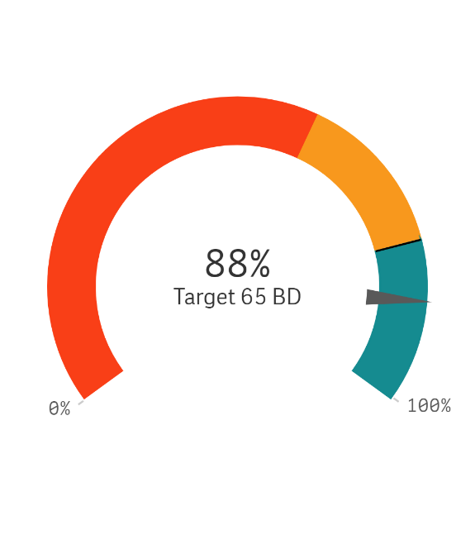
Trends for Received, Finalised and Open

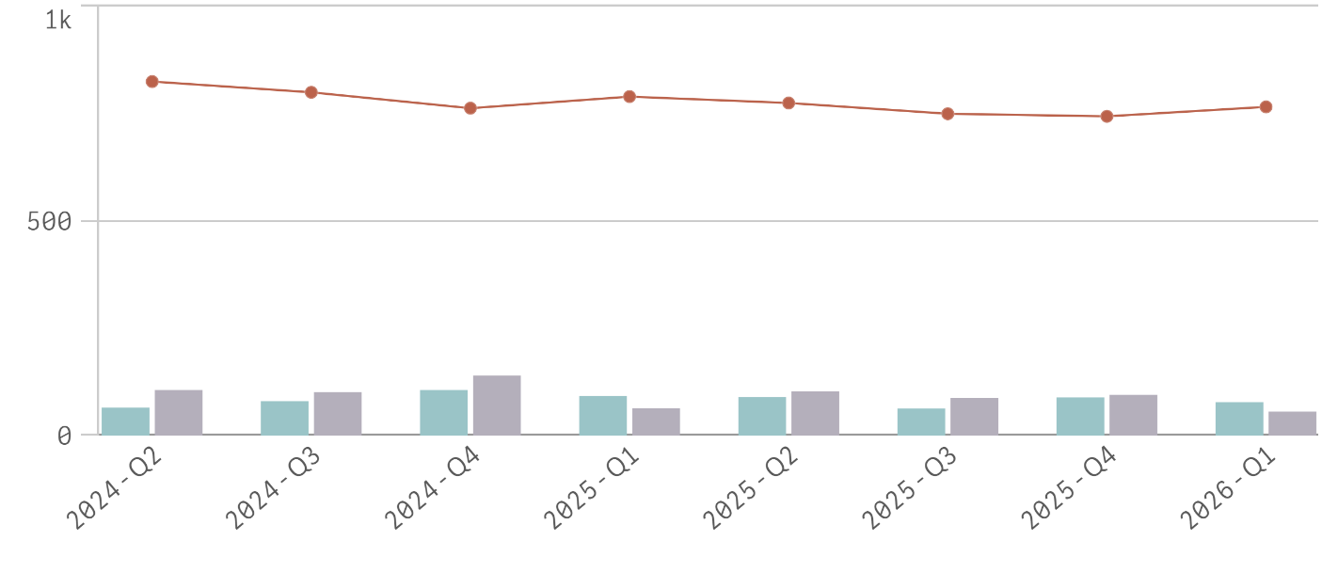
⬛Received in quarter ⬛Finalised in quarter — Open at end of quarter

Mining Act 1978 - Environmental applications
Programme of Work

Average 0 days total | % Finalised within Target Timeline
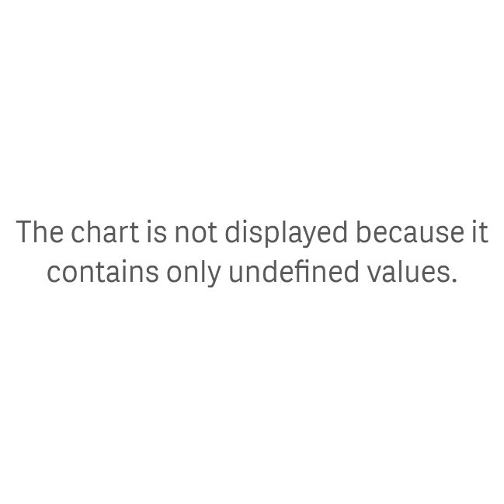  ⬛DMPE ⬛Proponent ⬛Other Agencies  ⬛ Parallel Processing | 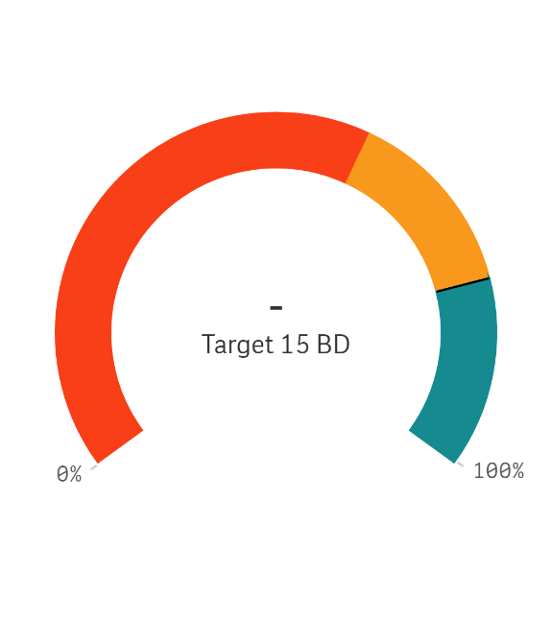
Trends for Received, Finalised and Open

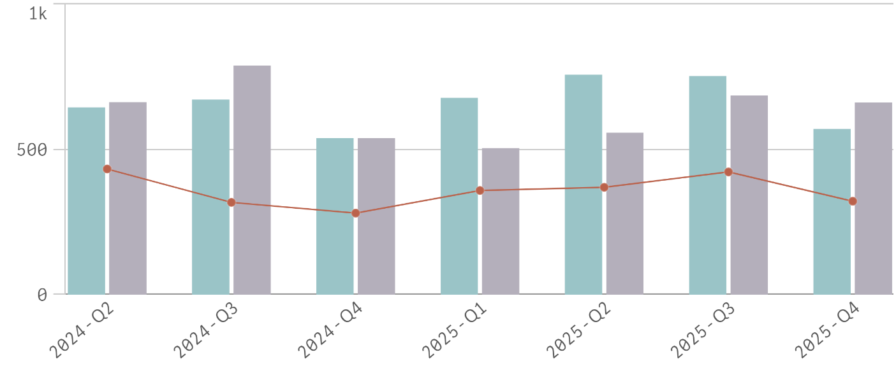
⬛Received in quarter ⬛Finalised in quarter — Open at end of quarter

Mining Act 1978 - Environmental applications
Mining Proposal

Average 0 days total | % Finalised within Target Timeline
⬛DMPE ⬛Proponent ⬛Other Agencies  ⬛ Parallel Processing | 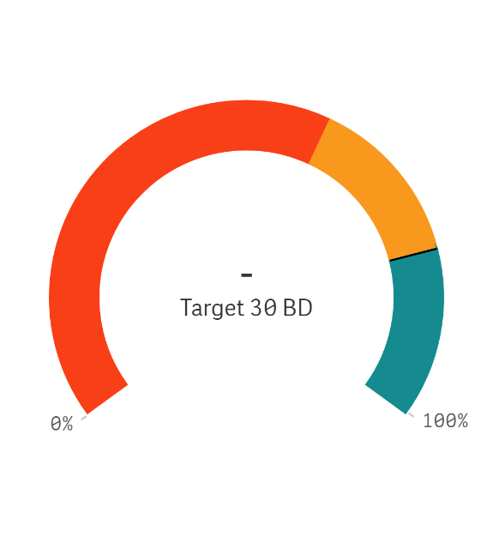
Trends for Received, Finalised and Open

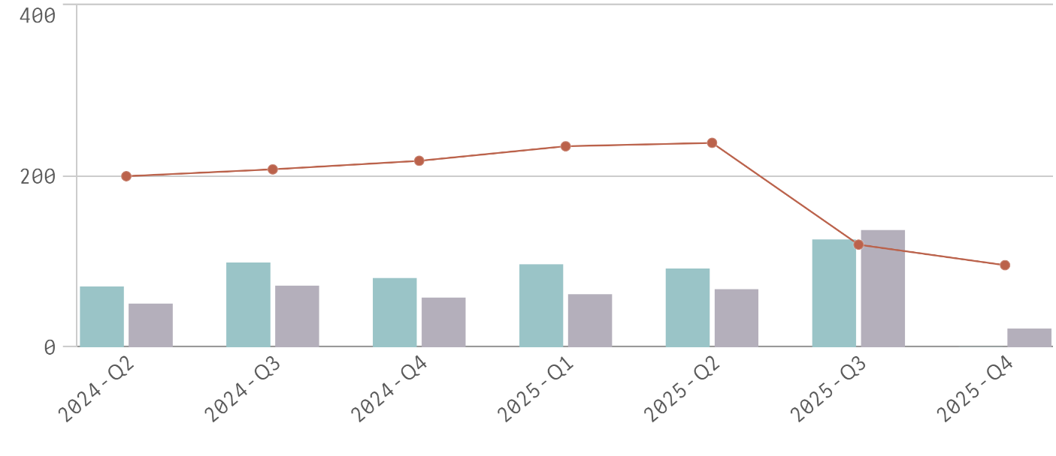
⬛Received in quarter ⬛Finalised in quarter — Open at end of quarter

WA Petroleum Legislation
Petroleum Tenure

Average 89 days total | % Finalised within Target Timeline
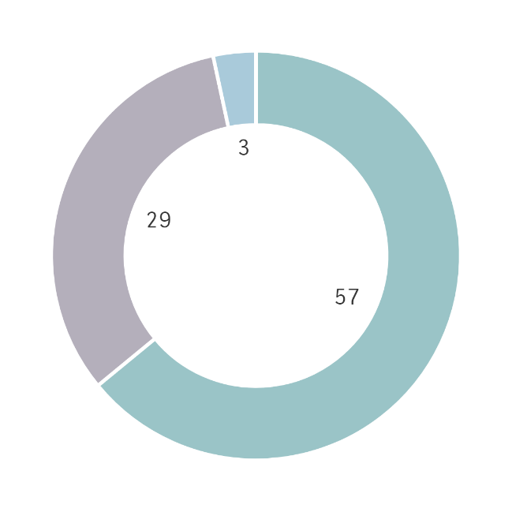  ⬛DMPE ⬛Proponent ⬛Other Agencies  ⬛ Parallel Processing | 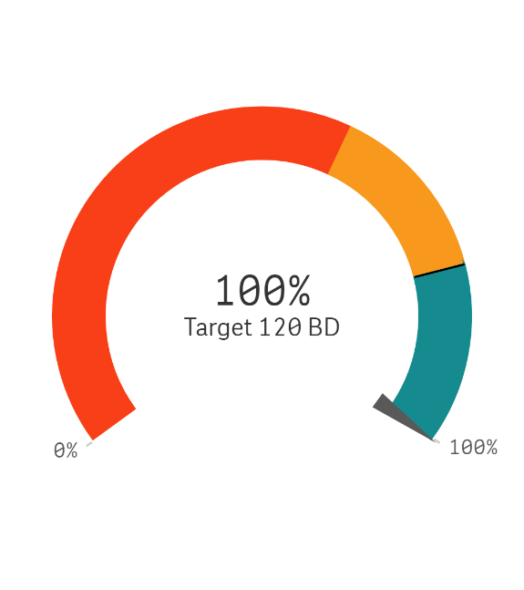
Trends for Received, Finalised and Open

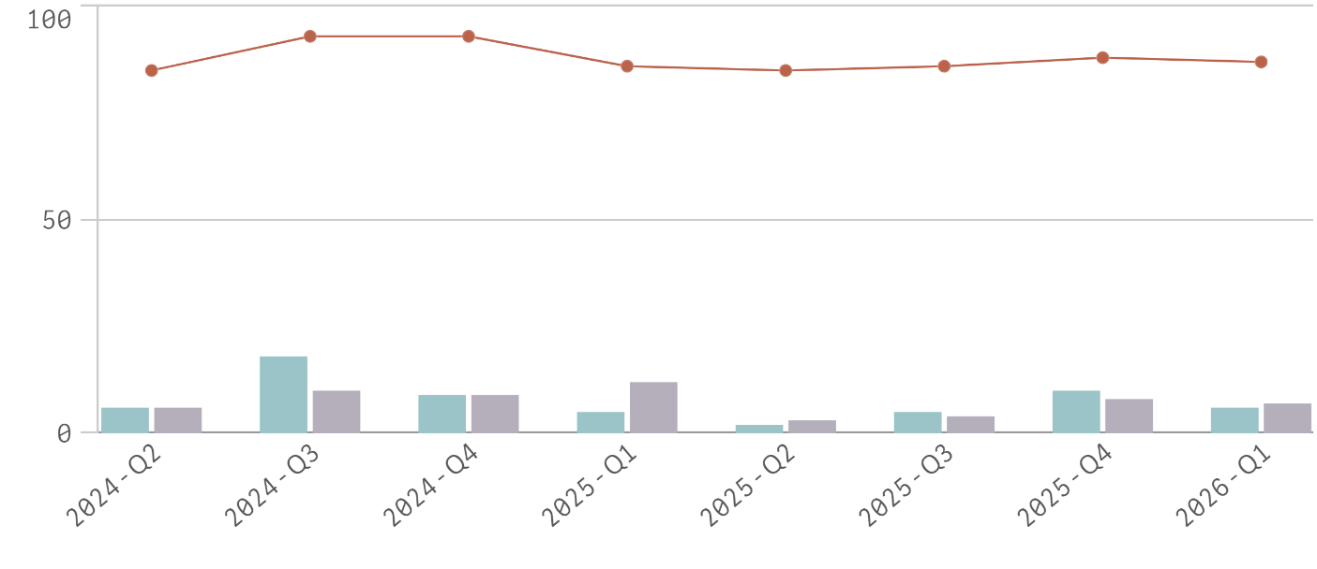
⬛Received in quarter ⬛Finalised in quarter — Open at end of quarter

WA Petroleum Legislation
Petroleum Environment Plans

Average 31 days total | % Finalised within Target Timeline
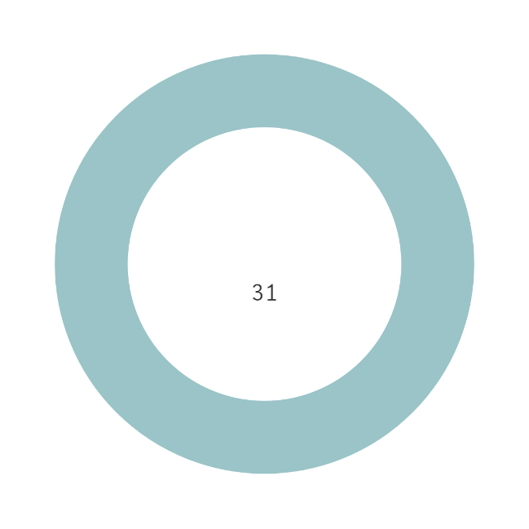  ⬛DMPE ⬛Proponent ⬛Other Agencies  ⬛ Parallel Processing | 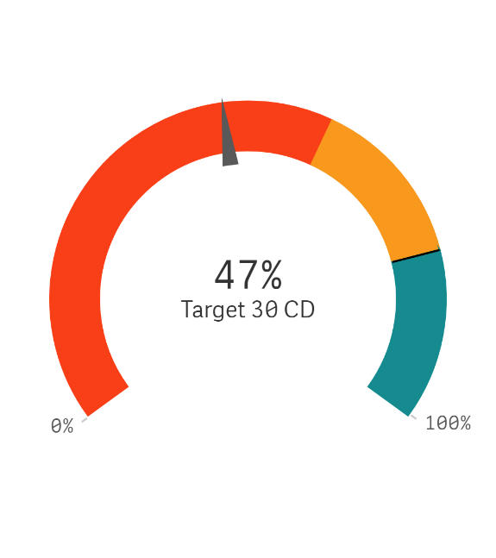
Trends for Received, Finalised and Open

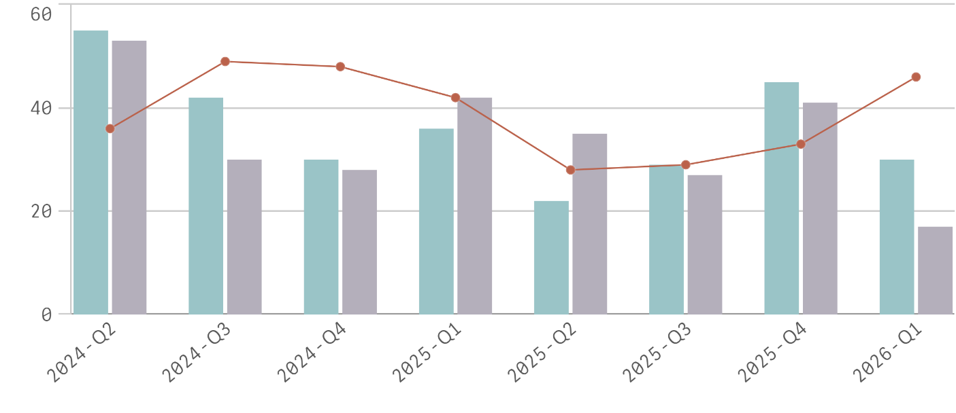
⬛Received in quarter ⬛Finalised in quarter — Open at end of quarter

WA Petroleum Legislation
Well Activities

Average 25 days total | % Finalised within Target Timeline
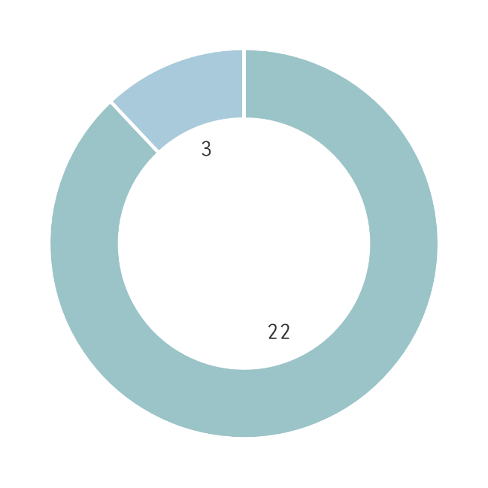  ⬛DMPE ⬛Proponent ⬛Other Agencies  ⬛ Parallel Processing | 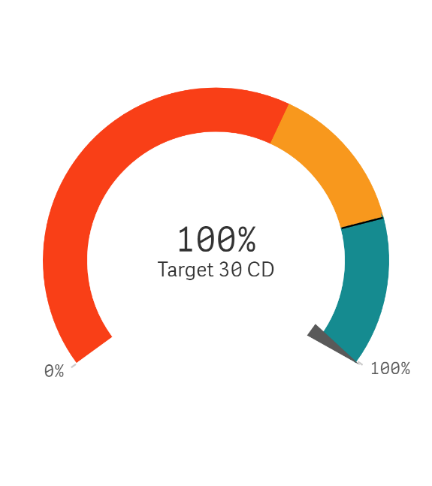
Trends for Received, Finalised and Open

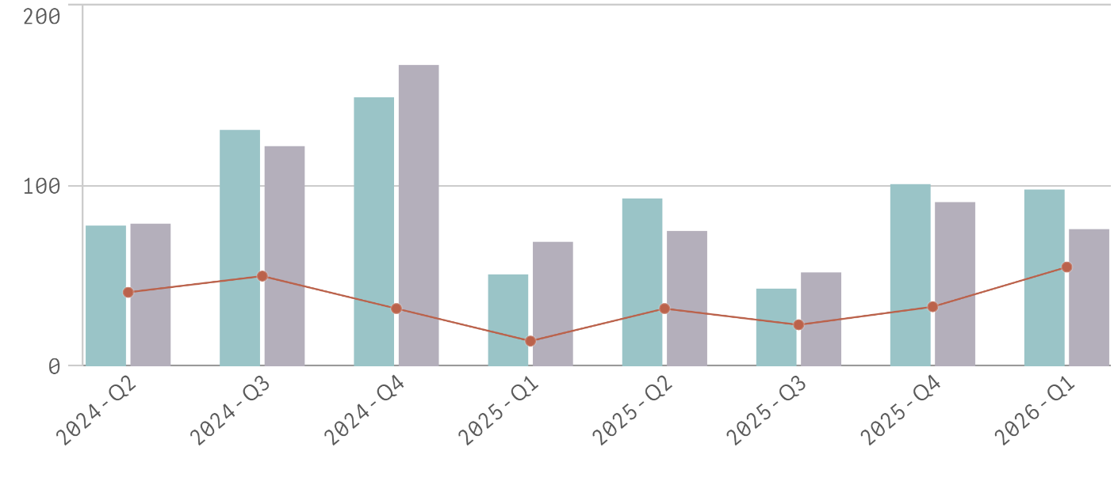
⬛Received in quarter ⬛Finalised in quarter — Open at end of quarter

